DocuSign Process for PNS Letter of Intent

To initiate an LOI, click the PowerForm link on Bionet.
https://na2.docusign.net/Member/PowerFormSigning.aspx?PowerFormId=f336b33c-dd81-4e80-a7b1-0c4e7418a507&env=na2&acct=99c9a173-6504-4e9f-a6b1-92a3713cdcd8&v=2
In the PowerForm landing page, enter your name and email address, the name and email address of your DOS and the name and email address of your customer contact who will be receiving the quote. Then click the “Begin Signing” button.
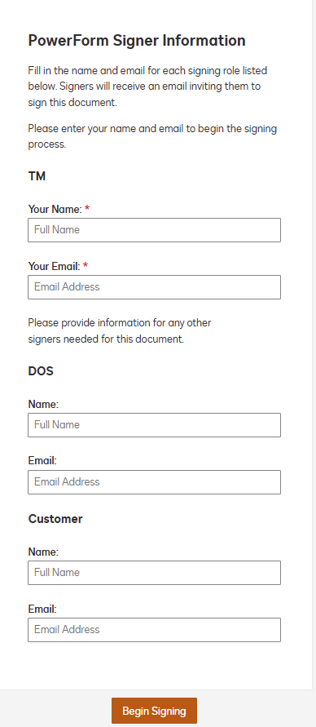

You may be prompted to agree to use electronic records and signatures – please click the checkbox and then the Continue button.
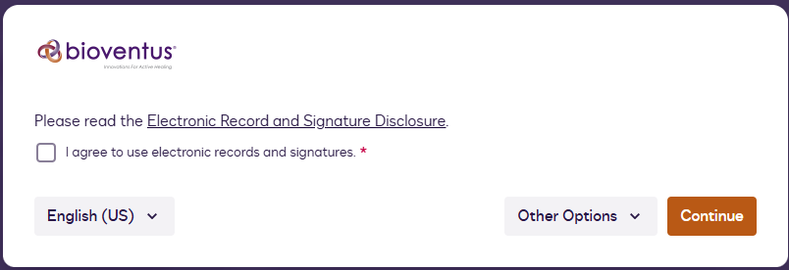

Once the LOI document appears, you will need to fill in the name if the Customer (this is the facility name, not an individual contact’s name) and the facility address and phone number. The Customer will be able to edit these fields if any corrections are needed.

The Customer Contact Name and email are already populated with the contact’s name you filled in on the PowerForm landing page – though you may not see them, be assured that the customer will.

Lastly, fill in the prices for TM-1001 and TM-1002. Do not include a dollar sign, comma, or decimal. The dollar sign is already on the document, and DocuSign will take care of formatting the number you enter.

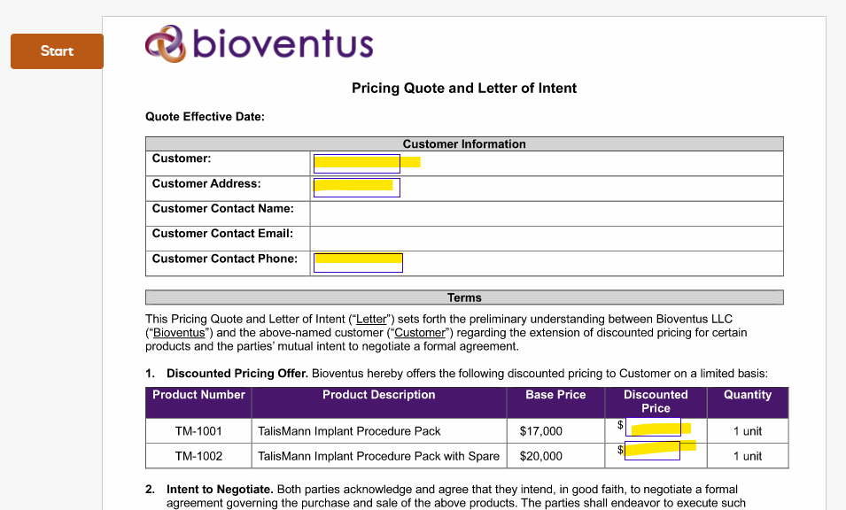
Once the fields are populated with valid data, you will see a finish button appear in the upper right corner. Click Finish to complete your role in the workflow.
Next, the document will be routed for approval. Each of the following roles will receive a DocuSign email notification to review the document once the previous role has been completed. They will have the ability to edit the customer’s name, address, and pricing so that if any adjustments need to be made, the TM will not have to start over with a new form.
- DOS
- NSD
- Finance
- Market Access
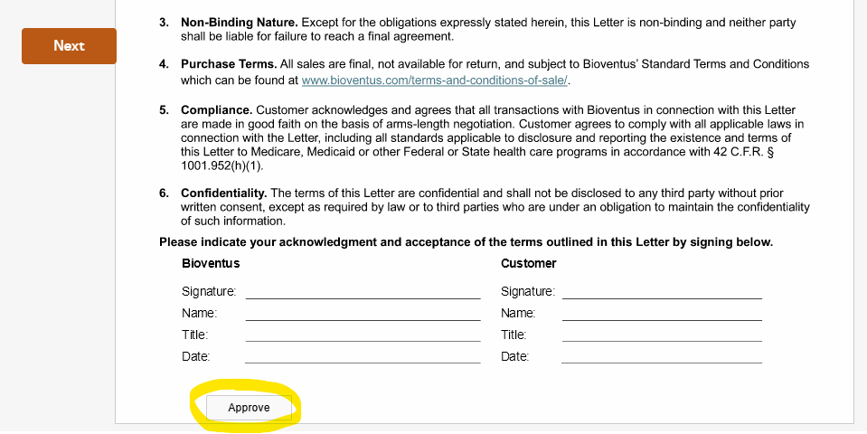

After the approvals are met, the document will go back to the NSD for final Bioventus signature before moving on to the Customer.

Lastly, the customer contact person will receive a DocuSign email notification to review the envelope.
Customer contact will be able to make any necessary changes to the customer’s name, address, and phone number, but is not able to change the price.

Once the workflow is complete, all participants receive a DocuSign email notification indicating the envelope is complete and all can download, save, or print the document.

The business process owner for the LOI should download/save a copy of the fully executed LOI to a repository outside of DocuSign.

