DocuSign Process for PNS Quote (List Price)

To initiate a quote, click the PowerForm link on Bionet.
https://na2.docusign.net/Member/PowerFormSigning.aspx?PowerFormId=53aa3754-d919-4730-9312-ef55685121e7&env=na2&acct=99c9a173-6504-4e9f-a6b1-92a3713cdcd8&v=2
In the PowerForm landing page, enter your name and email address and the name and email address of your customer contact who will be receiving the quote. Then click the “Begin Signing” button.
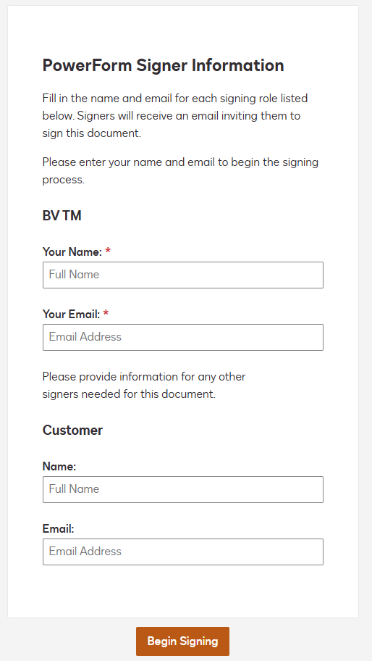

You may be prompted to agree to use electronic records and signatures – please click the checkbox and then the Continue button.
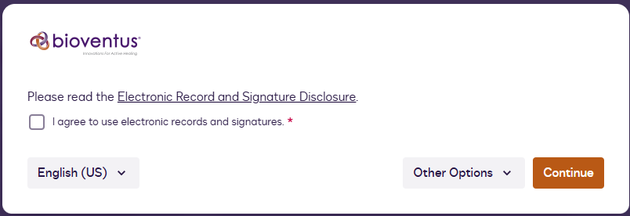

Once the Quote document appears, you will need to fill in the name if the Customer (this is the facility name, not an individual contact’s name) and the facility address. The Customer will be able to edit both fields if any corrections are needed.

The customer contact name is already populated with the contact’s name you filled in on the PowerForm landing page.

Lastly, fill in the price for the implant procedure pack. Only values ranging from 15500 and 17000 will be accepted. Do not include a dollar sign, comma, or decimal. The dollar sign is already on the document, and DocuSign will take care of formatting the number you enter.

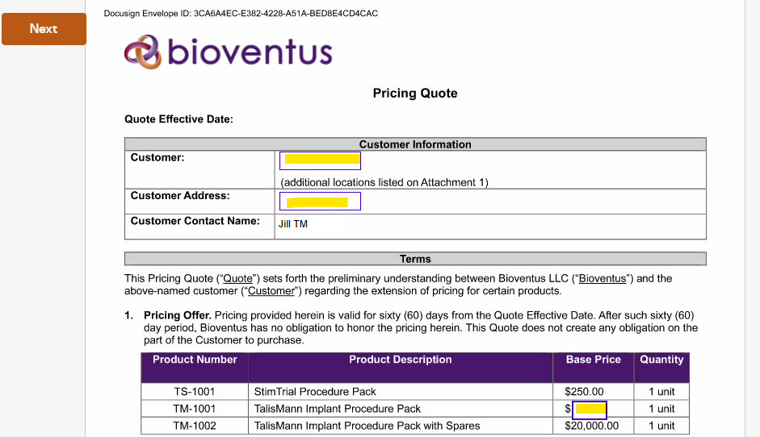
Once all three fields are populated with valid data, you will see a finish button appear in the upper right corner. Click Finish to complete your role in the workflow.
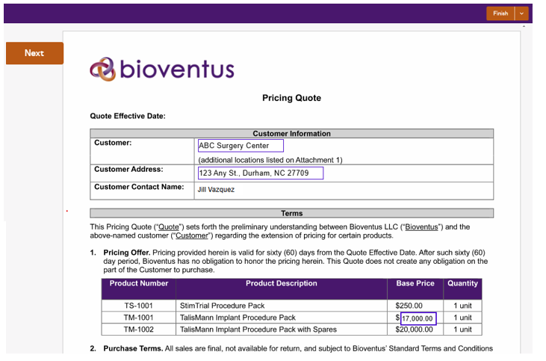

Next, the National Sales Director will receive a DocuSign email notification to review and sign the envelope. The NSD can make any necessary corrections to the customer’s name, address, or the price before signing the document.

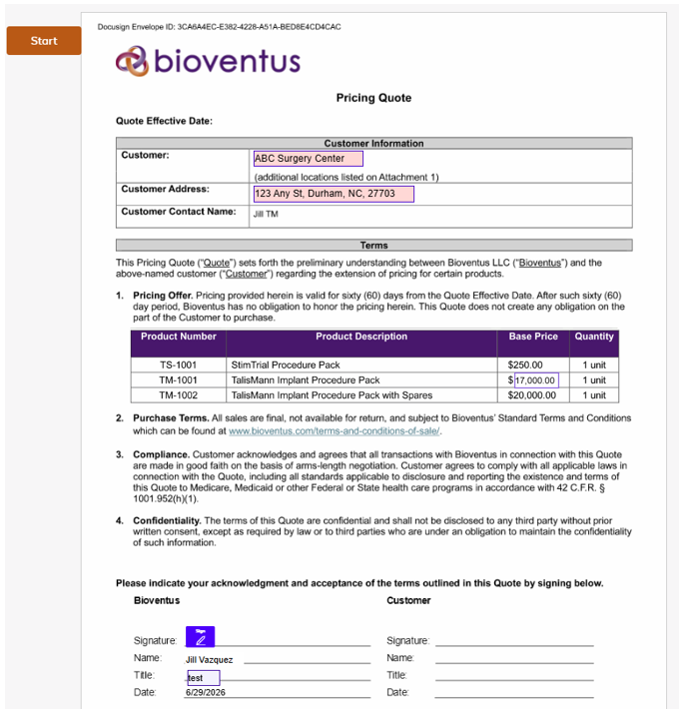

Lastly, the customer contact person will receive a DocuSign email notification to review the envelope.
Customer contact will be able to make any necessary changes to the customer’s name and address but cannot change the price.
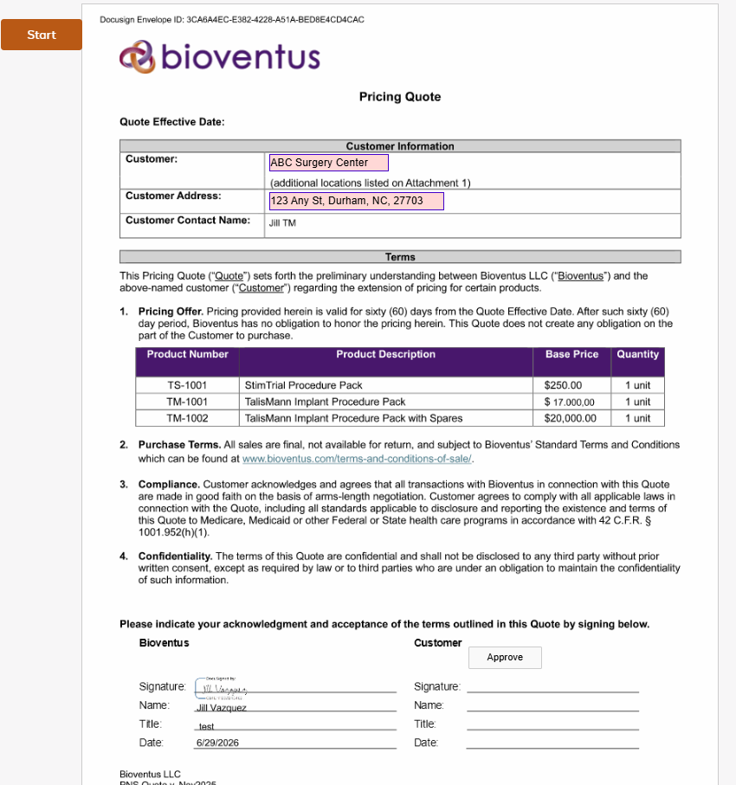
The customer contact can upload a list of additional locations if applicable and will click the “Approve” button to complete their role in the workflow. Customer contact is not required to sign.
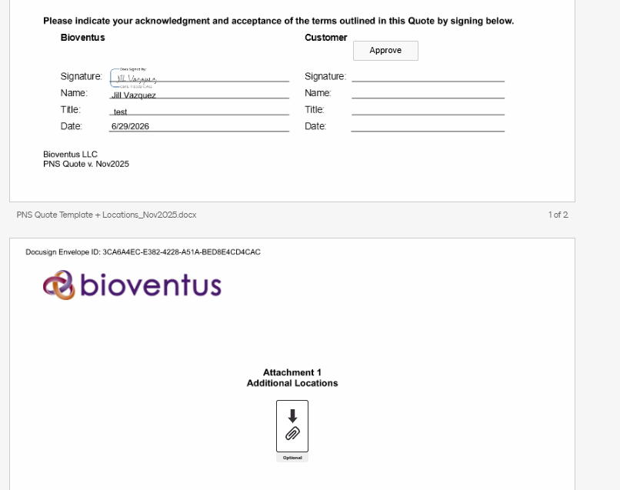
Once the workflow is complete, all participants receive a DocuSign email notification indicating the envelope is complete and all can download, save, or print the document.
The business process owner for the Quote should download/save a copy of the accepted quote to a repository outside of DocuSign.

