Specification: SPC-000067
Title: EXOGEN Product Claim Book

Nondisclosure Statement
This document contains information confidential and proprietary to Bioventus LLC, Durham, North Carolina, and is conditionally loaned only. By retention, the recipient agrees not to reproduce or copy it in whole or in part, disclose any or all of its contents without prior written permission, or make any use of it contrary to the interests of Bioventus LLC. Recipient further agrees to return it upon request.

Table of Contents
Specification: SPC-000067 1
1. Introduction 2
2. Scope 2
3. References 2
3.1 External Standards and Regulations 2
3.2 Internal Procedures and Documents 2
4. Definitions 2
5. Requirements 2
5.1 EXOGEN Tag Lines / Messaging (no references needed) 3
5.2 EXOGEN Market Claims 12
5.3 EXOGEN Product Claims 22
5.4 EXOGEN Safety Claims 32
5.5 EXOGEN Clinical Effectiveness Claims 35
5.6 Mechanism of Action Claims 72
5.7 Health Economic Claims 87
5.8 General Fracture Claims (not EXOGEN specific) 90
5.9 EXOGEN Indication Statement 101
5.10 EXOGEN Writing Guidelines 102
Appendix 1. AMERICAN MEDICAL ASSOCIATION CITATION STYLE 104

Introduction
The purpose of the EXOGEN Product Claim Book is to provide all pertinent information for the EXOGEN brand to assist in developing, reviewing and approving EXOGEN marketing materials. This Product Claim Book contains approved messaging, supported claims with references, plus branding and writing information. The expectation is that promotional materials will use the exact wording contained within the Product Claim Book. Deviation from approved wording will result in approval delays.

Scope
EXOGEN is marketed by Bioventus LLC and is available for use in the United States and internationally with differing indications of use and approved labeling. This claims book pertains to claims made in the United States only. All promotional material requires a unique identifier (generated from the Document Management System), together with a revision level and date.

References

External Standards and Regulations
- 21 USC 9 - Food Drug and Cosmetic Act

Internal Procedures and Documents

Reference | Description
Q105007-BC | Copy Review Approval Process
Work Instruction 0059335 | Dissemination of Promotional Material
Bioventus Code of Conduct | Bioventus is committed to doing business with the highest integrity, which means complying with all applicable laws and regulations and adhering to the highest ethical standards.

Definitions
N/A

Requirements
This section(s) defines requirements section. Each individually identifiable item is included, explained, or referenced so that qualified individuals, possessing the normally required education and experience for the job description under which the procedure may be required can understand and apply the specification with adequate training.

EXOGEN Tag Lines / Messaging (references required where indicated)

Messaging for Physicians
Claim | Compliance  - Successful bone healing depends upon both effectiveness and treatment compliance. EXOGEN delivers both.¹⁻⁵ [Heckman 1994: 1a; Kristiansen 1997: 2b; Schofer 2010: 3a; Pounder 2016: 3a, 4a; Roussignol 2012: 3a]  - Adherence to prescribed treatment is essential.⁶ [EXOGEN User Guide: 4a]  - EXOGEN >> Designed for Treatment Compliance⁴ [Pounder 2016: 1a-b]  - Added confidence and a high level of treatment compliance¹⁻⁵ [Heckman 1994: 1a; Kristiansen 1997: 2b; Schofer 2010: 3a; Pounder 2016: 3a, 4a; Roussignol 2012: 3]  - EXOGEN has a built-in treatment-tracking calendar, making compliance convenient for patients and verifiable for clinicians.⁴ [Pounder 2016: 1a-b, 4a-c]
Reference | - Heckman JD, Ryaby JP, McCabe J, Frey JJ, Kilcoyne RF. Acceleration of tibial fracture-healing by non-invasive, low-intensity pulsed ultrasound. J Bone Joint Surg Am. 1994;76(1):26‐34. doi:10.2106/00004623-199401000-00004  - Kristiansen TK, Ryaby JP, McCabe J, Frey JJ, Roe LR. Accelerated healing of distal radial fractures with the use of specific, low-intensity ultrasound. A multicenter, prospective, randomized, double-blind, placebo-controlled study. J Bone Joint Surg Am. 1997;79(7):961‐73. doi:10.2106/00004623-199707000-00002  - Schofer MD, Block JE, Aigner J, Schmetz A. Improved healing response in delayed unioins of the tibia with low-intensity pulse ultrasound: results of a randomized sham-controlled trial. BMC Musculoskelet Disord. 2010;11:229. doi:10.1186/1471-2474-11-229  - Pounder NM, Jones JT, Tanis KJ. Design evolution enhances patient compliance for low-intensity pulsed ultrasound device usage. Med Devices (Auckl). 2016;9:423‐7. doi:10.2147/MDER.S119887  - Roussignol X, Currey C, Duparc F, Dujardin F. Indications and results for the Exogen™ ultrasound system in the management of non-union: a 59-case pilot study. Orthop Traumatol Surg Res. 2012;98(2):206‐13. doi:10.1016/j.otsr.2011.10.011  - Bioventus LLC. EXOGEN user guide. Data on file, 81081790 Rev 0.

Claim | 20 minutes  - 20-minute daily treatment – with treatments lasting just 20 minutes, EXOGEN can fit easily into the patient’s daily routine.  - EXOGEN has the shortest daily treatment time compared to other bone stimulators, at just 20 minutes a day.  - EXOGEN may also help increase compliance, with a short treatment of only 20 minutes per day.¹⁻⁴ [Schofer 2010: 3a; Roussignol 2012: 3a; Gebauer 2005: 8a; Pounder 2016: 3a, 4a-c]  - With daily treatments lasting just 20 minutes, help speed your patients’ ability to return to their normal activities faster.⁵ [EXOGEN User Guide: 4a]
Reference | - Schofer MD, Block JE, Aigner J, Schmelz A. Improved healing response in delayed unions of the tibia with low-intensity pulsed ultrasound: results of a randomized sham-controlled trial. BMC Musculoskelet Disord. 2010;11:229. doi:10.1186/1471-2474-11-229  - Roussignol X, Currey C, Duparc F, Dujardin F. Indications and results for the Exogen™ ultrasound system in the management of non-union: a 59-case pilot study. Orthop Traumatol Surg Res. 2012;98(2):206‐13. doi:10.1016/j.otsr.2011.10.011  - Gebauer D, Mayr E, Orthner E, Ryaby JP. Low-intensity pulsed ultrasound: effects on nonunions. Ultrasound Med Biol. 2005;31(10):1391‐402. doi:10.1016/j.ultrasmedbio.2005.06.002  - Pounder NM, Jones JT, Tanis KJ. Design evolution enhances patient compliance for low-intensity pulsed ultrasound device usage. Med Devices (Auckl). 2016;9:423‐7. doi:10.2147/MDER.S119887  - Bioventus LLC. EXOGEN user guide. Data on file, 81081790 Rev 0.

Claim | Healing  - Count on EXOGEN to help heal fractures.^{1,2} [Heckman 1994: 1a; Kristiansen 1997: 2b]  - EXOGEN treatment may help patients get back to their normal activities faster.^{3,4} [Mehta 2015: 7a; Heckman 1997: 9a, 10a]  - EXOGEN is a unique fracture healing device that has demonstrated the ability to accelerate indicated* fresh fracture healing.^{1,2} [Heckman 1994: 1a; Kristiansen 1997: 2b] *Summary of Indications  - Discover the non-invasive choice for resolution of nonunions.⁵ [Nolte 2001: 1a]  - The only FDA-approved bone healing system indicated to treat acute distal radius fractures.⁶ [EXOGEN User Guide: 3a]  - Bone Healing. Proven.^{1,2,5,7,8} [Heckman 1994: 1a; Kristiansen 1997: 2b; Nolte 2001: 1a-b; Gebauer 2005: 1a; Mayr 2000b: 1a]  - Fresh Fracture Healing. Accelerated.^{1,2} [Heckman 1994: 1a; Kristiansen 1997: 2b]  - Nonunions. Resolved.^{5,7,8} [Nolte 2001: 1a-b; Gebauer 2005: 1a; Mayr 2000b: 1a]  - The EXOGEN Bone Healing System uses FDA-approved safe, painless, low-intensity ultrasound waves to amplify your patient’s natural bone repair processes.⁶ [EXOGEN User Guide: 14a-b]
Reference | - Heckman JD, Ryaby JP, McCabe J, Frey JJ, Kilcoyne RF. Acceleration of tibial fracture-healing by non-invasive, low-intensity pulsed ultrasound. J Bone Joint Surg Am. 1994;76(1):26‐34. doi:10.2106/00004623-199401000-00004  - Kristiansen TK, Ryaby JP, McCabe J, Frey JJ, Roe LR. Accelerated healing of distal radial fractures with the use of specific, low-intensity ultrasound. A multicenter, prospective, randomized, double-blind, placebo-controlled study. J Bone Joint Surg Am. 1997;79(7):961‐73. doi:10.2106/00004623-199707000-00002  - Mehta S, Long K, DeKoven M, Smith E, Steen RG. Low-intensity pulsed ultrasound (LIPUS) can decrease the economic burden of fracture non-union. J Med Econ. 2015;18(7):542‐9. doi:10.3111/13696998.2015.1019887  - Heckman JD, Sarasohn-Kahn J. The economics of treating tibia fractures. The cost of delayed unions. Bull Hosp Jt Dis. 1997;56(1):63-72.  - Nolte PA, van der Krans A, Patka P, Janssen IM, Ryaby JP, Albers GH. Low-intensity pulsed ultrasound in the treatment of nonunions. J Trauma. 2001;51(4):693‐703. doi:10.1097/00005373-200110000-00012  - Bioventus LLC. EXOGEN user guide. Data on file, 81081790 Rev 0.  - Gebauer D, Mayr E, Orthner E, Ryaby JP. Low-intensity pulsed ultrasound: effects on nonunions. Ultrasound Med Biol. 2005;31(10):1391‐402. doi:10.1016/j.ultrasmedbio.2005.06.002  - Mayr E, Frankel V, Rüter A. Ultrasound--an alternative healing method for nonunions? Arch Orthop Trauma Surg. 2000;120(1-2):1‐8. doi:10.1007/pl00021234

Claim | Risk Factors  - EXOGEN treatment helps improve fracture healing in patients with common risk factors, such as smoking or advanced age.^{1,2}  [Cook 1997: 1a-b; Zura 2015b: 1a-d]
Reference | - Cook SD, Ryaby JP, McCabe J, Frey JJ, Heckman JD, Kristiansen TK. Acceleration of tibia and distal radius fracture healing in patients who smoke. Clin Orthop Relat Res. 1997;(337):198‐207. doi:10.1097/00003086-199704000-0002200022  - Zura R, Mehta S, Della Rocca GJ, Jones J, Steen RG. A cohort study of 4,190 patients treated with low-intensity pulsed ultrasound (LIPUS): findings in the elderly versus all patients. BMC Musculoskelet Disord. 2015;16:45. doi:10.1186/s12891-015-0498-1

Claim | Support  - EXOGEN provides a full suite of support tools and services.  - Fracture patients are ready to heal – we’re ready to support them. EXOGEN offers a full suite of support tools to help patients use their device consistently and as prescribed.  - EXOGEN Customer Support is available to answer questions and help maintain continuity of treatment: 1-800-836-4080.  - EXOGEN is exceptional. EXOGEN delivers proven bone healing results, backed by exceptional support. Once you’ve written the prescription, we’ll take it from there.

Claim | Rewards Program  - Better treatment compliance leads to better health outcomes.¹ [DiMatteo 2002: 12a-b]  - Patient compliance with EXOGEN is easy, as the treatment fits easily into patients’ daily lives.² [EXOGEN User Guide: 3b]  - Patients can self-administer EXOGEN treatments in just 20 minutes per day.² [EXOGEN User Guide: 3b]  - The EXOGEN Rewards Program (available to eligible patients) further encourages compliance with daily treatment.  - The EXOGEN Rewards Program reimburses patients up to $500 of paid out-of-pocket costs if they are 95% compliant with daily treatment and they:  - Use EXOGEN daily for a minimum of 120 days (recorded automatically by the device), OR  - Provide proof of healing should healing occur prior to 120 days.*  *Terms and conditions apply. See details at www.exogen.com/rewards.
Reference | - DiMatteo MR, Giordani PJ, Lepper HS, Croughan TW. Patient adherence and medical treatment outcomes: a meta-analysis. Med Care. 2002:40(9):794-811. doi:10.1097/00005650-200209000-00009  - Bioventus LLC. EXOGEN user guide. Data on file, 81081790 Rev 0.

Claim | Other  - Effective in a variety of patients and fractures.¹⁻⁴ [Cook 1997: 1a-b; Zura 2015b: 1a-d; Heckman 1994: 1a; Kristiansen 1997: 2b]  - The EXOGEN device can be easily incorporated into a cast.⁵  - Any cast can be prepared with an EXOGEN treatment port by windowing the cast.⁵  - For patients with a cast, building the EXOGEN treatment port into the cast is the recommended method to facilitate EXOGEN treatment.⁵ [EXOGEN User Guide: p6]  - In 2 Level 1 studies, EXOGEN has been proven to heal bone rapidly.^{3,4} [Heckman 1994: 1a; Kristiansen 1997: 2b]  - Convenient and easy to use (just one button, 20 minutes a day)5 [EXOGEN User Guide: 7a]  - Help speed your patient’s ability to return to work.^{6,7} [Mehta 2015: 7a; Heckman 1997: 7a, 9a, 10a]  - EXOGEN has been on the market for more than 20 years,⁸ [FDA Bone Growth Stimulators 2020: 6a] demonstrating effective treatment and clinical support to help your patients move forward.^{3,4} [Heckman 1994: 1a; Kristiansen 1997: 2b]  - You treat the injury, EXOGEN works on the biology.⁵ [EXOGEN User Guide: 14a-b]  - 25 years of proven bone healing⁸ [FDA Bone Growth Stimulators 2020: 6a]  - Over 1 million patients treated⁹ [Bioventus DOF RPT-001321: 1a]  - 1 unique ultrasound technology⁵ [EXOGEN User Guide: 14a-b]  - Chosen by over 10,000 physicians annually for patient care¹⁰ [Bioventus DOF RPT-000965: 1a]
Reference | - Cook SD, Ryaby JP, McCabe J, Frey JJ, Heckman JD, Kristiansen TK. Acceleration of tibia and distal radius fracture healing in patients who smoke. Clin Orthop Relat Res. 1997;(337):198‐207. doi:10.1097/00003086-199704000-0002200022  - Zura R, Mehta S, Della Rocca GJ, Jones J, Steen RG. A cohort study of 4,190 patients treated with low-intensity pulsed ultrasound (LIPUS): findings in the elderly versus all patients. BMC Musculoskelet Disord. 2015;16:45. doi:10.1186/s12891-015-0498-1  - Heckman JD, Ryaby JP, McCabe J, Frey JJ, Kilcoyne RF. Acceleration of tibial fracture-healing by non-invasive, low-intensity pulsed ultrasound. J Bone Joint Surg Am. 1994;76(1):26‐34. doi:10.2106/00004623-199401000-00004  - Kristiansen TK, Ryaby JP, McCabe J, Frey JJ, Roe LR. Accelerated healing of distal radial fractures with the use of specific, low-intensity ultrasound. A multicenter, prospective, randomized, double-blind, placebo-controlled study. J Bone Joint Surg Am. 1997;79(7):961‐73. doi:10.2106/00004623-199707000-00002  - Bioventus LLC. EXOGEN® User Guide. Last updated 2020. www.exogen.com/wp-content/uploads/2021/10/81087030-US-2020-User-Guide.pdf  - Mehta S, Long K, DeKoven M, Smith E, Steen RG. Low-intensity pulsed ultrasound (LIPUS) can decrease the economic burden of fracture non-union. J Med Econ. 2015;18(7):542‐9. doi:10.3111/13696998.2015.1019887  - Heckman JD, Sarasohn-Kahn J. The economics of training tibia fractures. The cost of delayed unions. Bull Hosp Jt Dis. 1997;56(1):63-72.  - U.S. Food & Drug Administration. Reclassification of non-invasive bone growth stimulators. FDA Executive Summary. Prepared for the September 8-9, 2020 Meeting of the Orthopaedic and Rehabilitation Devices Panel.  - www.fda.gov/media/141850/download  - Bioventus, LLC. Data on File. RPT-001321.  - Bioventus, LLC. Data on File. RPT-000965.

Messaging for Patients
Claim | Healing  - EXOGEN may help heal your nonunion fracture.¹⁻⁵ [Nolte 2001: 1a-b; Gebauer 2005: 1a; Mayr 2000b: 1a; Zura 2015a: 1a-c; EXOGEN User Guide: 3a]  - A fracture healing device that uses safe, effective, low-intensity, pulsed ultrasound to help stimulate the body’s natural healing process.^{5,6}* [Azuma 2001: 1a; 6a-b; 9a-c; EXOGEN User Guide: 14a-b]  - Factors that may affect your healing: fracture location, smoking, diabetes, advanced age, obesity, osteoporosis, oral steroid or non-steroidal anti-inflammatory therapy, certain other medications, vascular insufficiency, and nutritional deficiency.⁷⁻⁹ [Scolaro 2014: 1a-b; Hernandez 2012: 1a-b; OrthoInfo Nonunions: 2a, 3a]  - Life is waiting…let’s get you healed.  - EXOGEN gives your bones a healing advantage.  - Sit back, relax and let the healing begin.  - Discover how EXOGEN can help you get back to life sooner.¹⁰⁻¹³ [Mehta 2015: 7a; Heckman 1997: 9a, 10a; Heckman 1994: 1a; Kristiansen 1997: 2b]  - The EXOGEN Bone Healing System uses safe, painless, low-intensity ultrasound waves to amplify your body’s natural bone repair processes.^{5,6}* [Azuma 2001: 1a; 6a-b; 9a-c; EXOGEN User Guide: 14a-b]  - EXOGEN turns your downtime into healing time.  - At just 20 minutes a day, EXOGEN has the shortest daily treatment time of all bone stimulators.^{5,14-18} [EXOGEN User Guide: 4a; OsteoGen PI: 2a; OrthoPak PI: 6a; EBI PI: 6a; PhysioStim PI: p7 bullet1; CMF PI: 26a]  *Add Note: The clinical relevance of in vivo findings is unknown.
Reference | - Nolte PA, van der Krans A, Patka P, Janssen IM, Ryaby JP, Albers GH. Low-intensity pulsed ultrasound in the treatment of nonunions. J Trauma. 2001;51(4):693‐703. doi:10.1097/00005373-200110000-00012  - Gebauer D, Mayr E, Orthner E, Ryaby JP. Low-intensity pulsed ultrasound: effects on nonunions. Ultrasound Med Biol. 2005;31(10):1391‐402. doi:10.1016/j.ultrasmedbio.2005.06.002  - Mayr E, Frankel V, Rüter A. Ultrasound--an alternative healing method for nonunions? Arch Orthop Trauma Surg. 2000;120(1-2):1‐8. doi:10.1007/pl00021234  - Zura R, Della Rocca GJ, Mehta S, et al. Treatment of chronic (>1 year) fracture nonunion: heal rate in a cohort of 767 patients treated with low-intensity pulsed ultrasound (LIPUS). Injury. 2015;46(10):2036‐41. doi:10.1016/j.injury.2015.05.042  - Bioventus LLC. EXOGEN® User Guide. Last updated 2020. www.exogen.com/wp-content/uploads/2021/10/81087030-US-2020-User-Guide.pdf  - Azuma Y, Ito M, Harada Y, Takagi H, Ohta T, Jingushi S. Low-intensity pulsed ultrasound accelerates rat femoral fracture healing by acting on the various cellular reactions in the fracture callus. J Bone Miner Res. 2001;16(4):671‐80. doi:10.1359/jbmr.2001.16.4.671  - Scolaro JA, Schenker ML, Yannascoli S, Baldwin K, Mehta S, Ahn J. Cigarette smoking increases complications following fracture: a systematic review. J Bone Joint Surg Am. 2014;96(8):674‐81. doi:10.2106/JBJS.M.00081  - Hernandez RK, Do TP, Critchlow CW, Dent RE, Jick SS. Patient-related risk factors for fracture-healing complications in the United Kingdom General Practice Research Database. Acta Orthop. 2012;83(6):653-60. doi:10.3109/17453674.2012.747054  - OrthoInfo, American Academy of Orthopaedic Surgeons. Nonunions. Last updated March 2014. https://orthoinfo.aaos.org/en/diseases--conditions/nonunions/  - Mehta S, Long K, DeKoven M, Smith E, Steen RG. Low-intensity pulsed ultrasound (LIPUS) can decrease the economic burden of fracture non-union. J Med Econ. 2015;18(7):542‐9. doi:10.3111/13696998.2015.1019887  - Heckman JD, Sarasohn-Kahn J. The economics of treating tibia fractures. The cost of delayed unions. Bull Hosp Jt Dis. 1997;56(1):63-72.  - Heckman JD, Ryaby JP, McCabe J, Frey JJ, Kilcoyne RF. Acceleration of tibial fracture-healing by non-invasive, low-intensity pulsed ultrasound. J Bone Joint Surg Am. 1994;76(1):26‐34. doi:10.2106/00004623-199401000-00004  - Kristiansen TK, Ryaby JP, McCabe J, Frey JJ, Roe LR. Accelerated healing of distal radial fractures with the use of specific, low-intensity ultrasound. A multicenter, prospective, randomized, double-blind, placebo-controlled study. J Bone Joint Surg Am. 1997;79(7):961‐73. doi:10.2106/00004623-199707000-00002  - OsteoGen [package insert]. Warsaw, IN: Biomet Trauma; 2012.  - OrthoPak [package insert]. Parsippany, NJ: Biomet; 2014.  - EBI [package insert]. Parsippany, NJ: Biomet; 2013.  - Physio-Stim [package insert]. Lewisville, TX: Orthofix; 2014.  - CMF OL1000 [package insert]. Vista, CA: DJO, LLC; 2015.

Claim | Treatment  - Helping promote faster bone healing in just 20 minutes a day.¹⁻³ [EXOGEN User Guide: 3b; Heckman 1994: 1a; Kristiansen 1997: 2b]  - 20-minute treatment that fits easily into your day.¹ [EXOGEN User Guide: 3b]  - Adherence to prescribed treatment is essential to your recovery.¹ [EXOGEN User Guide: 4a]
Reference | - Bioventus LLC. EXOGEN® User Guide. Last updated 2020. www.exogen.com/wp-content/uploads/2021/10/81087030-US-2020-User-Guide.pdf  - Heckman JD, Ryaby JP, McCabe J, Frey JJ, Kilcoyne RF. Acceleration of tibial fracture-healing by non-invasive, low-intensity pulsed ultrasound. J Bone Joint Surg Am. 1994;76(1):26‐34. doi:10.2106/00004623-199401000-00004  - Kristiansen TK, Ryaby JP, McCabe J, Frey JJ, Roe LR. Accelerated healing of distal radial fractures with the use of specific, low-intensity ultrasound. A multicenter, prospective, randomized, double-blind, placebo-controlled study. J Bone Joint Surg Am. 1997;79(7):961‐73. doi:10.2106/00004623-199707000-00002

Claim | Other  - Get back on track with our active healing therapies.  - Many US health insurance plans consider a fracture is a nonunion when there is no visible progression of healing at 90 days.¹⁻⁵ [BS California: 1a; Aetna Coverage: 2a; Cigna coverage: 2a; Humana Coverage: 5a; United Healthcare Coverage: 1a]  - The EXOGEN CONNECTS app is at your side 24/7, keeping you connected during your healing journey.  - Features of the free app include:  - A quick start guide and instructional videos  - The EXOGEN @Home Experience, with useful tools and resources available 24/7  - The ability to sync your treatment reminders with your smart device  - Inspirational user testimonials  - Social media links, so you can connect with other users and share your EXOGEN story  - Download: The EXOGEN CONNECTS app, available on the App Store and Google Play, is easy to download and activate.  - Treat: Automated reminders encourage patients to complete their daily 20-minute treatment.  - Heal: Using EXOGEN as prescribed can help put patients on the road to faster healing.^{6,7} [Heckman 1994: 1a; Kristiansen 1997: 2b]
Reference | - Blue Shield of California. Medical Policy # 1.01.05. Ultrasound accelerated fracture healing device. Last Updated May 1, 2019. www.blueshieldca.com/bsca/bsc/public/common/PortalComponents/provider/StreamDocumentServlet?fileName=PRV_Low_Intensity_Pulsed_Ultrasound_Healing_Device.pdf  - Aetna. Medical Clinical Policy Bulletins. Bone growth stimulators. Last updated May 25, 2021. www.aetna.com/cpb/medical/data/300_399/0343.html  - Cigna. Medical Coverage Policy. Bone growth stimulators: electrical (invasive, noninvasive), ultrasound. Last updated May 15, 2021. https://static.cigna.com/assets/chcp/pdf/coveragePolicies/medical/mm_0084_coveragepositioncriteria_bone_growth_stimulators.pdf  - Humana. Medical Coverage Policy. Bone growth stimulators. Last updated February 24, 2022. http://apps.humana.com/tad/tad_new/Search.aspx?criteria=Bone+growth+stimulators&searchtype=freetext&policyType=both  - UnitedHealthcare. Commercial Medical Policy. Electrical and ultrasound bone growth stimulators. Last updated January 1, 2021. http://www.uhcprovider.com/content/provider/en/viewer.html?file=https%3A%2F%2Fwww.uhcprovider.com%2Fcontent%2Fdam%2Fprovider%2Fdocs%2Fpublic%2Fpolicies%2Fcomm-medical-drug%2Felectrical-ultrasound-bone-growth-stimulators.pdf  - Heckman JD, Ryaby JP, McCabe J, Frey JJ, Kilcoyne RF. Acceleration of tibial fracture-healing by non-invasive, low-intensity pulsed ultrasound. J Bone Joint Surg Am. 1994;76(1):26‐34. doi:10.2106/00004623-199401000-00004  - Kristiansen TK, Ryaby JP, McCabe J, Frey JJ, Roe LR. Accelerated healing of distal radial fractures with the use of specific, low-intensity ultrasound. A multicenter, prospective, randomized, double-blind, placebo-controlled study. J Bone Joint Surg Am. 1997;79(7):961‐73. doi:10.2106/00004623-199707000-00002

Claim | FAQs  - Is EXOGEN treatment painful?  - Most patients don’t feel anything at the treatment site.¹ [EXOGEN User Guide: 3c]  - How will I know if the EXOGEN unit is working?  - Your device is working properly when you see the display screen counting down from 20 minutes during treatment. Your physician will update you on your healing status at follow-up appointments.¹ [EXOGEN User Guide: 7a]  - What if I don’t place the EXOGEN transducer in exactly the right spot?  - Best results are achieved when the EXOGEN transducer is placed at the location marked by your physician.¹ [EXOGEN User Guide: 6a]  - Will having two or more treatments per day result in better or faster healing?  - Clinical studies have evaluated the effectiveness of EXOGEN with one 20-minute treatment per day, with demonstrated healing acceleration. Multiple or longer-duration daily treatments have not been studied.¹ [EXOGEN User Guide: 4b]  - What if I miss a treatment?  - Try to get back on schedule as soon as possible. To stay consistent with your treatments, check the treatment tracking calendar on your device and identify a convenient time to use EXOGEN each day. You can also download EXOGEN CONNECTS, a free treatment reminder app.¹  - What is the EXOGEN Rewards Program?  - Patients who achieve 95% compliance with their daily treatment may be eligible to be reimbursed a portion of their out-of-pocket cost for the EXOGEN device (terms and conditions apply).¹
Reference | - Bioventus LLC. EXOGEN® User Guide. Last updated 2020. www.exogen.com/wp-content/uploads/2021/10/81087030-US-2020-User-Guide.pdf

EXOGEN Market Claims

Claim | EXOGEN ultrasound is the #1 bone healing device prescribed for fracture stimulation.^{1*} [iData Research: p3 Fig1-2]  *For long bones in the United States
Reference | - iData Research. Trauma devices market report suite, United States, 2019-2025. Posted 2019. Subscription-based website. https://idataresearch.com/product/trauma-devices-market-united-states/

Claim | - #1 prescribed bone healing system.^{1*} [iData Research: p3 Fig1-2]  - EXOGEN ultrasound - #1 bone healing device for fracture stimulation.¹ [iData Research: p3 Fig1-2]  *For long bones in the United States
Reference | - iData Research. Trauma devices market report suite, United States, 2019-2025. Posted 2019. Subscription-based website. https://idataresearch.com/product/trauma-devices-market-united-states/

Claim | As the #1 prescribed bone healing system for long bones in the US, [iData Research: p3 Fig1-2] EXOGEN has proven clinical efficacy for accelerated healing of fresh fractures [Heckman 1994: 1a; Kristiansen 1997: 2b] and repair of established nonunions.¹⁻⁶ [Nolte 2001: 1a-b; Gebauer 2005: 1a; Mayr 2000b: 1a]
Reference | - iData Research. Trauma devices market report suite, United States, 2019-2025. Posted 2019. Subscription-based website. https://idataresearch.com/product/trauma-devices-market-united-states/  - Heckman JD, Ryaby JP, McCabe J, Frey JJ, Kilcoyne RF. Acceleration of tibial fracture-healing by non-invasive, low-intensity pulsed ultrasound. J Bone Joint Surg Am. 1994;76(1):26‐34. doi:10.2106/00004623-199401000-00004  - Kristiansen TK, Ryaby JP, McCabe J, Frey JJ, Roe LR. Accelerated healing of distal radial fractures with the use of specific, low-intensity ultrasound. A multicenter, prospective, randomized, double-blind, placebo-controlled study. J Bone Joint Surg Am. 1997;79(7):961‐73. doi:10.2106/00004623-199707000-00002  - Nolte PA, van der Krans A, Patka P, Janssen IM, Ryaby JP, Albers GH. Low-intensity pulsed ultrasound in the treatment of nonunions. J Trauma. 2001;51(4):693‐703. doi:10.1097/00005373-200110000-00012  - Gebauer D, Mayr E, Orthner E, Ryaby JP. Low-intensity pulsed ultrasound: effects on nonunions. Ultrasound Med Biol. 2005;31(10):1391‐402. doi:10.1016/j.ultrasmedbio.2005.06.002  - Mayr E, Frankel V, Rüter A. Ultrasound--an alternative healing method for nonunions? Arch Orthop Trauma Surg. 2000;120(1-2):1‐8. doi:10.1007/pl00021234

Graph | 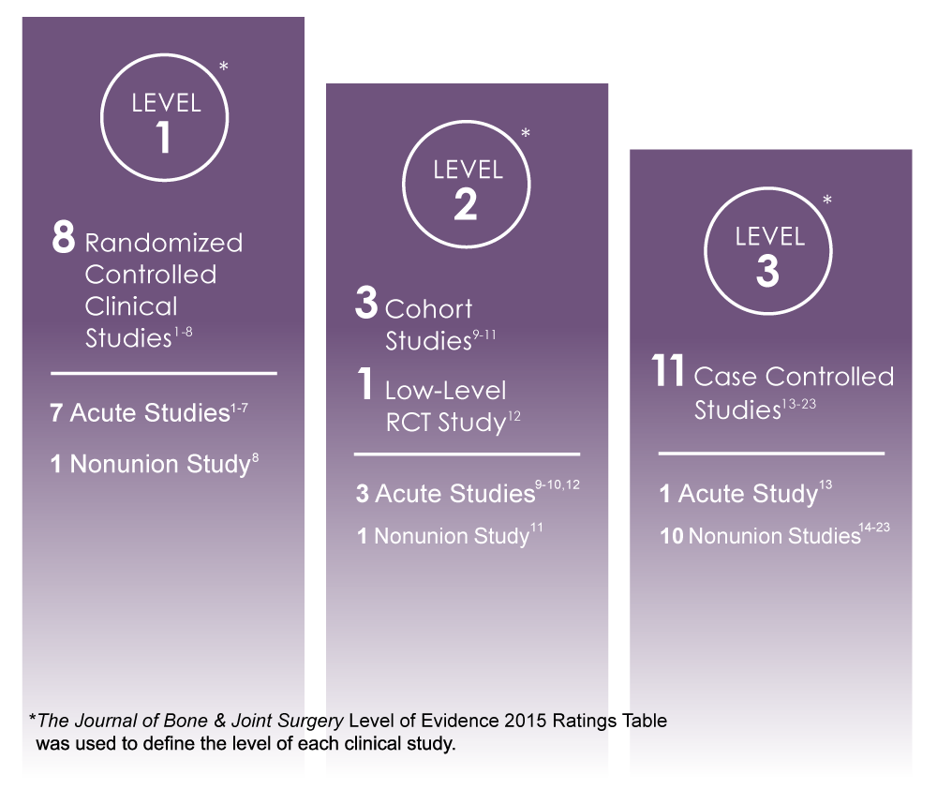  Add Note: These studies, which reflect the body of evidence for EXOGEN, also include evaluations of bone applications outside of the indicated bones in the FDA-approved labeling for EXOGEN (such as distraction osteogenesis, bone transport, acceleration of scaphoid fracture, acute metatarsal fractures, acute complex tibia fractures, high tibial osteotomy, and arthrodesis).
Reference | *Marx RG, Wilson SM, Swiontkowski MF. Updating the assignment of levels of evidence. J Bone Joint Surg Am. 2015;97(1)1-2. doi:10.2106/JBJS.N.01112  R1. Dudda M, Hauser J, Muhr G, Esenwein SA. Low-intensity pulsed ultrasound as a useful adjuvant during distraction osteogenesis: a prospective, randomized controlled trial. J Trauma. 2011;71(5):1376‐80. doi:10.1097/TA.0b013e31821912b2  R2. El-Mowafi H, Mohsen M. The effect of low-intensity pulsed ultrasound on callus maturation in tibial distraction osteogenesis. Int Orthop. 2005;29(2):121‐4. doi:10.1007/s00264-004-0625-3  R3. Heckman JD, Ryaby JP, McCabe J, Frey JJ, Kilcoyne RF. Acceleration of tibial fracture-healing by non-invasive, low-intensity pulsed ultrasound. J Bone Joint Surg Am. 1994;76(1):26‐34. doi:10.2106/00004623-199401000-00004  R4. Kristiansen TK, Ryaby JP, McCabe J, Frey JJ, Roe LR. Accelerated healing of distal radial fractures with the use of specific, low-intensity ultrasound. A multicenter, prospective, randomized, double-blind, placebo-controlled study. J Bone Joint Surg Am. 1997;79(7):961‐73. doi:10.2106/00004623-199707000-00002  R5. Leung KS, Lee WS, Tsui HF, Liu PP, Cheung WH. Complex tibial fracture outcomes following treatment with low-intensity pulsed ultrasound. Ultrasound Med Biol. 2004;30(3):389‐95. doi:10.1016/j.ultrasmedbio.2003.11.008  R6. Mayr E, Rudzki MM, Rudzki M, Borchardt B, Häusser H, Rüter A. Does low intensity, pulsed ultrasound speed healing of scaphoid fractures? Handchir Mikrochir Plast Chir. 2000;32(2):115‐22. doi:10.1055/s-2000-19253  R7. Tsumaki N, Kakiuchi M, Sasaki J, Ochi T, Yoshikawa H. Low-intensity pulsed ultrasound accelerates maturation of callus in patients treated with opening-wedge high tibial osteotomy by hemicallotasis. J Bone Joint Surg Am. 2004;86(11):2399‐405. doi:10.2106/00004623-200411000-00006  R8. Schofer MD, Block JE, Aigner J, Schmelz A. Improved healing response in delayed unions of the tibia with low-intensity pulsed ultrasound: results of a randomized sham-controlled trial. BMC Musculoskelet Disord. 2010;11:229. doi:10.1186/1471-2474-11-229  R9. Coughlin MJ, Smith BW, Traughber P. The evaluation of the healing rate of subtalar arthrodeses, part 2: the effect of low-intensity ultrasound stimulation. Foot Ankle Int. 2008;29(10):970‐7. doi:10.3113/FAI.2008.0970  R10. Gold SM, Wasserman R. Preliminary results of tibial bone transports with pulsed low intensity ultrasound (Exogen). J Orthop Trauma. 2005;19(1):10‐6. doi:10.1097/00005131-200501000-00003  R11. Romanò CL, Messina J, Meani E. Low-intensity, pulsed ultrasound for the treatment of septic pseudoarthrosis. Quarderni di Infezioni Osteoarticolari. 1999;(suppl 561);83-93.  R12. Salem KH, Schmelz A. Low-intensity pulsed ultrasound shortens the treatment time in tibial distraction osteogenesis. Int Orthop. 2014;38(7):1477‐82. doi:10.1007/s00264-013-2254-1  R13. Kinami Y, Noda T, Ozaki T. Efficacy of low-intensity pulsed ultrasound treatment for surgically managed fresh diaphyseal fractures of the lower extremity: multi-center retrospective cohort study. J Orthop Sci. 2013;18(3):410‐8. doi:10.1007/s00776-013-0358-5  R14. Gebauer D, Mayr E, Orthner E, Ryaby JP. Low-intensity pulsed ultrasound: effects on nonunions. Ultrasound Med Biol. 2005;31(10):1391‐402. doi:10.1016/j.ultrasmedbio.2005.06.002  R15. Jingushi S, Mizuno K, Matsushita T, Itoman M. Low-intensity pulsed ultrasound treatment for postoperative delayed union or nonunion of long bone fractures. J Orthop Sci. 2007;12(1):35‐41. doi:10.1007/s00776-006-1080-3  R16. Lerner A, Stein H, Soudry M. Compound high-energy limb fractures with delayed union: our experience with adjuvant ultrasound stimulation (exogen). Ultrasonics. 2004;42(1-9):915‐7. doi:10.1016/j.ultras.2003.11.014  R17. Mayr E, Möckl C, Lenich A, Ecker M, Rüter A. Is low intensity ultrasound effective in treatment of disorders of fracture healing? Unfallchirurg. 2002;105(2):108‐15. doi:10.1007/s001130100301  R18. Nolte PA, van der Krans A, Patka P, Janssen IM, Ryaby JP, Albers GH. Low-intensity pulsed ultrasound in the treatment of nonunions. J Trauma. 2001;51(4):693‐703. doi:10.1097/00005373-200110000-00012  R19. Pigozzi F, Moneta MR, Giombini A, et al. Low-intensity pulsed ultrasound in the conservative treatment of pseudoarthrosis. J Sports Med Phys Fitness. 2004;44(2):173‐8.  R20. Roussignol X, Currey C, Duparc F, Dujardin F. Indications and results for the Exogen™ ultrasound system in the management of non-union: a 59-case pilot study. Orthop Traumatol Surg Res. 2012;98(2):206‐13. doi:10.1016/j.otsr.2011.10.011  R21. Rutten S, Nolte PA, Guit GL, Bouman DE, Albers GH. Use of low-intensity pulsed ultrasound for posttraumatic nonunions of the tibia: a review of patients treated in the Netherlands. J Trauma. 2007;62(4):902‐8. doi:10.1097/01.ta.0000238663.33796.fb  R22. Watanabe Y, Arai Y, Takenaka N, Kobayashi M, Matsushita T. Three key factors affecting treatment results of low-intensity pulsed ultrasound for delayed unions and nonunions: instability, gap size, and atrophic nonunion. J Orthop Sci. 2013;18(5):803‐10. doi:10.1007/s00776-013-0415-0  R23. Zura R, Della Rocca GJ, Mehta S, et al. Treatment of chronic (>1 year) fracture nonunion: heal rate in a cohort of 767 patients treated with low-intensity pulsed ultrasound (LIPUS). Injury. 2015;46(10):2036‐41. doi:10.1016/j.injury.2015.05.042

Claim | Claim specific to acute fractures:*  In seven Level 1 studies, three Level 2 studies, and one Level 3 study, EXOGEN has been proven in a wide range of patients to accelerate the healing of acute bone fractures.^{1-7,9-10,12,13}  Claim specific to nonunion:*  In one Level 1 study, one Level 2 study, and ten Level 3 studies, EXOGEN has been proven in a wide range of patients to treat established nonunions (excluding the skull and vertebrae). It has also been reported as an effective non-invasive adjuvant treatment of established nonunions in patients:^{8,11,14-23}  - with internal and external fracture fixation hardware present;  - patients undergoing treatment for infection at the fracture site;  - and in patients who are believed to have diminished bone quality.  Claim specific to both indications:*  In eight Level 1 studies, four Level 2 studies, and eleven Level 3 studies, EXOGEN has demonstrated the treatment of established nonunions (excluding the skull and vertebrae), as well as, accelerating the time to heal acute fractures.¹⁻²³  *Add Note: These studies, which reflect the body of evidence for EXOGEN, include evaluations of applications to bone fractures that are not among the bone fractures in the FDA-approved labeling for EXOGEN (such as distraction osteogenesis, bone transport, acceleration of scaphoid fracture, acute metatarsal fractures, acute complex tibia fractures, high tibial osteotomy, and arthrodesis).
Reference | *Marx RG, Wilson SM, Swiontkowski MF. Updating the assignment of levels of evidence. J Bone Joint Surg Am. 2015;97(1)1-2. doi:10.2106/JBJS.N.01112  R1. Dudda M, Hauser J, Muhr G, Esenwein SA. Low-intensity pulsed ultrasound as a useful adjuvant during distraction osteogenesis: a prospective, randomized controlled trial. J Trauma. 2011;71(5):1376‐80. doi:10.1097/TA.0b013e31821912b2  R2. El-Mowafi H, Mohsen M. The effect of low-intensity pulsed ultrasound on callus maturation in tibial distraction osteogenesis. Int Orthop. 2005;29(2):121‐4. doi:10.1007/s00264-004-0625-3  R3. Heckman JD, Ryaby JP, McCabe J, Frey JJ, Kilcoyne RF. Acceleration of tibial fracture-healing by non-invasive, low-intensity pulsed ultrasound. J Bone Joint Surg Am. 1994;76(1):26‐34. doi:10.2106/00004623-199401000-00004  R4. Kristiansen TK, Ryaby JP, McCabe J, Frey JJ, Roe LR. Accelerated healing of distal radial fractures with the use of specific, low-intensity ultrasound. A multicenter, prospective, randomized, double-blind, placebo-controlled study. J Bone Joint Surg Am. 1997;79(7):961‐73. doi:10.2106/00004623-199707000-00002  R5. Leung KS, Lee WS, Tsui HF, Liu PP, Cheung WH. Complex tibial fracture outcomes following treatment with low-intensity pulsed ultrasound. Ultrasound Med Biol. 2004;30(3):389‐95. doi:10.1016/j.ultrasmedbio.2003.11.008  R6. Mayr E, Rudzki MM, Rudzki M, Borchardt B, Häusser H, Rüter A. Does low intensity, pulsed ultrasound speed healing of scaphoid fractures? Handchir Mikrochir Plast Chir. 2000;32(2):115‐22. doi:10.1055/s-2000-19253  R7. Tsumaki N, Kakiuchi M, Sasaki J, Ochi T, Yoshikawa H. Low-intensity pulsed ultrasound accelerates maturation of callus in patients treated with opening-wedge high tibial osteotomy by hemicallotasis. J Bone Joint Surg Am. 2004;86(11):2399‐405. doi:10.2106/00004623-200411000-00006  R8. Schofer MD, Block JE, Aigner J, Schmelz A. Improved healing response in delayed unions of the tibia with low-intensity pulsed ultrasound: results of a randomized sham-controlled trial. BMC Musculoskelet Disord. 2010;11:229. doi:10.1186/1471-2474-11-229  R9. Coughlin MJ, Smith BW, Traughber P. The evaluation of the healing rate of subtalar arthrodeses, part 2: the effect of low-intensity ultrasound stimulation. Foot Ankle Int. 2008;29(10):970‐7. doi:10.3113/FAI.2008.0970  R10. Gold SM, Wasserman R. Preliminary results of tibial bone transports with pulsed low intensity ultrasound (Exogen). J Orthop Trauma. 2005;19(1):10‐6. doi:10.1097/00005131-200501000-00003  R11. Romanò CL, Messina J, Meani E. Low-intensity, pulsed ultrasound for the treatment of septic pseudoarthrosis. Quarderni di Infezioni Osteoarticolari. 1999;(suppl 561);83-93.  R12. Salem KH, Schmelz A. Low-intensity pulsed ultrasound shortens the treatment time in tibial distraction osteogenesis. Int Orthop. 2014;38(7):1477‐82. doi:10.1007/s00264-013-2254-1  R13. Kinami Y, Noda T, Ozaki T. Efficacy of low-intensity pulsed ultrasound treatment for surgically managed fresh diaphyseal fractures of the lower extremity: multi-center retrospective cohort study. J Orthop Sci. 2013;18(3):410‐8. doi:10.1007/s00776-013-0358-5  R14. Gebauer D, Mayr E, Orthner E, Ryaby JP. Low-intensity pulsed ultrasound: effects on nonunions. Ultrasound Med Biol. 2005;31(10):1391‐402. doi:10.1016/j.ultrasmedbio.2005.06.002  R15. Jingushi S, Mizuno K, Matsushita T, Itoman M. Low-intensity pulsed ultrasound treatment for postoperative delayed union or nonunion of long bone fractures. J Orthop Sci. 2007;12(1):35‐41. doi:10.1007/s00776-006-1080-3  R16. Lerner A, Stein H, Soudry M. Compound high-energy limb fractures with delayed union: our experience with adjuvant ultrasound stimulation (exogen). Ultrasonics. 2004;42(1-9):915‐7. doi:10.1016/j.ultras.2003.11.014  R17. Mayr E, Möckl C, Lenich A, Ecker M, Rüter A. Is low intensity ultrasound effective in treatment of disorders of fracture healing? Unfallchirurg. 2002;105(2):108‐15. doi:10.1007/s001130100301  R18. Nolte PA, van der Krans A, Patka P, Janssen IM, Ryaby JP, Albers GH. Low-intensity pulsed ultrasound in the treatment of nonunions. J Trauma. 2001;51(4):693‐703. doi:10.1097/00005373-200110000-00012  R19. Pigozzi F, Moneta MR, Giombini A, et al. Low-intensity pulsed ultrasound in the conservative treatment of pseudoarthrosis. J Sports Med Phys Fitness. 2004;44(2):173‐8.  R20. Roussignol X, Currey C, Duparc F, Dujardin F. Indications and results for the Exogen™ ultrasound system in the management of non-union: a 59-case pilot study. Orthop Traumatol Surg Res. 2012;98(2):206‐13. doi:10.1016/j.otsr.2011.10.011  R21. Rutten S, Nolte PA, Guit GL, Bouman DE, Albers GH. Use of low-intensity pulsed ultrasound for posttraumatic nonunions of the tibia: a review of patients treated in the Netherlands. J Trauma. 2007;62(4):902‐8. doi:10.1097/01.ta.0000238663.33796.fb  R22. Watanabe Y, Arai Y, Takenaka N, Kobayashi M, Matsushita T. Three key factors affecting treatment results of low-intensity pulsed ultrasound for delayed unions and nonunions: instability, gap size, and atrophic nonunion. J Orthop Sci. 2013;18(5):803‐10. doi:10.1007/s00776-013-0415-0  R23. Zura R, Della Rocca GJ, Mehta S, et al. Treatment of chronic (>1 year) fracture nonunion: heal rate in a cohort of 767 patients treated with low-intensity pulsed ultrasound (LIPUS). Injury. 2015;46(10):2036‐41. doi:10.1016/j.injury.2015.05.042

Claim | 1. The EXOGEN Ultrasound Bone Healing System is an FDA-approved device with 38% accelerated healing of indicated fresh fractures.^{1,2} [Heckman 1994: 7a; Kristiansen 1997:7a]  2. EXOGEN has demonstrated 58 days accelerated healing in fresh tibial diaphysis fractures.¹
Reference | - Heckman JD, Ryaby JP, McCabe J, Frey JJ, Kilcoyne RF. Acceleration of tibial fracture-healing by non-invasive, low-intensity pulsed ultrasound. J Bone Joint Surg Am. 1994;76(1):26‐34. doi:10.2106/00004623-199401000-00004  - Kristiansen TK, Ryaby JP, McCabe J, Frey JJ, Roe LR. Accelerated healing of distal radial fractures with the use of specific, low-intensity ultrasound. A multicenter, prospective, randomized, double-blind, placebo-controlled study. J Bone Joint Surg Am. 1997;79(7):961‐73. doi: 10.2106/00004623-199707000-00002

Claim | EXOGEN is covered by many major insurance plans, including but not limited to: Aetna, Blue Cross Blue Shield, Cigna, Humana, and UnitedHealthcare.¹⁻⁵ [BCBS California: 1a; Aetna Coverage: 2a; Cigna coverage: 2a; Humana Coverage: 5a; United Healthcare Coverage: 1a]
Reference | - Aetna. Medical Clinical Policy Bulletin. Bone growth stimulators. Last updated May 25, 2021. www.aetna.com/cpb/medical/data/300_399/0343.html  - Blue Shield of California. Medical Policy # 1.01.05, Ultrasound accelerated fracture healing device. Last Updated May 1, 2019. www.blueshieldca.com/bsca/bsc/public/common/PortalComponents/provider/StreamDocumentServlet?fileName=PRV_Ultrasnd_FracHealingDevice.pdf  - Cigna. Medical Coverage Policy. Bone growth stimulators: electrical (invasive, noninvasive), ultrasound. Last updated May 15, 2021. https://static.cigna.com/assets/chcp/pdf/coveragePolicies/medical/mm_0084_coveragepositioncriteria_bone_growth_stimulators.pdf  - Humana. Medical Coverage Policy. Bone growth stimulators. Last updated February 24, 2022. http://apps.humana.com/tad/tad_new/Search.aspx?criteria=Bone+growth+stimulators&searchtype=freetext&policyType=both  - UnitedHealthcare. Commercial Medical Policy. Electrical and ultrasound bone growth stimulators. Last updated January 1, 2021. www.uhcprovider.com/content/provider/en/viewer.html?file=https%3A%2F%2Fwww.uhcprovider.com%2Fcontent%2Fdam%2Fprovider%2Fdocs%2Fpublic%2Fpolicies%2Fcomm-medical-drug%2Felectrical-ultrasound-bone-growth-stimulators.pdf

Claim | EXOGEN was shown to reduce opioid analgesic prescriptions by 33% in a study of patients with nonunion fractures.¹ [Mehta 2015: 7b].
Reference | R1. Mehta S, Long K, DeKoven M, Smith E, Steen RG. Low-intensity pulsed ultrasound (LIPUS) can decrease the economic burden of fracture non-union. J Med Econ. 2015;18(7):542‐9. doi:10.3111/13696998.2015.1019887

EXOGEN Product Claims

Claim | Added confidence and high level of treatment compliance.¹⁻³ [Schofer 2010: 3a; Pounder 2016: 3a, 4a-c; Roussignol 2012: 3a]
Reference | - Schofer MD, Block JE, Aigner J, Schmetz A. Improved healing response in delayed unions of the tibia with low-intensity pulse ultrasound: results of a randomized sham-controlled trial. BMC Musculoskelet Disord. 2010;11:229. doi:10.1186/1471-2474-11-229  - Pounder NM, Jones JT, Tanis KJ. Design evolution enhances patient compliance for low-intensity pulsed ultrasound device usage. Med Devices (Auckl). 2016;9:423‐7. doi:10.2147/MDER.S119887  - Roussignol X, Currey C, Duparc F, Dujardin F. Indications and results for the Exogen™ ultrasound system in the management of non-union: a 59-case pilot study. Orthop Traumatol Surg Res. 2012;98(2):206‐13. doi:10.1016/j.otsr.2011.10.011

Claim | The EXOGEN Ultrasound Bone Healing System uses low-intensity, pulsed ultrasound to stimulate the body’s natural healing response at all stages of the fracture process.*^{1,2} [Azuma 2001: 1a; 6a-b; 9a-c; EXOGEN User Guide: 14a-b]  Add Note: *The clinical relevance of these findings has not been determined.
Reference | - Azuma Y, Ito M, Harada Y, Takagi H, Ohta T, Jingushi S. Low-intensity pulsed ultrasound accelerates rat femoral fracture healing by acting on the various cellular reactions in the fracture callus. J Bone Miner Res. 2001;16(4):671‐80. doi:10.1359/jbmr.2001.16.4.671  - Bioventus LLC. EXOGEN® User Guide. Last updated 2020. www.exogen.com/wp-content/uploads/2021/10/81087030-US-2020-User-Guide.pdf

Claim | The EXOGEN Ultrasound Bone Healing System uses ultrasound technology to amplify the power of your bones to heal by:  - Accelerating your natural fracture healing processes;^{1,2} [EXOGEN User Guide: 14a-b; Heckman 1994: 1a, 7a; Kristiansen 1997: 2b,7a]  - Increasing your chances of healing;¹⁻³ [Nolte 2001: 1a-b; Gebauer 2005: 1a; Mayr 2000b: 1a; Zura 2015a: 1a-c]  - Healing fractures that fail to heal on their own (called a nonunion).³⁻⁵ [Nolte 2001:pg1/col3/par1-2;Gebauer 2005:pg1/col1/par1; Zura 2015: pg1/col1/par3]
Reference | R1. Heckman JD, Ryaby JP, McCabe J, Frey J, Kilcoyne RF. Acceleration of tibial fracture-healing by non-invasive, low-intensity pulsed ultrasound. J Bone Joint Surg Am. 1994;76(1):26-34. 12. doi:10.2106/00004623-199401000-00004  R2. Kristiansen TK, Ryaby JP, McCabe J, Frey JJ, Roe LR. Accelerated healing of distal radial fractures with the use of specific, low-intensity ultrasound. A multicenter, prospective, randomized, double-blind, placebo-controlled study. J Bone Joint Surg Am. 1997;79(7):961-73. doi:10.2106/00004623-199707000-00002  R3. Nolte PA, van der Krans A, Patka P, Janssen IM, Ryaby JP, Albers GH. Low-intensity pulsed ultrasound in the treatment of nonunions. J Trauma. 2001;51(4):693-703. doi:10.1097/00005373-200110000-00012  R4. Zura R, Della Rocca GJ, Mehta S, et al. Treatment of chronic (>1 year) fracture nonunion: heal rate in a cohort of 767 patients treated with low-intensity pulsed ultrasound (LIPUS). Injury. 2015;46(10):2036‐41. doi:10.1016/j.injury.2015.05.042  R5. Gebauer D, Mayr E, Orthner E, Ryaby JP. Low-intensity pulsed ultrasound: effects on nonunions. Ultrasound Med Biol. 2005;31(10):1391‐402. doi:10.1016/j.ultrasmedbio.2005.06.002

Claim | Helping promote faster bone healing in just 20 minutes a day.¹ [EXOGEN User Guide: p4 col2 par3]
Reference | R1. Bioventus LLC. EXOGEN® User Guide. Last updated 2020. www.exogen.com/wp-content/uploads/2021/10/81087030-US-2020-User-Guide.pdf

Claim | - EXOGEN is FDA-approved for accelerating the healing of indicated fresh fractures.¹ [EXOGEN User Guide: p3 col1 par1; p3 col1 bullet3]  - The EXOGEN Ultrasound Bone Healing System has a fresh fracture indication.¹ [EXOGEN User Guide: p3 col1 par1; p3 col1 bullet3]  - Accelerated healing with the EXOGEN ultrasound technology may help injured patients get back to work faster.¹⁻³ [Heckman 1994: p1 abstract; Heckman 1997:pg9/col2/par2,pg10/col1/par1]
Reference | R1. Bioventus LLC. EXOGEN® User Guide. Last updated 2020. www.exogen.com/wp-content/uploads/2021/10/81087030-US-2020-User-Guide.pdf  R2. Heckman JD, Ryaby JP, McCabe J, Frey JJ, Kilcoyne RF. Acceleration of tibial fracture-healing by non-invasive, low-intensity pulsed ultrasound. J Bone Joint Surg Am. 1994;76(1):26‐34. doi:10.2106/00004623-199401000-00004  R3. Heckman JD, Sarasohn-Kahn J. The economics of treating tibia fractures. The cost of delayed unions. Bull Hosp Jt Dis. 1997;56(1):63-72.

Claim | EXOGEN is safe and effective for nonunion fracture management.¹⁻⁵ [Nolte 2001: 1a-b; Gebauer 2005: 1a; Mayr 2000b: 1a; Zura 2015a: 1a-c; EXOGEN User Guide: 3a]
Reference | - Nolte PA, van der Krans A, Patka P, Janssen IM, Ryaby JP, Albers GH. Low-intensity pulsed ultrasound in the treatment of nonunions. J Trauma. 2001;51(4):693‐703. doi:10.1097/00005373-200110000-00012  - Gebauer D, Mayr E, Orthner E, Ryaby JP. Low-intensity pulsed ultrasound: effects on nonunions. Ultrasound Med Biol. 2005;31(10):1391‐402. doi:10.1016/j.ultrasmedbio.2005.06.002  - Mayr E, Frankel V, Rüter A. Ultrasound--an alternative healing method for nonunions? Arch Orthop Trauma Surg. 2000;120(1-2):1‐8. doi:10.1007/pl00021234  - Zura R, Della Rocca GJ, Mehta S, et al. Treatment of chronic (>1 year) fracture nonunion: heal rate in a cohort of 767 patients treated with low-intensity pulsed ultrasound (LIPUS). Injury. 2015;46(10):2036‐41. doi:10.1016/j.injury.2015.05.042  - Bioventus LLC. EXOGEN® User Guide. Last updated 2020. www.exogen.com/wp-content/uploads/2021/10/81087030-US-2020-User-Guide.pdf

Claim | Comparable incidence of healing with EXOGEN have been observed in cases with both operative and non-operative treatment of fractures.*¹⁻⁶ [Gebauer 2005: pg1/abstract, pg10/Table6; El-Mowafi 2005: title, and p2 table1; Kristiansen 1997: p2 col 2 par 5; p7 col2 par4; Salem 2014: title; p1 col1 par3; p1 col2 par2; Tsumaki 2004: title; p1 abstract par4; Heckman 1994: p2 col2 par4]  Add Note: *These studies include evaluations of applications to bone fractures that are not among the bone fractures indicated in the FDA-approved labeling for EXOGEN (such as distraction osteogenesis, bone transport, acceleration of scaphoid fracture, acute metatarsal fractures, acute complex tibia fractures, high tibial osteotomy, and arthrodesis).
Reference | R1. Gebauer D, Mayr E, Orthner E, Ryaby JP. Low-intensity pulsed ultrasound: effects on nonunions. Ultrasound Med Biol. 2005;31(10):1391‐402. doi:10.1016/j.ultrasmedbio.2005.06.002  R2. El-Mowafi H, Mohsen M. The effect of low-intensity pulsed ultrasound on callus maturation in tibial distraction osteogenesis. Int Orthop. 2005;29(2):121‐4. doi:10.1007/s00264-004-0625-3  R3. Kristiansen TK, Ryaby JP, McCabe J, Frey JJ, Roe LR. Accelerated healing of distal radial fractures with the use of specific, low-intensity ultrasound. A multicenter, prospective, randomized, double-blind, placebo-controlled study. J Bone Joint Surg Am. 1997;79(7):961‐73. doi:10.2106/00004623-199707000-00002  R4. Salem KH, Schmelz A. Low-intensity pulsed ultrasound shortens the treatment time in tibial distraction osteogenesis. Int Orthop. 2014;38(7):1477‐82. doi:10.1007/s00264-013-2254-1  R5. Tsumaki N, Kakiuchi M, Sasaki J, Ochi T, Yoshikawa H. Low-intensity pulsed ultrasound accelerates maturation of callus in patients treated with opening-wedge high tibial osteotomy by hemicallotasis. J Bone Joint Surg Am. 2004;86(11):2399‐405. doi:10.2106/00004623-200411000-00006  R6. Heckman JD, Ryaby JP, McCabe J, Frey JJ, Kilcoyne RF. Acceleration of tibial fracture-healing by non-invasive, low-intensity pulsed ultrasound. J Bone Joint Surg Am. 1994;76(1):26‐34. doi:10.2106/00004623-199401000-00004

Claim | - High level of treatment compliance + Proven clinical effectiveness >> Successful fracture healing outcomes.¹⁻⁵ [Heckman 1994: 1a; Kristiansen 1997: 2b; Schofer 2010: 3a; Pounder 2016: 3a, 4a; Roussignol 2012: 3a]  - High level of treatment compliance. Proven clinical effectiveness. Successful fracture healing outcomes.¹⁻⁵ [Heckman 1994: 1a; Kristiansen 1997: 2b; Schofer 2010: 3a; Pounder 2016: 3a, 4a; Roussignol 2012: 3a]
Reference | - Heckman JD, Ryaby JP, McCabe J, Frey JJ, Kilcoyne RF. Acceleration of tibial fracture-healing by non-invasive, low-intensity pulsed ultrasound. J Bone Joint Surg Am. 1994;76(1):26‐34. doi:10.2106/00004623-199401000-00004  - Kristiansen TK, Ryaby JP, McCabe J, Frey JJ, Roe LR. Accelerated healing of distal radial fractures with the use of specific, low-intensity ultrasound. A multicenter, prospective, randomized, double-blind, placebo-controlled study. J Bone Joint Surg Am. 1997;79(7):961‐73. doi:10.2106/00004623-199707000-00002  - Schofer MD, Block JE, Aigner J, Schmetz A. Improved healing response in delayed unioins of the tibia with low-intensity pulse ultrasound: results of a randomized sham-controlled trial. BMC Musculoskelet Disord. 2010;11:229. doi:10.1186/1471-2474-11-229  - Pounder NM, Jones JT, Tanis KJ. Design evolution enhances patient compliance for low-intensity pulsed ultrasound device usage. Med Devices (Auckl). 2016;9:423‐7. doi:10.2147/MDER.S119887  - Roussignol X, Currey C, Duparc F, Dujardin F. Indications and results for the Exogen™ ultrasound system in the management of non-union: a 59-case pilot study. Orthop Traumatol Surg Res. 2012;98(2):206‐13. doi:10.1016/j.otsr.2011.10.011

Claim | - Clinically proven: 91% treatment compliance¹ [Schofer 2010: 3a]  - Backed by a full suite of patient support tools, EXOGEN is the only bone healing device with documented 91% treatment compliance.¹ [Schofer 2010: 3a]  - Adherence to 20 minutes of daily EXOGEN treatment for effective treatment. EXOGEN has demonstrated a 91% treatment compliance rate.¹ [Schofer 2010: 3a]
Reference | - Schofer MD, Block JE, Aigner J, Schmelz A. Improved healing response in delayed unions of the tibia with low-intensity pulsed ultrasound: results of a randomized sham-controlled trial. BMC Musculoskelet Disord. 2010;11:229. doi:10.1186/1471-2474-11-229

Claim | The EXOGEN treatment calendar encourages patient compliance with a course of treatment – up to 93%¹ [Pounder 2016:1a-b, 4a-c]
Reference | - Pounder NM, Jones JT, Tanis KJ. Design evolution enhances patient compliance for low-intensity pulsed ultrasound device usage. Med Devices (Auckl). 2016;9:423‐7. doi:10.2147/MDER.S119887

Claim | The EXOGEN treatment calendar increases patient treatment compliance.¹ [Pounder 2016: 4a-c]
Reference | - Pounder NM, Jones JT, Tanis KJ. Design evolution enhances patient compliance for low-intensity pulsed ultrasound device usage. Med Devices (Auckl). 2016;9:423‐7. doi:10.2147/MDER.S119887

Claim | With the push of a button, patients can track their treatments, helping to increase patient compliance.^{1,2} [Pounder 2016: 4a-c; EXOGEN User Guide:7a]
Reference | - Pounder NM, Jones JT, Tanis KJ. Design evolution enhances patient compliance for low-intensity pulsed ultrasound device usage. Med Devices (Auckl). 2016;9:423‐7. doi:10.2147/MDER.S119887  - Bioventus LLC. EXOGEN® User Guide. Last updated 2020. www.exogen.com/wp-content/uploads/2021/10/81087030-US-2020-User-Guide.pdf

Claim | The EXOGEN treatment calendar significantly increased patient treatment compliance versus the model that did not have a treatment calendar.¹ [Pounder 2016: 3a, 4a-c]
Reference | - Pounder NM, Jones JT, Tanis KJ. Design evolution enhances patient compliance for low-intensity pulsed ultrasound device usage. Med Devices (Auckl). 2016;9:423‐7. doi:10.2147/MDER.S119887

Claim | EXOGEN has demonstrated a non-compliance incidence of <5% per patient.¹ [Roussignol 2012: 3a]
Reference | - Roussignol X, Currey C, Duparc F, Dujardin F. Indications and results for the Exogen™ ultrasound system in the management of non-union: a 59-case pilot study. Orthop Traumatol Surg Res. 2012;98(2):206‐13. doi:10.1016/j.otsr.2011.10.011

Claim | In multiple studies, EXOGEN has demonstrated a high level of treatment compliance.¹⁻³ [Schofer 2010: 3a; Roussignol 2012: 3a; Gebauer 2005: 8a]
Reference | R1. Schofer MD, Block JE, Aigner J, Schmelz A. Improved healing response in delayed unions of the tibia with low-intensity pulsed ultrasound: results of a randomized sham-controlled trial. BMC Musculoskelet Disord. 2010;11:229. doi:10.1186/1471-2474-11-229  R2. Roussignol X, Currey C, Duparc F, Dujardin F. Indications and results for the Exogen™ ultrasound system in the management of non-union: a 59-case pilot study. Orthop Traumatol Surg Res. 2012;98(2):206‐13. doi:10.1016/j.otsr.2011.10.011  R3. Gebauer D, Mayr E, Orthner E, Ryaby JP. Low-intensity pulsed ultrasound: effects on nonunions. Ultrasound Med Biol. 2005;31(10):1391‐402. doi:10.1016/j.ultrasmedbio.2005.06.002

Claim | - The EXOGEN Ultrasound Bone Healing System is a device that uses low-intensity, pulsed ultrasound (LIPUS) technology to stimulate the body’s natural bone healing processes.^{1*} [Azuma 2001: 1a; 6a-b; 9a-c]  - EXOGEN’s ultrasound waves stimulate the body’s natural bone healing processes.^{1*} [Azuma 2011: 1a; 6a-b; 9a-c]  - EXOGEN accelerates the natural bone healing processes at every stage.^{1*} [Azuma 2011: 1a; 6a-b; 9a-c]  - EXOGEN accelerates all stages of fracture healing.^{1*} [Azuma 2011: 1a; 6a-b; 9a-c]  *Add Note: The clinical relevance of in vitro findings is unknown.
Reference | - Azuma Y, Ito M, Harada Y, Takagi H, Ohta T, Jingushi S. Low-intensity pulsed ultrasound accelerates rat femoral fracture healing by acting on the various cellular reactions in the fracture callus. J Bone Miner Res. 2001;16(4):671‐80. doi:10.1359/jbmr.2001.16.4.671

Claim | EXOGEN accelerates the healing of indicated fresh fractures by 38%, resolves 86% of nonunions, and has demonstrated 91% patient compliance.*¹⁻⁵ [Heckman 1994: 7a; Kristiansen 1997: 7a; Schofer 2010: 3a; Nolte 2001: 1b; Zura 2015a: 1b]  *Summary of Indications for Use
Reference | - Heckman JD, Ryaby JP, McCabe J, Frey JJ, Kilcoyne RF. Acceleration of tibial fracture-healing by non-invasive, low-intensity pulsed ultrasound. J Bone Joint Surg Am. 1994;76(1):26‐34. doi:10.2106/00004623-199401000-00004  - Kristiansen TK, Ryaby JP, McCabe J, Frey JJ, Roe LR. Accelerated healing of distal radial fractures with the use of specific, low-intensity ultrasound. A multicenter, prospective, randomized, double-blind, placebo-controlled study. J Bone Joint Surg Am. 1997;79(7):961‐73. doi:10.2106/00004623-199707000-00002  - Schofer MD, Block JE, Aigner J, Schmelz A. Improved healing response in delayed unions of the tibia with low-intensity pulsed ultrasound: results of a randomized sham-controlled trial. BMC Musculoskelet Disord. 2010;11:229. doi:10.1186/1471-2474-11-229  - Nolte PA, van der Krans A, Patka P, Janssen IM, Ryaby JP, Albers GH. Low-intensity pulsed ultrasound in the treatment of nonunions. J Trauma. 2001;51(4):693‐703. doi:10.1097/00005373-200110000-00012  - Zura R, Della Rocca GJ, Mehta S, et al. Treatment of chronic (>1 year) fracture nonunion: heal rate in a cohort of 767 patients treated with low-intensity pulsed ultrasound (LIPUS). Injury. 2015;46(10):2036‐41. doi:10.1016/j.injury.2015.05.042

Claim | Clinical studies show that EXOGEN heals fractures not healing on their own at a high incidence, healing of up to 86% of nonunion fractures, and speeds up healing indicated fresh fractures by 38%.*¹⁻⁴ [Heckman 1994: 7a; Kristiansen 1997: 7a; Nolte 2001: 1b; Zura 2015a: 1b]  *Summary of Indications for Use
Reference | - Heckman JD, Ryaby JP, McCabe J, Frey JJ, Kilcoyne RF. Acceleration of tibial fracture-healing by non-invasive, low-intensity pulsed ultrasound. J Bone Joint Surg Am. 1994;76(1):26‐34. doi:10.2106/00004623-199401000-00004  - Kristiansen TK, Ryaby JP, McCabe J, Frey JJ, Roe LR. Accelerated healing of distal radial fractures with the use of specific, low-intensity ultrasound. A multicenter, prospective, randomized, double-blind, placebo-controlled study. J Bone Joint Surg Am. 1997;79(7):961‐73. doi:10.2106/00004623-199707000-00002  - Nolte PA, van der Krans A, Patka P, Janssen IM, Ryaby JP, Albers GH. Low-intensity pulsed ultrasound in the treatment of nonunions. J Trauma. 2001;51(4):693‐703. doi:10.1097/00005373-200110000-00012  - Zura R, Della Rocca GJ, Mehta S, et al. Treatment of chronic (>1 year) fracture nonunion: heal rate in a cohort of 767 patients treated with low-intensity pulsed ultrasound (LIPUS). Injury. 2015;46(10):2036‐41. doi:10.1016/j.injury.2015.05.042

Claim | Multiple Level I evidence supports the use of EXOGEN as a safe and effective bone healing adjunct.^{1,2} [Heckman 1994: 1a; Kristiansen 1997:2b,f]
Reference | - Heckman JD, Ryaby JP, McCabe J, Frey JJ, Kilcoyne RF. Acceleration of tibial fracture-healing by non-invasive, low-intensity pulsed ultrasound. J Bone Joint Surg Am. 1994;76(1):26‐34. doi:10.2106/00004623-199401000-00004  - Kristiansen TK, Ryaby JP, McCabe J, Frey JJ, Roe LR. Accelerated healing of distal radial fractures with the use of specific, low-intensity ultrasound. A multicenter, prospective, randomized, double-blind, placebo-controlled study. J Bone Joint Surg Am. 1997;79(7):961‐73. doi:10.2106/00004623-199707000-00002

Claim | Treatment of fresh fractures with the EXOGEN system may speed healing, lower the need for further surgery, and help get patients back to their normal activities faster.^{1,2} [Heckman 1994: 1a; Heckman 1997: 1a-c, 7a]
Reference | - Heckman JD, Ryaby JP, McCabe J, Frey JJ, Kilcoyne RF. Acceleration of tibial fracture-healing by non-invasive, low-intensity pulsed ultrasound. J Bone Joint Surg Am. 1994;76(1):26‐34. doi:10.2106/00004623-199401000-00004  - Heckman JD, Sarasohn-Kahn J. The economics of treating tibia fractures. The cost of delayed unions. Bull Hosp Jt Dis. 1997;56(1):63-72.

Claim | The EXOGEN Ultrasound Bone Healing System jumpstarts the natural bone healing process and may prevent the need for further surgery.¹⁻⁴* [Heckman 1994: 1a; Heckman 1997: 1a-c, 7a; EXOGEN User Guide: 14a-b; Azuma 2001: 1a; 6a-b; 9a-c]  *Add Note: The clinical relevance of in vivo findings is unknown.
Reference | - Heckman JD, Ryaby JP, McCabe J, Frey JJ, Kilcoyne RF. Acceleration of tibial fracture-healing by non-invasive, low-intensity pulsed ultrasound. J Bone Joint Surg Am. 1994;76(1):26‐34. doi:10.2106/00004623-199401000-00004  - Heckman JD, Sarasohn-Kahn J. The economics of treating tibia fractures. The cost of delayed unions. Bull Hosp Jt Dis.1997;56(1):63-72.  - Bioventus LLC. EXOGEN® User Guide. Last updated 2020. www.exogen.com/wp-content/uploads/2021/10/81087030-US-2020-User-Guide.pdf  - Azuma Y, Ito M, Harada Y, Takagi H, Ohta T, Jingushi S. Low-intensity pulsed ultrasound accelerates rat femoral fracture healing by acting on the various cellular reactions in the fracture callus. J Bone Miner Res. 2001;16(4):671‐80. doi:10.1359/jbmr.2001.16.4.671

Claim | Proven clinical effectiveness in accelerating the healing of indicated fresh fractures and healing of established nonunions.^{1-4*} [Kristiansen 1997: 2b; Heckman1994: 1a; Nolte 2001:1a-b; Gebauer 2005: 1a]  *Summary of Indications for Use
Reference | - Heckman JD, Ryaby JP, McCabe J, Frey JJ, Kilcoyne RF. Acceleration of tibial fracture-healing by non-invasive, low-intensity pulsed ultrasound. J Bone Joint Surg Am. 1994;76(1):26‐34. doi:10.2106/00004623-199401000-00004  - Kristiansen TK, Ryaby JP, McCabe J, Frey JJ, Roe LR. Accelerated healing of distal radial fractures with the use of specific, low-intensity ultrasound. A multicenter, prospective, randomized, double-blind, placebo-controlled study. J Bone Joint Surg Am. 1997;79(7):961‐73. doi:10.2106/00004623-199707000-00002  - Nolte PA, van der Krans A, Patka P, Janssen IM, Ryaby JP, Albers GH. Low-intensity pulsed ultrasound in the treatment of nonunions. J Trauma. 2001;51(4):693‐703. doi:10.1097/00005373-200110000-00012  - Gebauer D, Mayr E, Orthner E, Ryaby JP. Low-intensity pulsed ultrasound: effects on nonunions. Ultrasound Med Biol. 2005;31(10):1391‐402. doi:10.1016/j.ultrasmedbio.2005.06.002002

Claim | Bone Healing Systems – Comparison Chart^{1-11*}
Graph | 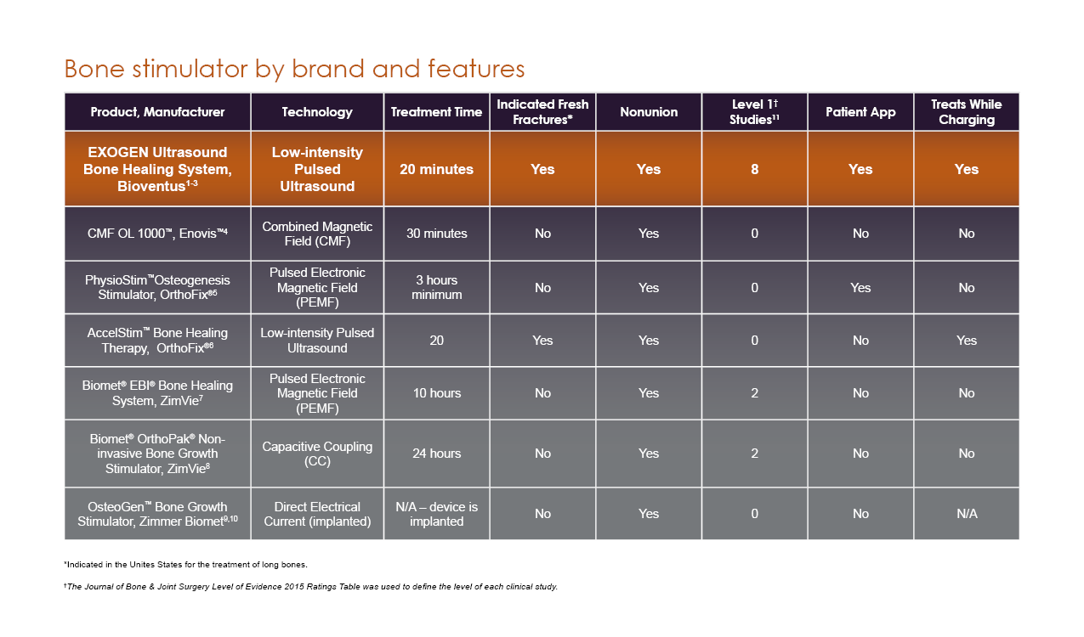  [Exogen User Guide: 3a-b, 11a; Heckman 1994; Kristiansen 1997; CMF OL1000 PI: 2a, 3a, 26a; Physio-Stim PI: p4 par1, p7 col1 par1&5, p5 par1, p15 par1; AccelStim PI; EBI PI: 4a-b, 6a, 9a; OrthoPak PI: 2a; OsteoGen PI: 1a, 2a; OsteoGen Surgical Technique: 3a; RPT-000557]  *Add Note: These studies include evaluations of applications to bone fractures that are not among the bone fractures indicated in the FDA-approved labeling for EXOGEN (such as distraction osteogenesis, bone transport, acceleration of scaphoid fracture, acute metatarsal fractures, acute complex tibia fractures, high tibial osteotomy, and arthrodesis).
Reference | R1. Bioventus LLC. EXOGEN® User Guide. Last updated 2020.  R2. Heckman JD, Ryaby JP, McCabe J, Frey JJ, Kilcoyne RF. Acceleration of tibial fracture-healing by non-invasive, low-intensity pulsed ultrasound. J Bone Joint Surg Am. 1994;76(1):26‐34. doi:10.2106/00004623-199401000-00004  R3. Kristiansen TK, Ryaby JP, McCabe J, Frey JJ, Roe LR. Accelerated healing of distal radial fractures with the use of specific, low-intensity ultrasound. A multicenter, prospective, randomized, double-blind, placebo-controlled study. J Bone Joint Surg Am. 1997;79(7):961‐73. doi:10.2106/00004623-199707000-00002  R4. CMF OL1000™ [package insert]. Vista, CA: Enovis; 2015.  R5. Physio-Stim™ [package insert]. Lewisville, TX: Orthofix; 2014.  R6. AccelStim™ [package insert]. Lewisville, TX: Orthofix; 2022.  R7. Biomet® EBI® [package insert]. Parsippany, NJ: Biomet; 2013.  R8. OrthoPak® [package insert]. Parsippany, NJ: Biomet; 2014..  R9. OsteoGen™ [package insert]. Warsaw, IN: Biomet Trauma; 2012.  R10. Biomet. OsteoGen™ Surgically Implanted Bone Growth Stimulator. Posted 2013. https://www.zimmerbiomet.com/content/dam/zimmer-biomet/medical-professionals/000-surgical-techniques/trauma/osteogen-surgically-implanted-bone-growth-stimulator-surgical-technique.pdf  - R11. Bioventus LLC. EXOGEN studies and competitor studies analysis literature search, United States. Data on file, RPT-000557

Claim | High level of compliance: 91% average patient compliance.¹ [Schofer 2010: 3a]
Reference | - Schofer MD, Block JE, Aigner J, Schmelz A. Improved healing response in delayed unions of the tibia with low-intensity pulsed ultrasound: results of a randomized sham-controlled trial. BMC Musculoskelet Disord. 2010;11:229. doi:10.1186/1471-2474-11-229

EXOGEN Safety Claims

Claim | The EXOGEN Ultrasound Bone Healing System has no known contraindications.¹ [Exogen User Guide: 4c]
Reference | - Bioventus LLC. EXOGEN® User Guide. Last updated 2020. www.exogen.com/wp-content/uploads/2021/10/81087030-US-2020-User-Guide.pdf

Claim | The EXOGEN ultrasound signal is a safe and effective adjunct to conservative treatment or surgical management of nonunions, including fractures with metal fixation and implants.^{1,2*} [Lehman 1959: 1a; Exogen User Guide: 3a,c]  *Add Note: The clinical relevance of in vivo findings is unknown.
Reference | - Lehmann JF, Brunne GD, Martinis AJ, McMillan JA. Ultrasonic effects as demonstrated in live pigs with surgical metallic implants. Arch Phys Med Rehabil. 1959;40:483‐8.  - Bioventus LLC. EXOGEN® User Guide. Last updated 2020. www.exogen.com/wp-content/uploads/2021/10/81087030-US-2020-User-Guide.pdf

Claim | EXOGEN is safe and effective for nonunion fractures with metal fixation or implants.^{1,2*} [Lehman 1959: 1a; Exogen User Guide: 3a,c]  *Add Note: The clinical relevance of these findings has not been determined.
Reference | - Lehmann JF, Brunne GD, Martinis AJ, McMillan JA. Ultrasonic effects as demonstrated in live pigs with surgical metallic implants. Arch Phys Med Rehabil. 1959;40:483‐8.  - Bioventus LLC. EXOGEN® User Guide. Last updated 2020. www.exogen.com/wp-content/uploads/2021/10/81087030-US-2020-User-Guide.pdf

Claim | EXOGEN is effective on nonunions with metal implants.¹⁻³ [EXOGEN User Guide:3a, 13a, 14d; Gebauer 2005: 7a; Zura 2015a: 4b]  - Cells respond even if the fracture is fixed with metal implants.¹ [EXOGEN User Guide: 13a, 14d]
Reference | - Bioventus LLC. EXOGEN® User Guide. Last updated 2020. www.exogen.com/wp-content/uploads/2021/10/81087030-US-2020-User-Guide.pdf  - Gebauer D, Mayr E, Orthner E, Ryaby JP. Low-intensity pulsed ultrasound: effects on nonunions. Ultrasound Med Biol. 2005;31(10):1391‐402. doi:10.1016/j.ultrasmedbio.2005.06.002  - Zura R, Della Rocca GJ, Mehta S, et al. Treatment of chronic (>1 year) fracture nonunion: heal rate in a cohort of 767 patients treated with low-intensity pulsed ultrasound (LIPUS). Injury. 2015;46(10):2036‐41. doi:10.1016/j.injury.2015.05.042

Claim | EXOGEN cannot penetrate metal, but placement of the transducer on the opposite side of the limb effectively enables the signal to reach the fracture.¹ [Exogen User Guide: 4d-e]
Reference | - Bioventus LLC. EXOGEN® User Guide. Last updated 2020. www.exogen.com/wp-content/uploads/2021/10/81087030-US-2020-User-Guide.pdf

Claim | EXOGEN is non-cavitating – no pin migration, hardware loosening, or loss of structural integrity.¹⁻³ [Lotsova 1979: 1a-b; Lehmann 1959: 1a; Skoubo-Kristensen 1982 abs: 1a]
Reference | - Lŏtsova EI. Effect of ultrasound on the strength of metal fixing pins for fractured bones. Mech Compos Mater. 1979;15(3):330. doi:10.1007/BF00624006  - Lehmann JF, Brunne GD, Martinis AJ, McMillan JA. Ultrasonic effects as demonstrated in live pigs with surgical metallic implants. Arch Phys Med Rehabil. 1959;40:483‐8.  - Skoubo-Kristensen E, Sommer J. Ultrasound influence on internal fixation with a rigid plate in dogs. Arch Phys Med Rehabil. 1982;63(8):371-3.

Claim | EXOGEN does not affect the integrity of metal fixations,^{1,2} [Gersten 1958: 7a; EXOGEN User Guide: 13a] is non-thermal,² [EXOGEN User Guide: 13b, 14c] and does not cause pin migration.^{2,3} [Lotsova 1979: 1a-b; EXOGEN User Guide: 13c]
Reference | - Gersten JW. Effect of metallic objects on temperature rises produced in tissues by ultrasound. Amer J Phys Med. 1958;37(2):75-82  - Bioventus LLC. EXOGEN® User Guide. Last updated 2020. www.exogen.com/wp-content/uploads/2021/10/81087030-US-2020-User-Guide.pdf  - Lŏtsova EI. Effect of ultrasound on the strength of metal fixing pins for fractured bones. Mech Compos Mater. 1979;15(3):330. doi:10.1007/BF00624006

Claim | - EXOGEN used on animal models with metal fixation has been shown to be:  - Safe^{1,2} [Lehman 1959: 1a; Gersten 1958: 7a]  - Non-cavitating¹ [Lehman 1959: 1a]  - Nonthermal² [Gersten 1958: 7a]  - Preclinical studies demonstrated EXOGEN is:*  - Safe – no untoward effects in the presence of metal implants³ [EXOGEN User Guide: 13a]  - Non-cavitating – no pin migration or effect on a pin’s structural integrity^{1,4} [Lehman 1959: 1a; Lotsova 1979: 1a-b]  - Non-thermal – detrimental thermal effects are not a concern³ [EXOGEN User Guide: 13b, 14c]  *Add Note: The clinical relevance of in vitro findings is unknown.
Reference | - Lehmann JF, Brunne GD, Martinis AJ, McMillan JA. Ultrasonic effects as demonstrated in live pigs with surgical metallic implants. Arch Phys Med Rehabil. 1959;40:483‐8.  - Gersten JW. Effect of metallic objects on temperature rises produced in tissues by ultrasound. Amer J Phys Med. 1958;37(2):75-82  - Bioventus LLC. EXOGEN® User Guide. Last updated 2020. www.exogen.com/wp-content/uploads/2021/10/81087030-US-2020-User-Guide.pdf  - Lŏtsova EI. Effect of ultrasound on the strength of metal fixing pins for fractured bones. Mech Compos Mater. 1979;15(3):330. doi:10.1007/BF00624006

Claim | EXOGEN’s LIPUS technology is proven to:  - Reach a width of up to 45 mm from the transducer surface.¹ [RPT-000368: 20a]  - Penetrate soft tissue at a depth of more than 250 mm (10 inches).¹ [RPT-000368: 20b]  - Treat indicated fresh fractures, as well as nonunions, including those with metal fixation or implants.^{2,3} [EXOGEN User Guide: 3a, Lehmann 1959: 1a]  - The shape of the beam in the graphic was determined to be 2 mW/cm² via experimental research; this is the minimum required for cellular biological stimulation.^{1,4} [RPT-000368: 19-25]
Graph | 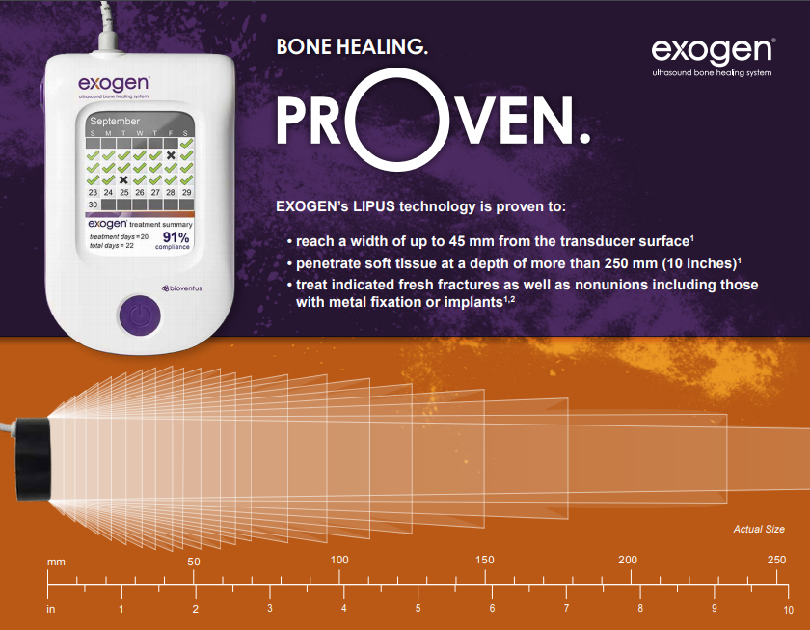
Reference | - Bioventus LLC. EXOGEN ultrasound signal depth and penetration. Data on file, RPT-000368  - Bioventus LLC. EXOGEN® User Guide. Last updated 2020. www.exogen.com/wp-content/uploads/2021/10/81087030-US-2020-User-Guide.pdf  - Lehmann JF, Brunne GD, Martinis AJ, McMillan JA. Ultrasonic effects as demonstrated in live pigs with surgical metallic implants. Arch Phys Med Rehabil. 1959;40:483-8.  - Angle SR, Sena K, Sumner DR, Virdi AS. Osteogenic differentiation of rat bone marrow stromal cells by various intensities of low-intensity pulsed ultrasound. Ultrasonics. 2011;51(3):281-8. PMID: 20965537. https://pubmed.ncbi.nlm.nih.gov/20965537/

EXOGEN Clinical Effectiveness Claims

Fresh Fractures
Please note that the use of the phrase "indicated fresh fractures" must include a footnote symbol that refers to the summary of Indications for Use.

Claim* | - EXOGEN is an FDA-approved bone healing device with 38% accelerated healing of indicated fresh fractures^{1,2}* [Heckman 1994: 7a; Kristiansen 1997:7a]  - EXOGEN ultrasound accelerates healing of indicated fresh fractures by 38%.^{1,2}* [Heckman 1994: 7a; Kristiansen 1997:7a]  - EXOGEN accelerates the time to healing of indicated fresh fractures.^{1,2}* [Heckman 1994: 7a; Kristiansen 1997:7a]  - 38% faster healing of indicated fresh fractures.^{1,2}* [Heckman 1994: 7a; Kristiansen 1997:7a]  - 38% accelerated healing of indicated fresh fractures.^{1,2}* [Heckman 1994: 7a; Kristiansen 1997:7a]  *Indications for Use
Reference | - Heckman JD, Ryaby JP, McCabe J, Frey JJ, Kilcoyne RF. Acceleration of tibial fracture-healing by non-invasive, low-intensity pulsed ultrasound. J Bone Joint Surg Am. 1994;76(1):26‐34. doi:10.2106/00004623-199401000-00004  - Kristiansen TK, Ryaby JP, McCabe J, Frey JJ, Roe LR. Accelerated healing of distal radial fractures with the use of specific, low-intensity ultrasound. A multicenter, prospective, randomized, double-blind, placebo-controlled study. J Bone Joint Surg Am. 1997;79(7):961‐73. doi: 10.2106/00004623-199707000-00002

Claim | EXOGEN decreased the time to heal by 38% in fresh tibial diaphysis fractures.¹ [Heckman 1994: p7a]
Graph [Heckman 1994: p7a] | 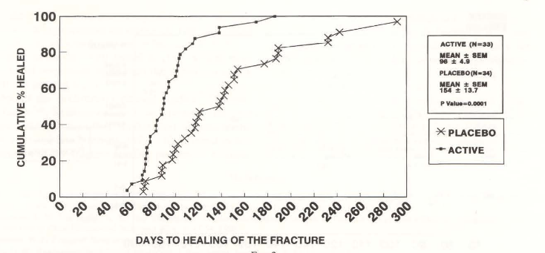  Add Note: ACTIVE = EXOGEN; PLACEBO = sham device
Reference | - Heckman JD, Ryaby JP, McCabe J, Frey JJ, Kilcoyne RF. Acceleration of tibial fracture-healing by non-invasive, low-intensity pulsed ultrasound. J Bone Joint Surg Am. 1994;76(1):26‐34. doi:10.2106/00004623-199401000-00004

Claim | At 150 days, 94% of EXOGEN patients were healed, while only 62% of placebo-treated patients healed.¹ [Heckman 1994: 6a, 7a]
Graph | 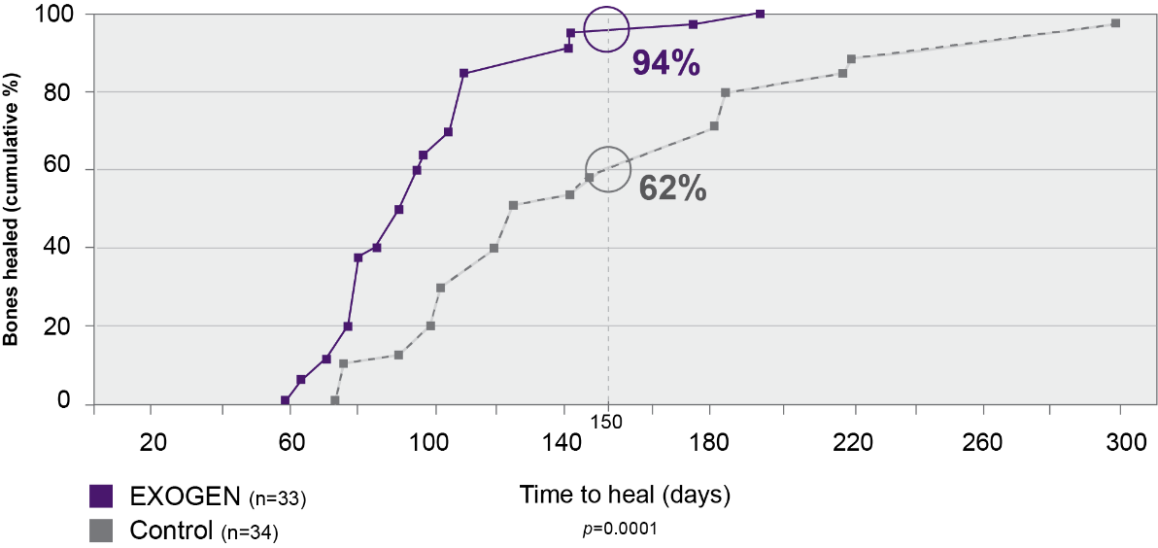
Reference | - Heckman JD, Ryaby JP, McCabe J, Frey JJ, Kilcoyne RF. Acceleration of tibial fracture-healing by non-invasive, low-intensity pulsed ultrasound. J Bone Joint Surg Am. 1994;76(1):26‐34. doi:10.2106/00004623-199401000-00004

Claim | EXOGEN accelerates healing in tibial fractures.¹ [Heckman 1994: 1a, 7a]
Reference | - Heckman JD, Ryaby JP, McCabe J, Frey JJ, Kilcoyne RF. Acceleration of tibial fracture-healing by non-invasive, low-intensity pulsed ultrasound. J Bone Joint Surg Am. 1994;76(1):26‐34. doi:10.2106/00004623-199401000-00004

Claim | In a prospective, randomized, double-blind, placebo-controlled (Level I) study of 67 tibial fractures, EXOGEN treatment accelerated healing by 38% —a difference of more than 8 weeks.¹ [Heckman 1994: 1a, 6a, 7a]
Graph  [Heckman 1994: 1a, 6a, 7a] | 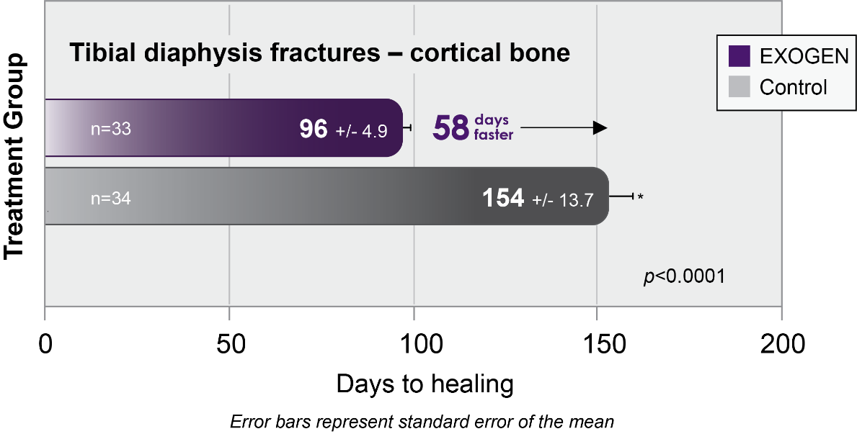
Reference | - Heckman JD, Ryaby JP, McCabe J, Frey JJ, Kilcoyne RF. Acceleration of tibial fracture-healing by non-invasive, low-intensity pulsed ultrasound. J Bone Joint Surg Am. 1994;76(1):26‐34. doi:10.2106/00004623-199401000-00004

Claim | A separate Level I trial of 61 distal radius fractures also reported a 38% acceleration of healing, as well as significantly greater alignment.¹ [Kristiansen 1997: 2b,f, 7a, 8a-b]
Graph [Kristiansen 1997: 2b,f, 7a] | 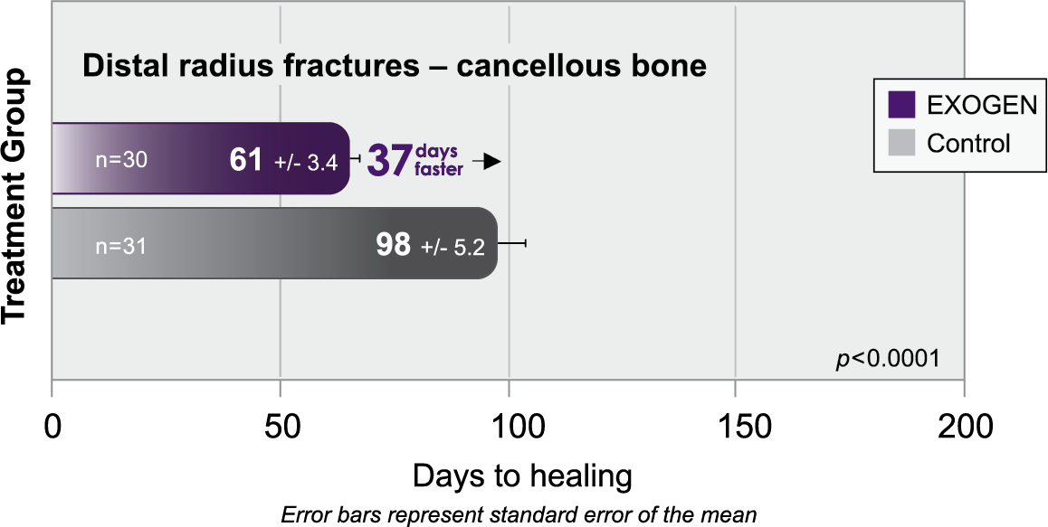
Reference | - Kristiansen TK, Ryaby JP, McCabe J, Frey JJ, Roe LR. Accelerated healing of distal radial fractures with the use of specific, low-intensity ultrasound. A multicenter, prospective, randomized, double-blind, placebo-controlled study. J Bone Joint Surg Am. 1997;79(7):961‐73. doi:10.2106/00004623-199707000-00002

Claim | EXOGEN accelerates healing time by 38%.¹ [Kristiansen 1997: 7a]
Graph [Kristiansen 1997: 2b,f, 7a]
Reference | - Kristiansen TK, Ryaby JP, McCabe J, Frey JJ, Roe LR. Accelerated healing of distal radial fractures with the use of specific, low-intensity ultrasound. A multicenter, prospective, randomized, double-blind, placebo-controlled study. J Bone Joint Surg Am. 1997;79(7):961‐73. doi:10.2106/00004623-199707000-00002

Claim | - EXOGEN treatment also showed reduced volar angulation.¹ [Kristiansen 1997: 2b,f]  - Loss of fracture alignment (%) measured by degree of volar angulation.¹  [Kristiansen 1997: 2b,f]
Graph [Kristiansen 1997: 8b, 13d, 14b] | 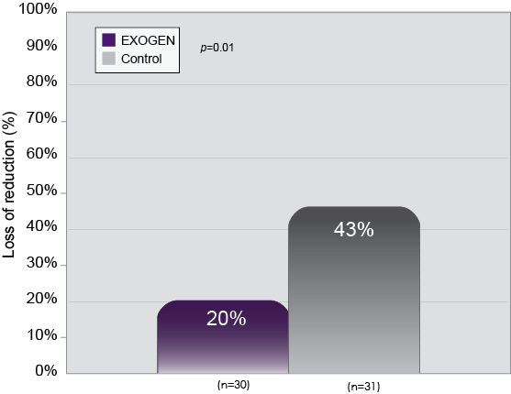
Reference | - Kristiansen TK, Ryaby JP, McCabe J, Frey JJ, Roe LR. Accelerated healing of distal radial fractures with the use of specific, low-intensity ultrasound. A multicenter, prospective, randomized, double-blind, placebo-controlled study. J Bone Joint Surg Am. 1997;79(7):961‐73. doi:10.2106/00004623-199707000-00002

Claim | A Level I, randomized controlled trial of acute distal radius fractures reported a 38% acceleration of healing with EXOGEN, as well as significantly less loss of reduction.*¹ [Kristiansen 1997: 2b,f, 8a-b]  Fractures included:¹ [Kristiansen 1997: 5a-b, 13a]  - Intra-articular involvement of either the radiocarpal or the radioulnar joint  - Concomitant fracture of the ulnar styloid process  *Closed, dorsally angulated, metaphyseal fracture of the distal radius within four centimeters of the tip of the radial styloid process¹ [Kristiansen 1997: 3a]
Reference | - Kristiansen TK, Ryaby JP, McCabe J, Frey JJ, Roe LR. Accelerated healing of distal radial fractures with the use of specific, low-intensity ultrasound. A multicenter, prospective, randomized, double-blind, placebo-controlled study. J Bone Joint Surg Am. 1997;79(7):961‐73. doi:10.2106/00004623-199707000-00002

Claim | Significantly decreases the loss of reduction during healing of a distal radius fracture.¹ [Kristiansen 1997: 2a-b,f, 8a-b]
Reference | - Kristiansen TK, Ryaby JP, McCabe J, Frey JJ, Roe LR. Accelerated healing of distal radial fractures with the use of specific, low-intensity ultrasound. A multicenter, prospective, randomized, double-blind, placebo-controlled study. J Bone Joint Surg Am. 1997;79(7):961‐73. doi:10.2106/00004623-199707000-00002

Claim | EXOGEN treatment accelerates healing in both cortical and cancellous bone.^{1,2} [Kristiansen 1997: 7a, 14a; Heckman 1994: 6a,7a]
Graph  [Kristiansen 1997: 7a; Heckman 1994: 6a,7a] | 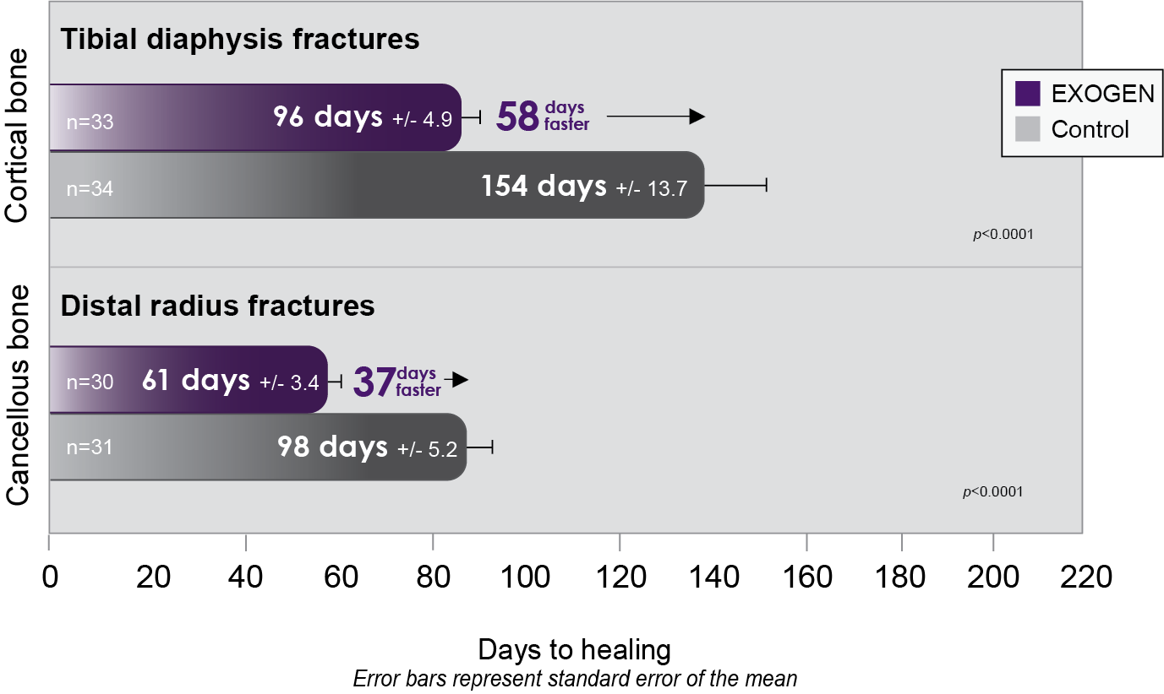
Reference | - Heckman JD, Ryaby JP, McCabe J, Frey JJ, Kilcoyne RF. Acceleration of tibial fracture-healing by non-invasive, low-intensity pulsed ultrasound. J Bone Joint Surg Am. 1994;76(1):26‐34. doi:10.2106/00004623-199401000-00004  - Kristiansen TK, Ryaby JP, McCabe J, Frey JJ, Roe LR. Accelerated healing of distal radial fractures with the use of specific, low-intensity ultrasound. A multicenter, prospective, randomized, double-blind, placebo-controlled study. J Bone Joint Surg Am. 1997;79(7):961‐73. doi:10.2106/00004623-199707000-00002

Claim | EXOGEN treatment has been demonstrated to accelerate healing of indicated fresh fractures by 38%.*^{1,2} [Kristiansen 1997: 7a; Heckman 1994: 6a, 7a]  *Summary of Indications for Use
Reference | - Heckman JD, Ryaby JP, McCabe J, Frey JJ, Kilcoyne RF. Acceleration of tibial fracture-healing by non-invasive, low-intensity pulsed ultrasound. J Bone Joint Surg Am. 1994;76(1):26‐34. doi:10.2106/00004623-199401000-00004  - Kristiansen TK, Ryaby JP, McCabe J, Frey JJ, Roe LR. Accelerated healing of distal radial fractures with the use of specific, low-intensity ultrasound. A multicenter, prospective, randomized, double-blind, placebo-controlled study. J Bone Joint Surg Am. 1997;79(7):961‐73. doi:10.2106/00004623-199707000-00002

Claim | - EXOGEN treatment accelerates healing of indicated fresh fractures in both younger and older patients.*¹ [Heckman 1997: 6a]  - EXOGEN treatment accelerates healing of indicated fresh fractures of the tibia in both younger and older patients.*¹ [Heckman 1997: 6a]  - EXOGEN treatment accelerates healing of indicated* fresh tibia fractures in younger (42 days faster) and older patients (84 days faster).*^{†,1} [Heckman 1997: 6a]  Either claim may be used with the reference.  *Summary of Indications for Use  †Patients ≤30 years of age
Graph [Heckman 1997: 6a] | 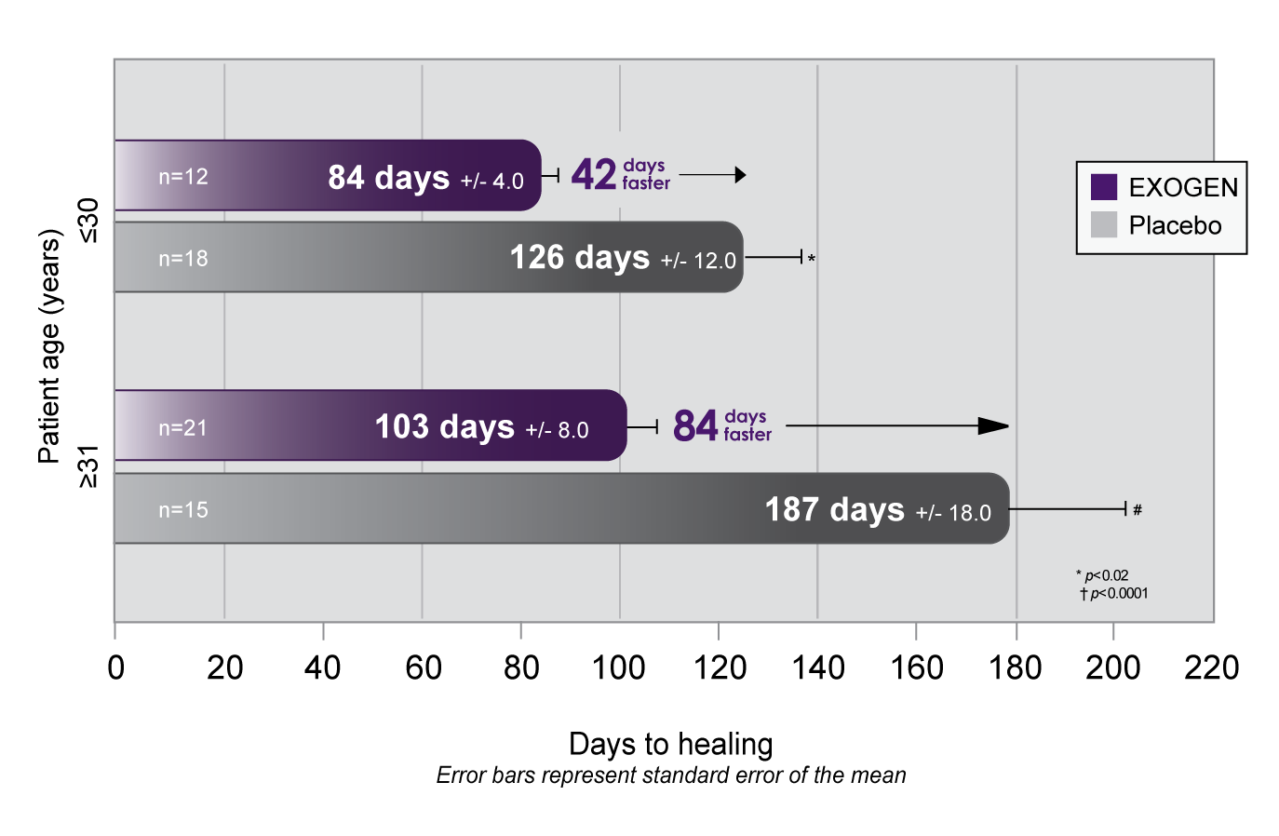
Reference | - Heckman JD, Sarasohn-Kahn J. The economics of treating tibia fractures. The cost of delayed unions. Bull Hosp Jt Dis.1997;56(1):63-72.

Claim | - EXOGEN reduces the incidence of delayed unions by 83%.¹ [Heckman 1997: 7b]  - EXOGEN treatment reduced the incidence of delayed unions in tibial fractures by 83%, decreasing the need for secondary procedures.¹ [Heckman 1997: 2a; 7b]  Either claim may be used with the reference.
Reference | - Heckman JD, Sarasohn-Kahn J. The economics of treating tibia fractures. The cost of delayed unions. Bull Hosp Jt Dis.1997;56(1):63-72.

Claim | EXOGEN accelerates healing in cortical bone 58 days faster than without bone stimulation.¹ [Heckman 1994: 6a, 7a]
Reference | - Heckman JD, Ryaby JP, McCabe J, Frey JJ, Kilcoyne RF. Acceleration of tibial fracture-healing by non-invasive, low-intensity pulsed ultrasound. J Bone Joint Surg Am. 1994;76(1):26‐34. doi:10.2106/00004623-199401000-00004

Claim | EXOGEN accelerates healing in cancellous bone 37 days faster than without bone stimulation.¹ [Kristiansen 1997: 7a, 14a]
Reference | - Kristiansen TK, Ryaby JP, McCabe J, Frey JJ, Roe LR. Accelerated healing of distal radial fractures with the use of specific, low-intensity ultrasound. A multicenter, prospective, randomized, double-blind, placebo-controlled study. J Bone Joint Surg Am. 1997;79(7):961‐73. doi:10.2106/00004623-199707000-00002

Claim | EXOGEN accelerates healing of indicated fresh tibia fractures in younger and older patients, 42 and 84 days faster, respectively.¹ [Heckman 1997: 6a]
Reference | - Heckman JD, Sarasohn-Kahn J. The economics of treating tibia fractures. The cost of delayed unions. Bull Hosp Jt Dis.1997;56(1):63-72.

Claim | EXOGEN reduces the incidence of delayed unions in indicated fresh fractures by 83%.¹* [Heckman 1997: 7b]  *Summary of Indications for Use
Reference | - Heckman JD, Sarasohn-Kahn J. The economics of training tibia fractures. The cost of delayed unions. Bull Hosp Jt Dis. 1997;56(1):63-72.

Claim | EXOGEN has been shown to heal tibial bone fractures 41% faster and distal radius bone fractures 51% faster, compared to placebo, in patients who smoke.¹* [Cook 1997: 1a]  *41% faster [EXOGEN (n) = 7; Placebo (n) = 14] and 51% faster [EXOGEN (n) = 6; Placebo (n) = 3]
Reference | - Cook SD, Ryaby JP, McCabe J, Frey JJ, Heckman JD, Kristiansen TK. Acceleration of tibia and distal radius fracture healing in patients who smoke. Clin Orthop Relat Res. 1997;(337):198‐207. doi:10.1097/00003086-199704000-00022

Claim | EXOGEN’s technology is successfully compatible with conservative fracture management techniques, and has been shown to reduce loss of fracture alignment.^{1,2} [Heckman 1994: 1a; Kristiansen 1997: 2a,b,f, 8a-b, 14b]
Graph  [Kristiansen 1997: 14b] | 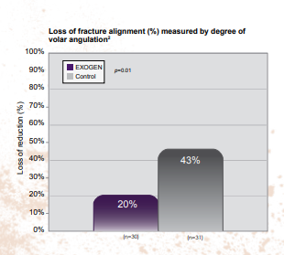*  *This image is from Dr. Peter Nolte and permission was given for use by Bioventus.
Reference | - Heckman JD, Ryaby JP, McCabe J, Frey JJ, Kilcoyne RF. Acceleration of tibial fracture-healing by non-invasive, low-intensity pulsed ultrasound. J Bone Joint Surg Am. 1994;76(1):26‐34. doi:10.2106/00004623-199401000-00004  - Kristiansen TK, Ryaby JP, McCabe J, Frey JJ, Roe LR. Accelerated healing of distal radial fractures with the use of specific, low-intensity ultrasound. A multicenter, prospective, randomized, double-blind, placebo-controlled study. J Bone Joint Surg Am. 1997;79(7):961‐73. doi:10.2106/00004623-199707000-00002

Nonunion Fractures

Claim | Discover the non-invasive choice for resolution of nonunions. In 14 Level 1, 2, 3, and 4 clinical studies, low-intensity, pulsed ultrasound waves successfully and non-invasively repaired delayed or nonunion fractures.¹⁻¹⁴ [Schofer 2010: 5a-c; Romano 1999: 1a; Gebauer 2005: 1a; Jinguishi 2007: 1a; Lerner 2004: 1a; Nolte 2001: 1a-b; Pigozzi 2004: 1a; Roussignol 2012: 1a; Rutten 2007: 1a; Watanabe 2013: 3a; Zura 2015a: 1b-c; Mayr 2002: 1a; Majeed 2019: 1a-b; Teoh 2018: 1a]
Reference | - Schofer MD, Block JE, Aigner J, Schmelz A. Improved healing response in delayed unions of the tibia with low-intensity pulsed ultrasound: results of a randomized sham-controlled trial. BMC Musculoskelet Disord. 2010;11:229. doi:10.1186/1471-2474-11-229  - Romanò C, Messina J, Meani E. Low-intensity, pulsed ultrasound for the treatment of septic pseudoarthrosis. Quarderni di Infezioni Osteoarticolari. 1999;(suppl 561):83-93.  - Gebauer D, Mayr E, Orthner E, Ryaby JP. Low-intensity pulsed ultrasound: effects on nonunions. Ultrasound Med Biol. 2005;31(10):1391‐402. doi:10.1016/j.ultrasmedbio.2005.06.002  - Jingushi S, Mizuno K, Matsushita T, Itoman M. Low-intensity pulsed ultrasound treatment for postoperative delayed union or nonunion of long bone fractures. J Orthop Sci. 2007;12(1):35‐41. doi:10.1007/s00776-006-1080-3  - Lerner A, Stein H, Soudry M. Compound high-energy limb fractures with delayed union: our experience with adjuvant ultrasound stimulation (exogen). Ultrasonics. 2004;42(1-9):915‐7. doi:10.1016/j.ultras.2003.11.014  - Nolte PA, van der Krans A, Patka P, Janssen IM, Ryaby JP, Albers GH. Low-intensity pulsed ultrasound in the treatment of nonunions. J Trauma. 2001;51(4):693‐703. doi:10.1097/00005373-200110000-00012  - Pigozzi F, Moneta MR, Giombini A, et al. Low-intensity pulsed ultrasound in the conservative treatment of pseudoarthrosis. J Sports Med Phys Fitness. 2004;44(2):173-8.  - Roussignol X, Currey C, Duparc F, Dujardin F. Indications and results for the Exogen™ ultrasound system in the management of non-union: a 59-case pilot study. Orthop Traumatol Surg Res. 2012;98(2):206‐13. doi:10.1016/j.otsr.2011.10.011  - Rutten S, Nolte PA, Guit GL, Bouman DE, Albers GH. Use of low-intensity pulsed ultrasound for posttraumatic nonunions of the tibia: a review of patients treated in the Netherlands. J Trauma. 2007;62(4):902‐8. doi:10.1097/01.ta.0000238663.33796.fb  - Watanabe Y, Arai Y, Takenaka N, Kobayashi M, Matsushita T. Three key factors affecting treatment results of low-intensity pulsed ultrasound for delayed unions and nonunions: instability, gap size, and atrophic nonunion. J Orthop Sci. 2013;18(5):803‐10. doi:10.1007/s00776-013-0415-0  - Zura R, Della Rocca GJ, Mehta S, et al. Treatment of chronic (>1 year) fracture nonunion: heal rate in a cohort of 767 patients treated with low-intensity pulsed ultrasound (LIPUS). Injury. 2015;46(10):2036‐41. doi:10.1016/j.injury.2015.05.042  - R12. Mayr E, Möckl C, Lenich A, Ecker M, Rüter A. Is low intensity ultrasound effective in treatment of disorders of fracture healing? Unfallchirurg. 2002;105(2):108‐15. doi:10.1007/s001130100301  - Majeed H, Karim T, Davenport J, Karski M, Smith R, Clough TM. Clinical and patient-reported outcomes following Low Intensity Pulsed Ultrasound (LIPUS, Exogen) for established post-traumatic and post-surgical nonunion in the foot and ankle. Foot Ankle Surg. 2020;26(4):405-411. doi:10.1016/j.fas.2019.05.009.  - R14. Teoh KH, Whitham R, Wong JF, Hariharan K. The use of low-intensity pulsed ultrasound in treating delayed union of fifth metatarsal fractures. Foot (Edinb). 2018;35:52-5. doi:10.1016/j.foot.2018.01.004

Claim | EXOGEN is effective in healing challenging, established nonunions—86% heal rate.¹⁻³ [Nolte 2001: 1a-b; Mayr 2002: 1a; Zura 2015a: 1b-c, 4a]
Reference | - Nolte PA, van der Krans A, Patka P, Janssen IM, Ryaby JP, Albers GH. Low-intensity pulsed ultrasound in the treatment of nonunions. J Trauma. 2001;51(4):693‐703. doi:10.1097/00005373-200110000-00012  - Mayr E, Möckl C, Lenich A, Ecker M, Rüter A. Is low intensity ultrasound effective in treatment of disorders of fracture healing? Unfallchirurg. 2002;105(2):108‐15. doi:10.1007/s001130100301  - Zura R, Della Rocca GJ, Mehta S, et al. Treatment of chronic (>1 year) fracture nonunion: heal rate in a cohort of 767 patients treated with low-intensity pulsed ultrasound (LIPUS). Injury. 2015;46(10):2036‐41. doi:10.1016/j.injury.2015.05.042

Claim | EXOGEN is effective in chronic nonunion fractures that failed to heal for at least one year—86% heal rate.¹ [Zura 2015: 1b-c, 4a]
Reference | - Zura R, Della Rocca GJ, Mehta S, et al. Treatment of chronic (>1 year) fracture nonunion: heal rate in a cohort of 767 patients treated with low-intensity pulsed ultrasound (LIPUS). Injury. 2015;46(10):2036‐41. doi:10.1016/j.injury.2015.05.042

Claim | EXOGEN is effective in high-energy nonunion fractures—89% heal rate.¹ [Lerner 2004: 1a]
Reference | - Lerner A, Stein H, Soudry M. Compound high-energy limb fractures with delayed union: our experience with adjuvant ultrasound stimulation (exogen). Ultrasonics. 2004;42(1-9):915‐7. doi:10.1016/j.ultras.2003.11.014

Claim | EXOGEN is effective in atrophic or hypertrophic nonunions.¹ [Nolte 2001: 7a]
Reference | - Nolte PA, van der Krans A, Patka P, Janssen IM, Ryaby JP, Albers GH. Low-intensity pulsed ultrasound in the treatment of nonunions. J Trauma. 2001;51(4):693‐703. doi:10.1097/00005373-200110000-00012

Claim | EXOGEN is effective for the treatment of nonunions with an inter-fragment gap less than 10 mm and stable osteosynthesis.¹ [Roussignol 2012: 2a]
Reference | - Roussignol X, Currey C, Duparc F, Dujardin F. Indications and results for the Exogen™ ultrasound system in the management of non-union: a 59-case pilot study. Orthop Traumatol Surg Res. 2012;98(2):206‐13. doi:10.1016/j.otsr.2011.10.011

Claim | EXOGEN is effective for achieving solid union—34% increase in bone mineral density.¹ [Schofer 2010: 5a-b]
Reference | - Schofer MD, Block JE, Aigner J, Schmelz A. Improved healing response in delayed unions of the tibia with low-intensity pulsed ultrasound: results of a randomized sham-controlled trial. BMC Musculoskelet Disord. 2010;11:229. doi:10.1186/1471-2474-11-229

Claim | Clinical evidence indicates EXOGEN may help nonunion healing.¹⁻⁶ [Gebauer 2005: 1a; Schofer 2010: 5a-c; Roussignol 2012: 1a; Nolte 2001: 1a-b; Lerner 2004: 1a; Zura 2015a: 1b-c]
Reference | - Gebauer D, Mayr E, Orthner E, Ryaby JP. Low-intensity pulsed ultrasound: effects on nonunions. Ultrasound Med Biol. 2005;31(10):1391‐402. doi:10.1016/j.ultrasmedbio.2005.06.002  - Schofer MD, Block JE, Aigner J, Schmelz A. Improved healing response in delayed unions of the tibia with low-intensity pulsed ultrasound: results of a randomized sham-controlled trial. BMC Musculoskelet Disord. 2010;11:229. doi:10.1186/1471-2474-11-229  - Roussignol X, Currey C, Duparc F, Dujardin F. Indications and results for the Exogen™ ultrasound system in the management of non-union: a 59-case pilot study. Orthop Traumatol Surg Res. 2012;98(2):206‐13. doi:10.1016/j.otsr.2011.10.011  - Nolte PA, van der Krans A, Patka P, Janssen IM, Ryaby JP, Albers GH. Low-intensity pulsed ultrasound in the treatment of nonunions. J Trauma. 2001;51(4):693‐703. doi:10.1097/00005373-200110000-00012  - Lerner A, Stein H, Soudry M. Compound high-energy limb fractures with delayed union: our experience with adjuvant ultrasound stimulation (exogen). Ultrasonics. 2004;42(1-9):915‐7. doi:10.1016/j.ultras.2003.11.014  - Zura R, Della Rocca GJ, Mehta S, et al. Treatment of chronic (>1 year) fracture nonunion: heal rate in a cohort of 767 patients treated with low-intensity pulsed ultrasound (LIPUS). Injury. 2015;46(10):2036‐41. doi:10.1016/j.injury.2015.05.042

Claim | - 86% nonunion heal rate*¹⁻³ [Nolte 2001: 1b; Mayr 2002: 1a; Zura 2015a: 1b]  *A nonunion is considered established when a fracture site shows no visible signs of progressive healing.  - High incidence of healing with EXOGEN: 86% of nonunion fractures, with an average time to healing of 152 days.¹⁻³ [Nolte 2001: 1b, 6a]  - EXOGEN has been shown to successfully resolve 86% of nonunion fractures.¹⁻³ [Nolte 2001: 1b; Mayr 2002: 1a; Zura 2015a: 1b]  - 86% heal rate for fractures not healing on their own¹⁻³ [Nolte 2001: 1b; Mayr 2002: 1a; Zura 2015a: 1b]  - EXOGEN has a high heal rate of nonunion healing of 86%.¹⁻³ [Nolte 2001: 1b; Mayr 2002: 1a; Zura 2015a: 1b]  - Deliver high heal rate with nonunion fractures¹⁻³ [Nolte 2001: 1b; Mayr 2002: 1a; Zura 2015a: 1b]  - Clinical evidence indicates EXOGEN may help nonunion healing.¹⁻³ [Nolte 2001: 1b; Mayr 2002: 1a; Zura 2015a: 1b]  Any of the claims may be used with the references. Claims can be used without either of the graphics.
Graph | 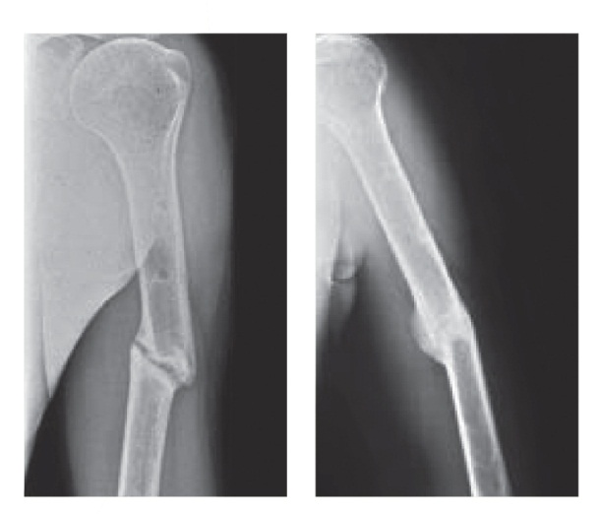  Radiograph depicting humeral nonunion fracture healing.  Image courtesy of Peter Nolte.
Graph [Nolte 2001: 1b] | 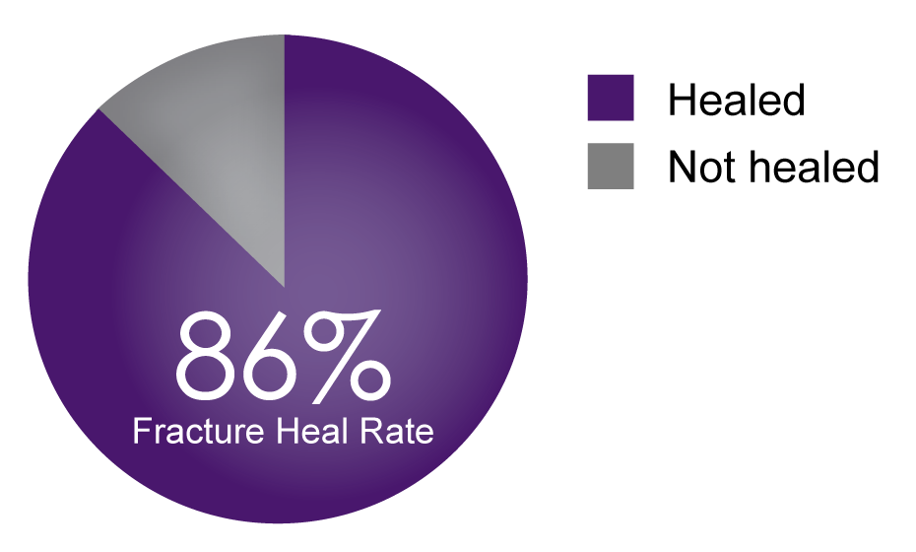  86% Fracture heal rate for nonunion fractures
Reference | - Nolte PA, van der Krans A, Patka P, Janssen IM, Ryaby JP, Albers GH. Low-intensity pulsed ultrasound in the treatment of nonunions. J Trauma. 2001;51(4):693‐703. doi:10.1097/00005373-200110000-00012  - Mayr E, Möckl C, Lenich A, Ecker M, Rüter A. Is low intensity ultrasound effective in treatment of disorders of fracture healing? Unfallchirurg. 2002;105(2):108‐15. doi: 10.1007/s001130100301  - Zura R, Della Rocca GJ, Mehta S, et al. Treatment of chronic (>1 year) fracture nonunion: heal rate in a cohort of 767 patients treated with low-intensity pulsed ultrasound (LIPUS). Injury. 2015;46(10):2036‐41. doi:10.1016/j.injury.2015.05.042

Claim | Clinical studies demonstrate EXOGEN has an 86% heal rate of nonunions.¹⁻⁴ [Nolte 2001: 1a-b; Mayr 2002: 1a; Zura 2015a: 1b-c, 4a; EXOGEN User Guide:13d]
Reference | - Nolte PA, van der Krans A, Patka P, Janssen IM, Ryaby JP, Albers GH. Low-intensity pulsed ultrasound in the treatment of nonunions. J Trauma. 2001;51(4):693‐703. doi:10.1097/00005373-200110000-00012  - Mayr E, Möckl C, Lenich A, Ecker M, Rüter A. Is low intensity ultrasound effective in treatment of disorders of fracture healing? Unfallchirurg. 2002;105(2):108‐15. doi: 10.1007/s001130100301  - Zura R, Della Rocca GJ, Mehta S, et al. Treatment of chronic (>1 year) fracture nonunion: heal rate in a cohort of 767 patients treated with low-intensity pulsed ultrasound (LIPUS). Injury. 2015;46(10):2036‐41. doi:10.1016/j.injury.2015.05.042  - Bioventus LLC. EXOGEN® User Guide. Last updated 2020. www.exogen.com/wp-content/uploads/2021/10/81087030-US-2020-User-Guide.pdf

Claim | EXOGEN heals scaphoid and metatarsal nonunions.¹ [Zura 2015a: 4c]
Graph  [Zura 2015a: 4c] | 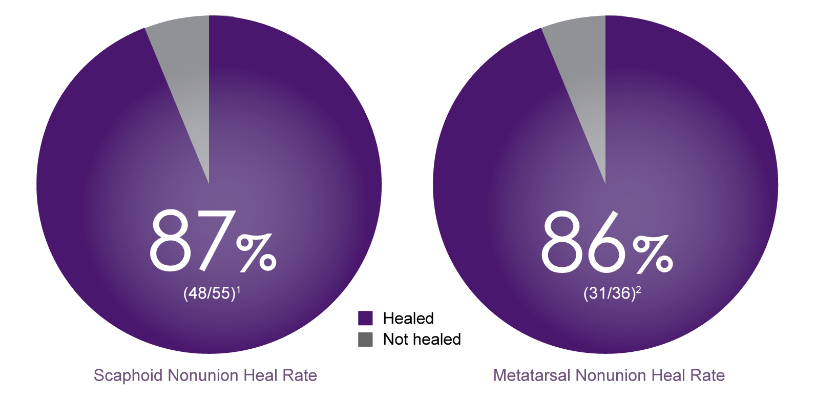
Reference | - Zura R, Della Rocca GJ, Mehta S, et al. Treatment of chronic (>1 year) fracture nonunion: heal rate in a cohort of 767 patients treated with low-intensity pulsed ultrasound (LIPUS). Injury. 2015;46(10):2036‐41. doi:10.1016/j.injury.2015.05.042

Claim | A cohort study shows that LIPUS treatment may be an appropriate option for chronic nonunion cases, with success rates comparable to that achieved with surgical intervention.^{1,2} [Zura 2015a: 1a-c, 5a; Gebauer 2005: 1a]
Reference | - Zura R, Della Rocca GJ, Mehta S, et al. Treatment of chronic (>1 year) fracture nonunion: heal rate in a cohort of 767 patients treated with low-intensity pulsed ultrasound (LIPUS). Injury. 2015;46(10):2036‐41. doi:10.1016/j.injury.2015.05.042  - Gebauer D, Mayr E, Orthner E, Ryaby JP. Low-intensity pulsed ultrasound: effects on nonunions. Ultrasound Med Biol. 2005;31(10):1391‐402. doi:10.1016/j.ultrasmedbio.2005.06.002

Claim | EXOGEN heals chronic nonunions without the need for revision surgery.^{1,2} [Zura 2015a: 1a-c, 5a; Gebauer 2005: 1a]
Reference | - Zura R, Della Rocca GJ, Mehta S, et al. Treatment of chronic (>1 year) fracture nonunion: heal rate in a cohort of 767 patients treated with low-intensity pulsed ultrasound (LIPUS). Injury. 2015;46(10):2036‐41. doi:10.1016/j.injury.2015.05.042  - Gebauer D, Mayr E, Orthner E, Ryaby JP. Low-intensity pulsed ultrasound: effects on nonunions. Ultrasound Med Biol. 2005;31(10):1391‐402. doi:10.1016/j.ultrasmedbio.2005.06.002

Claim | - EXOGEN successfully heals chronic nonunions.¹ [Zura 2015a: 1a-c]  - Patients included in the analysis averaged 3.1 surgical procedures prior to LIPUS treatment and healed in an average of 5.6 months after being unhealed for an average 28.7 months prior to LIPUS treatment.¹ [Zura 2015a: 3a]
Graph [Zura 2015a: 4c] | 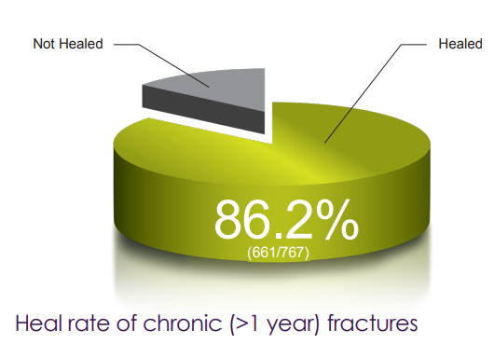
Reference | - Zura R, Della Rocca GJ, Mehta S, et al. Treatment of chronic (>1 year) fracture nonunion: heal rate in a cohort of 767 patients treated with low-intensity pulsed ultrasound (LIPUS). Injury. 2015;46(10):2036‐41. doi:10.1016/j.injury.2015.05.042

Claim | 1. This graph reports a subset of 91 (out of 767) chronic nonunion patients treated with EXOGEN at least 90 days after the most recent surgery. In this subset, the average number of days to LIPUS treatment* ranged from 347.2 days (femur) to 523.5 days (humerus).¹ [Zura 2015a: 5b]  *The average number of days delay to LIPUS treatment is the number of days from the last surgical treatment to the time when LIPUS treatment began.
Graph [Zura 2015a: 5b] | 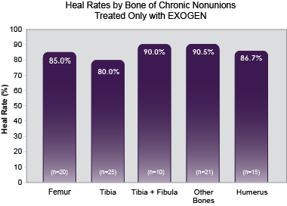
Reference | - Zura R, Della Rocca GJ, Mehta S, et al. Treatment of chronic (>1 year) fracture nonunion: heal rate in a cohort of 767 patients treated with low intensity pulsed ultrasound (LIPUS). Injury. 2015;46(10):2036‐41. doi:10.1016/j.injury.2015.05.042

Claim | Clinical study demonstrates 88% incidence of healing and >95% treatment compliance¹ [Roussignol 2012: 3a]
Graph | 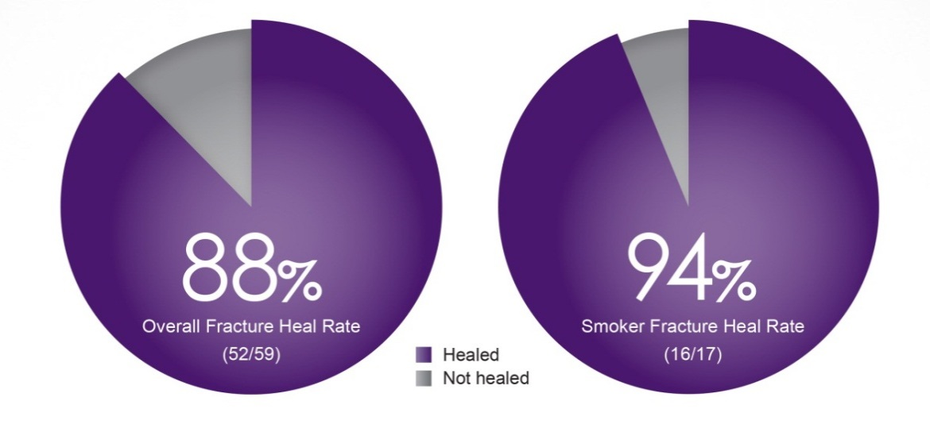  [Roussignol 2012: 3a, 4a]
Reference | - Roussignol X, Currey C, Duparc F, Dujardin F. Indications and results for the Exogen™ ultrasound system in the management of non-union: a 59-case pilot study. Orthop Traumatol Surg Res. 2012;98(2):206‐13. doi:10.1016/j.otsr.2011.10.011

Claim | EXOGEN was shown to be effective for use on nonunions with an inter-fragment gap less than 10 mm and stable osteosynthesis.¹ [Roussignol 2012: 2a]
Graph [Roussignol 2012: 7a] | 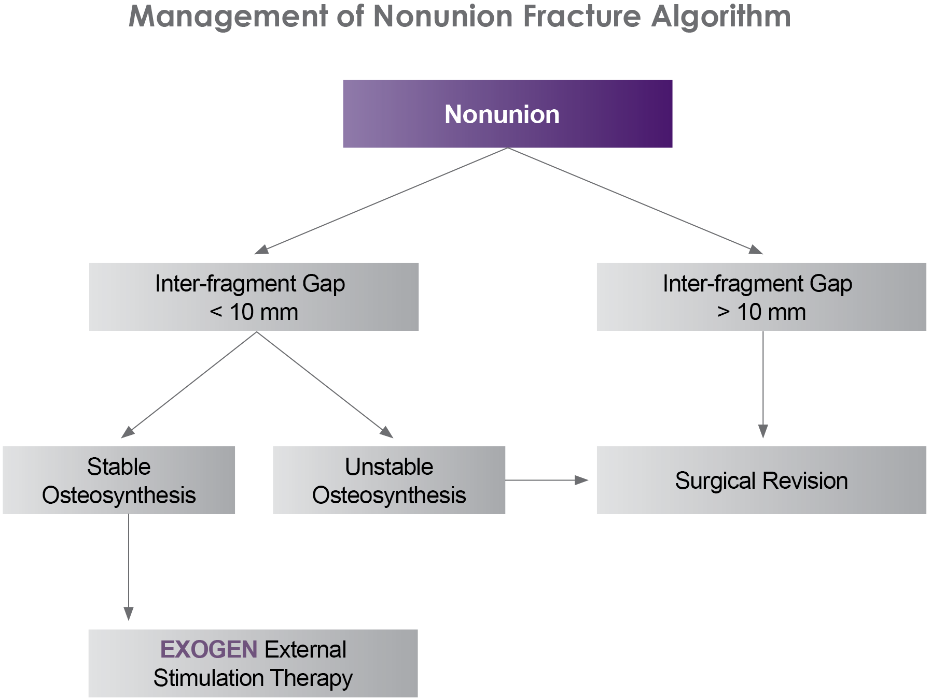
Reference | - Roussignol X, Currey C, Duparc F, Dujardin F. Indications and results for the Exogen™ ultrasound system in the management of non-union: a 59-case pilot study. Orthop Traumatol Surg Res. 2012;98(2):206‐13. doi:10.1016/j.otsr.2011.10.011

Claim | EXOGEN Ultrasound Bone Healing System is effective, either alone or as an adjunctive treatment to all methods of managing nonunion fractures.¹⁻⁵ [RPT-000413: p3 tableA-C; p4 tableA-B]
Graph [RPT-000413: p3 tableA-C; p4 tableA-B; RPT- 000389: p2 tableA; RPT-000391: p2 tableA; RPT-000396: p2 tableA; RPT-000395: p2 tableA] | 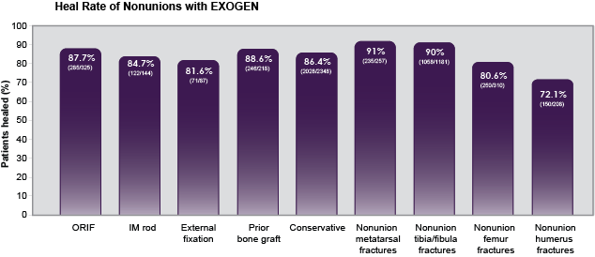
Reference | - Bioventus, LLC. Metal fixation nonunion claims based on EXOGEN Registry. Data on file, RPT-000413.  - Bioventus LLC. Data on file, RPT-000389.  - Bioventus LLC. Data on file, RPT-000391.  - Bioventus LLC. Data on file, RPT-000395.  - Bioventus LLC. Data on file, RPT-000396.

Claim | - Level 1 study shows an estimated 34% increase in bone mineral density in subjects treated with EXOGEN for 20 minutes a day.¹ [Schofer 2010: 5a-b]  - In a study of delayed union fracture healing, bone mineral density showed an estimated 34% increase in subjects treated with EXOGEN for 20 minutes a day. EXOGEN also demonstrated a significant benefit in fracture gap reduction compared to the control group.¹ [Schofer 2010: 1a, 5a-b]  - EXOGEN accelerates the healing process and increases the chance of achieving solid union.¹ [Schofer 2010: 5a-c]  Any of the claims may be used with the reference.
Graph [Schofer 2010: 4a] | 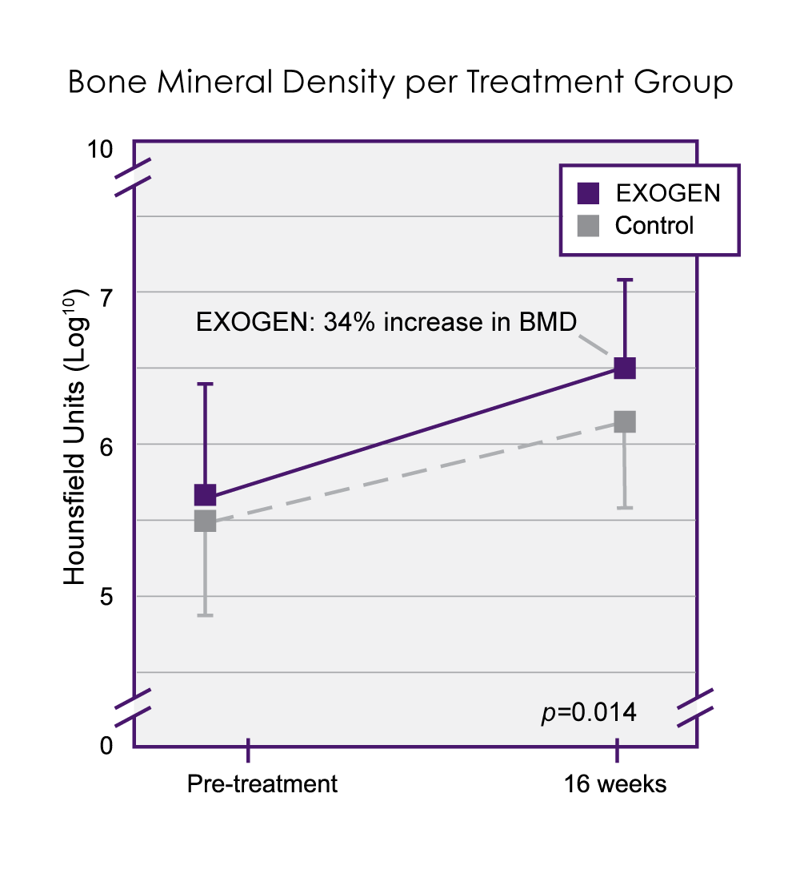  Line graph illustrating improvement in bone mineral density (BMD) for each treatment group separately through 16 weeks of follow-up.
Graph  [Schofer 2010: 4a] | 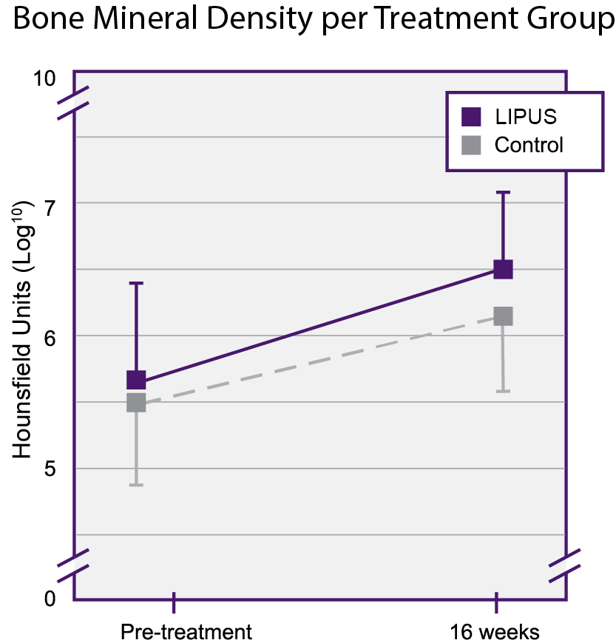
Reference | - Schofer MD, Block JE, Aigner J, Schmelz A. Improved healing response in delayed unions of the tibia with low-intensity pulsed ultrasound: results of a randomized sham-controlled trial. BMC Musculoskelet Disord. 2010;11:229. doi:10.1186/1471-2474-11-229

Claim | - EXOGEN has demonstrated a heal rate of 86% (31/36) for nonunion metatarsal fractures.¹ [Zura 2015a: 4c]  - EXOGEN has demonstrated a heal rate of 89% (50/56) for nonunion tibia/fibula fractures.¹ [Zura 2015a: 4c]
Reference | - Zura R, Della Rocca GJ, Mehta S, et al. Treatment of chronic (>1 year) fracture nonunion: heal rate in a cohort of 767 patients treated with low intensity pulsed ultrasound (LIPUS). Injury. 2015;46(10):2036‐41. doi:10.1016/j.injury.2015.05.042

Claim | - EXOGEN has demonstrated a heal rate of 84% (129/153) for nonunion femur fractures.¹ [Zura 2015a: 4c]  - EXOGEN has demonstrated a heal rate of 80% (52/65) for nonunion humerus fractures.¹ [Zura 2015a: 4c]
Reference | - Zura R, Della Rocca GJ, Mehta S, et al. Treatment of chronic (>1 year) fracture nonunion: heal rate in a cohort of 767 patients treated with low intensity pulsed ultrasound (LIPUS). Injury. 2015;46(10):2036‐41. doi:10.1016/j.injury.2015.05.042

Claim | High incidence of healing humeral nonunions¹ [Zura 2015a; 4c]
Graph | 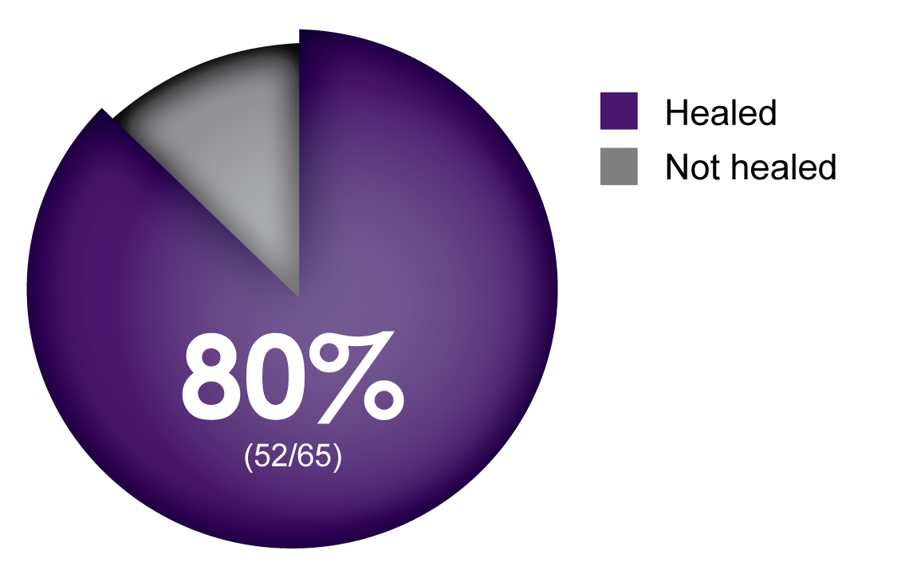
Reference | - Bioventus LLC. Data on file, RPT-000396.

Claim | - 89% of patients with high-energy nonunion fractures healed when using EXOGEN.¹ [Lerner 2004: 1a]  - EXOGEN has a high heal rate even in compound high energy nonunion fractures with severe soft tissue damage.¹ [Lerner 2004: 1a]  Either of the claims may be used with the reference. Either claim can be used without the graph.
Graph  [Lerner 2004: 1a] | 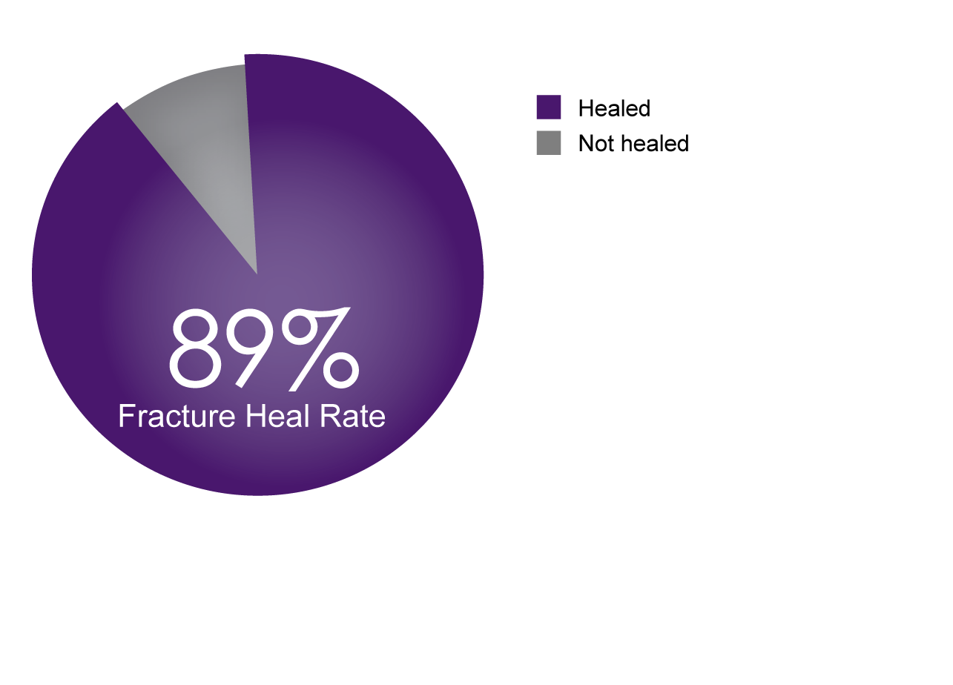
Reference | - Lerner A, Stein H, Soudry M. Compound high-energy limb fractures with delayed union: our experience with adjuvant ultrasound stimulation (exogen). Ultrasonics. 2004;42(1-9):915‐7. doi:10.1016/j.ultras.2003.11.014

Claim | Numerous clinical studies with EXOGEN treatment show high incidence of healing nonunions.¹⁻⁷ [Duarte 1996: 1a; Roussignol 2012: 2a; Mayr 2000b: 1a; Nolte 2001: 1a-b; Lerner 2004: 1a; Gebauer 2005: 1a; Majeed 2020: 1a-b]
Reference | - Duarte LR, Xavier CA, Choffie M, McCabe JM. Review of nonunions treated by pulsed low-intensity ultrasound. In: Proceedings of the 1996 Meeting of the Société International de Chirurgie Orthopaedique et de Traumatologie (SICOT). 1996: Amsterdam: 110.  - Roussignol X, Currey C, Duparc F, Dujardin F. Indications and results for the Exogen™ ultrasound system in the management of non-union: a 59-case pilot study. Orthop Traumatol Surg Res. 2012;98(2):206‐13. doi:10.1016/j.otsr.2011.10.011  - Mayr E, Frankel V, Rüter A. Ultrasound--an alternative healing method for nonunions? Arch Orthop Trauma Surg. 2000;120(1-2):1‐8. doi:10.1007/pl00021234  - Nolte PA, van der Krans A, Patka P, Janssen IM, Ryaby JP, Albers GH. Low-intensity pulsed ultrasound in the treatment of nonunions. J Trauma. 2001;51(4):693‐703. doi:10.1097/00005373-200110000-00012  - Lerner A, Stein H, Soudry M. Compound high-energy limb fractures with delayed union: our experience with adjuvant ultrasound stimulation (exogen). Ultrasonics. 2004;42(1-9):915‐7. doi:10.1016/j.ultras.2003.11.014  - Gebauer D, Mayr E, Orthner E, Ryaby JP. Low-intensity pulsed ultrasound: effects on nonunions. Ultrasound Med Biol. 2005;31(10):1391‐402. doi:10.1016/j.ultrasmedbio.2005.06.002  - Majeed H, Karim T, Davenport J, Karski M, Smith R, Clough TM. Clinical and patient-reported outcomes following Low Intensity Pulsed Ultrasound (LIPUS, Exogen) for established post-traumatic and post-surgical nonunion in the foot and ankle. Foot Ankle Surg. 2020;26(4):405-11. doi:10.1016/j.fas.2019.05.009

Claim | Numerous clinical studies with EXOGEN treatment demonstrate high nonunion heal rates across various fracture types.¹⁻⁶ [Nolte 2001: 1a-b, 3a, 9a; Mayr 2000b: 1a, 3a; Lerner 2004: 1a, 2a-b; Gebauer 2005: 1a, p4-5 table 2; Jinguishi 2007: 1a-b; Romano 1999: 2a]
Graph [Nolte 2001: 1a-b, 3a, 9a; Mayr 2000b: 1a, 3a, 4a-b; Lerner 2004: 1a, 2a-c; Gebauer 2005: 1a, p4-5 table 2; Jinguishi 2007: 1a-b, 2b-c; Romano 1999: 2a-b, 3a, 4a] | 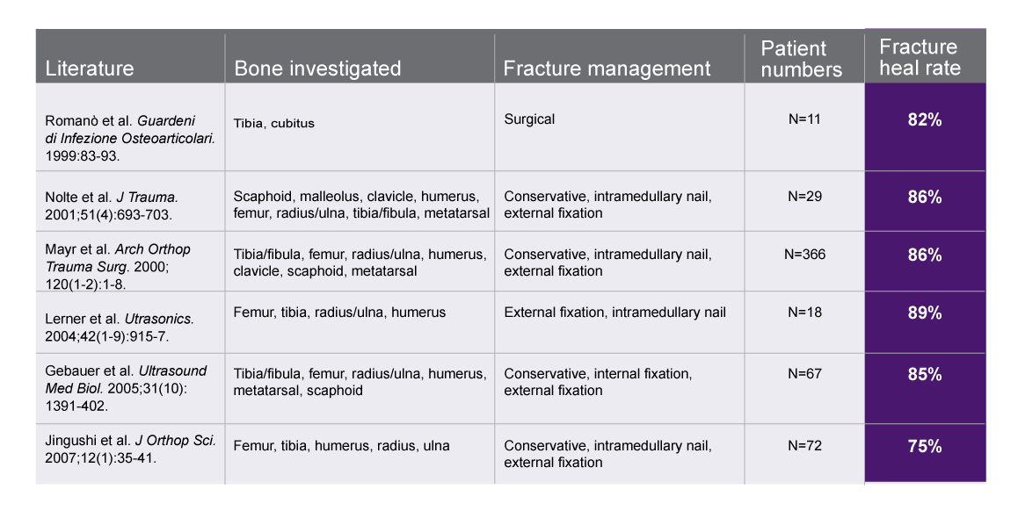
Reference | - Nolte PA, van der Krans A, Patka P, Janssen IM, Ryaby JP, Albers GH. Low-intensity pulsed ultrasound in the treatment of nonunions. J Trauma. 2001;51(4):693‐703. doi:10.1097/00005373-200110000-00012  - Mayr E, Frankel V, Rüter A. Ultrasound--an alternative healing method for nonunions? Arch Orthop Trauma Surg. 2000;120(1-2):1‐8. doi:10.1007/pl00021234  - Lerner A, Stein H, Soudry M. Compound high-energy limb fractures with delayed union: our experience with adjuvant ultrasound stimulation (exogen). Ultrasonics. 2004;42(1-9):915‐7. doi:10.1016/j.ultras.2003.11.014  - Gebauer D, Mayr E, Orthner E, Ryaby JP. Low-intensity pulsed ultrasound: effects on nonunions. Ultrasound Med Biol. 2005;31(10):1391‐402. doi:10.1016/j.ultrasmedbio.2005.06.002  - Jingushi S, Mizuno K, Matsushita T, Itoman M. Low-intensity pulsed ultrasound treatment for postoperative delayed union or nonunion of long bone fractures. J Orthop Sci. 2007;12(1):35‐41. doi:10.1007/s00776-006-1080-3  - Romanò C, Messina J, Meani E. Low-intensity, pulsed ultrasound for the treatment of septic pseudoarthrosis. Quarderni di Infezione Osteoarticolari. 1999;83-93.

Claim | Provide safe and effective healing in nonunion fractures with metal fixation¹ [Zura 2015a: 4b, 6a]
Reference | - Zura R, Della Rocca GJ, Mehta S, et al. Treatment of chronic (>1 year) fracture nonunion: heal rate in a cohort of 767 patients treated with low intensity pulsed ultrasound (LIPUS). Injury. 2015;46(10):2036‐41. doi:10.1016/j.injury.2015.05.042

Claim | EXOGEN shows results in special patient populations:  - Infected nonunions¹⁻³ [Leighton 2021: 6a-c; Romanò 1999: 1a, 2a; EXOGEN User Guide: 13e]  - Atrophic nonunions³⁻⁶ [EXOGEN User Guide: 13f; Roussignol 2012: 1a, 3b, 4a; Chaudhry 2019: 2a, 4a; Mayr 2002: 1a, 5c]  - Hypertrophic nonunions^{3,6,7} [EXOGEN User Guide: 13f; Mayr 2002: 1a, 5c; Leighton 2017: 4a]
Reference | - Leighton R, Phillips M, Bhandari M, Zura R. Low intensity pulsed ultrasound (LIPUS) use for the management of instrumented, infected, and fragility non-unions: a systematic review and meta-analysis of healing proportions. BMJ Musculoskelet Disord. 2021;22:532. doi:10.1186/s12891-021-04322-5  - Romanò C, Messina J, Meani E. Low-intensity, pulsed ultrasound for the treatment of septic pseudoarthrosis. Quarderni di Infezioni Osteoarticolari. 1999;(suppl 561):83-93.  - Bioventus LLC. EXOGEN® User Guide. Last updated 2020. www.exogen.com/wp-content/uploads/2021/10/81087030-US-2020-User-Guide.pdf  - Roussignol X, Currey C, Duparc F, Dujardin F. Indications and results for the Exogen™ ultrasound system in the management of non-union: a 59-case pilot study. Orthop Traumatol Surg Res. 2012;98(2):206‐13. doi:10.1016/j.otsr.2011.10.011  - Chaudhry S, Rajan R, Rubin S, Papamerkouriou YM. Low intensity pulsed ultrasound (Lipus) as a non-surgical cost effective method of managing atrophic non-union. J Orthop Surg Rehabil. 2019;3(1):1-5.  - Mayr E, Möckl C, Lenich A, Ecker M, Rüter A. Is low intensity ultrasound effective in treatment of disorders of fracture healing? Unfallchirurg. 2002;105(2):108‐15. doi: 10.1007/s001130100301  - Leighton R, Watson JT, Giannoudis P, Papakostidis C, Harrison A, Steen RG. Healing of fracture nonunions treated with low-intensity pulsed ultrasound (LIPUS): A systematic review and meta-analysis. Injury. 2017;48(7):1339-47. doi:10.1016/j.injury.2017.05.016

Claim | The healing of your fracture may be affected by the location of the bone.¹⁻⁴ [Bishop 2012: 1a; Nolte 2001: p4 table1; Gebauer 2005: p4 table2; Lerner 2004: p2 table1]
Graph | 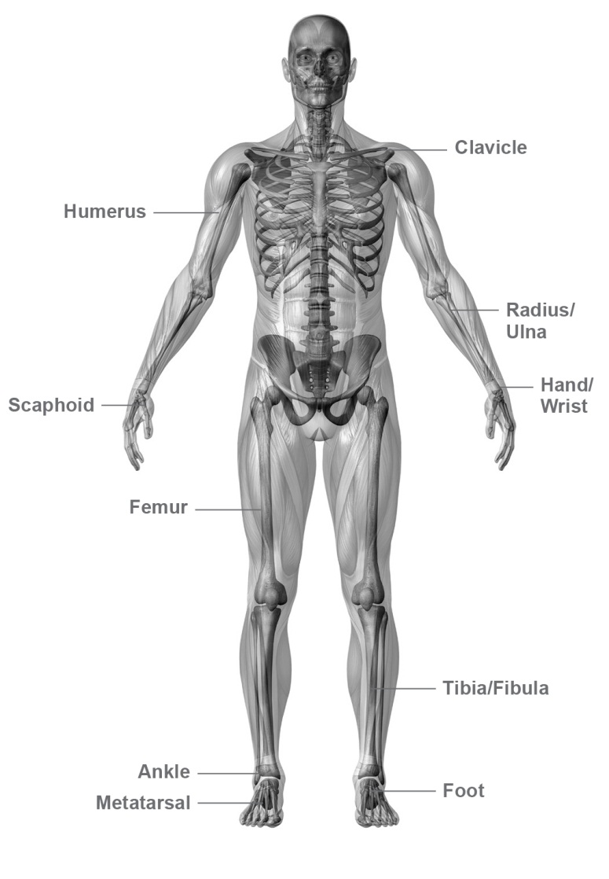
Reference | - Bishop JA, Palanca AA, Bellin MJ, Lowenberg DW. Assessment of compromised fracture healing. J Am Acad Orthop Surg. 2012;20(5):273-82. doi:10.5435/JAAOS-20-05-273  - Nolte PA, van der Krans A, Patka P, Janssen IM, Ryaby JP, Albers GH. Low-intensity pulsed ultrasound in the treatment of nonunions. J Trauma. 2001;51(4):693‐703. doi:10.1097/00005373-200110000-00012  - Gebauer D, Mayr E, Orthner E, Ryaby JP. Low-intensity pulsed ultrasound: effects on nonunions. Ultrasound Med Biol. 2005;31(10):1391‐402. doi:10.1016/j.ultrasmedbio.2005.06.002  - Lerner A, Stein H, Soudry M. Compound high-energy limb fractures with delayed union: our experience with adjuvant ultrasound stimulation (exogen). Ultrasonics. 2004;42(1-9):915‐7. doi:10.1016/j.ultras.2003.11.014

Claim | - Incidence of EXOGEN fracture healing, by bone location.¹  - EXOGEN can resolve nonunion fractures in both upper and lower extremities.¹
Graph | 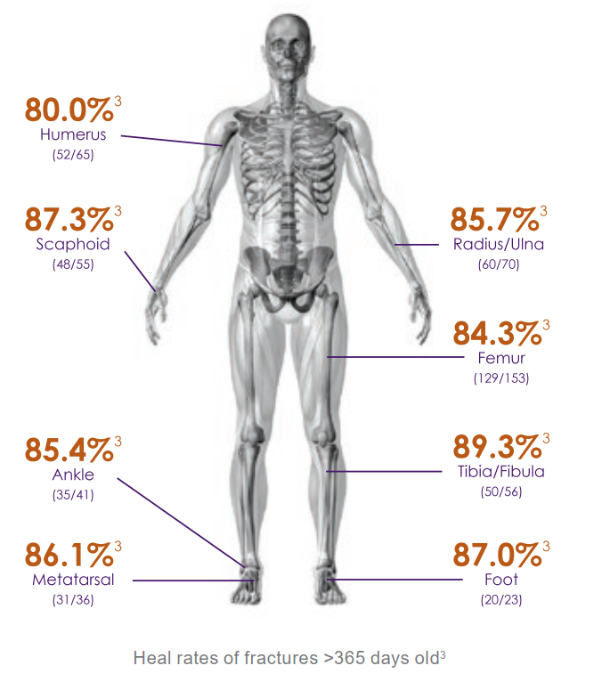
Reference | R1. Zura R, Della Rocca GJ, Mehta S, et al. Treatment of chronic (>1 year) fracture nonunion: heal rate in a cohort of 767 patients treated with low-intensity pulsed ultrasound (LIPUS). Injury. 2015;46(10):2036‐41. doi:10.1016/j.injury.2015.05.042

Claim | In many cases, EXOGEN may prevent the need for further surgery.¹⁻¹¹
Graph | 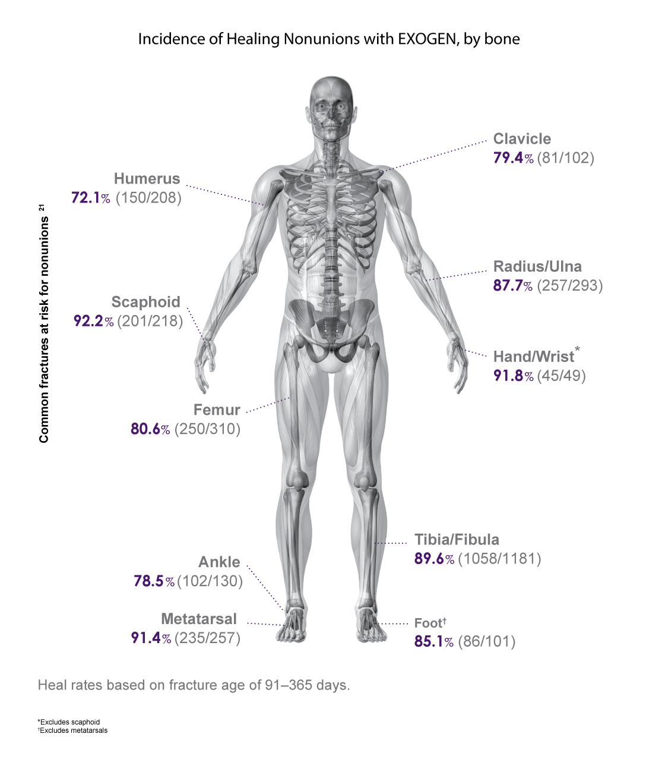
Reference | - Bioventus LLC. Humerus nonunion claims based on EXOGEN Registry. Data on file, RPT-000396. [RPT-000396: p2 tableA]  - Bioventus LLC. Scaphoid nonunion claims based on EXOGEN Registry. Data on file, RPT-000398. [RPT-000398: p2 tableA]  - Bioventus LLC. Femur nonunion claims based on EXOGEN Registry. Data on file, RPT-000395. [RPT-000395: p2 tableA]  - Bioventus LLC. Ankle nonunion claims based on EXOGEN Registry. Data on file, RPT-000408. [RPT-000408: p2 tableA]  - Bioventus LLC. Metatarsal nonunion claims based on EXOGEN Registry. Data on file, RPT-000389. [RPT-000389: p2 tableA]  - Bioventus LLC. Clavicle nonunion claims based on EXOGEN Registry. Data on file, RPT-000409. [RPT-000409: p2 tableA]  - Bioventus LLC. Radius/ulna nonunion claims based on EXOGEN Registry. Data on file, RPT-000410. [RPT-000410: p2 tableA]  - Bioventus LLC. Hand/wrist nonunion claims based on EXOGEN Registry. Data on file, RPT-000411. [RPT-000411: p2 tableA]  - Bioventus LLC. Tibia nonunion claims based on EXOGEN Registry. Data on file, RPT-000391. [RPT-000391: p2 tableA]  - Bioventus LLC. Foot nonunion claims based on EXOGEN Registry. Data on file, RPT-000412. [RPT-000412: p2 tableA]  - Nolte PA, van der Krans A, Patka P, Janssen IM, Ryaby JP, Albers GH. Low-intensity pulsed ultrasound in the treatment of nonunions. J Trauma. 2001;51(4):693‐703. doi:10.1097/00005373-200110000-00012 [Nolte 2001: p1 abstract col3/results; p1 col2 par2-3]

Claim | 1. Incidence of EXOGEN fracture healing, by bone location.¹⁻¹¹  2. EXOGEN can resolve nonunion fractures in both upper and lower extremities.¹⁻¹¹
Graph | 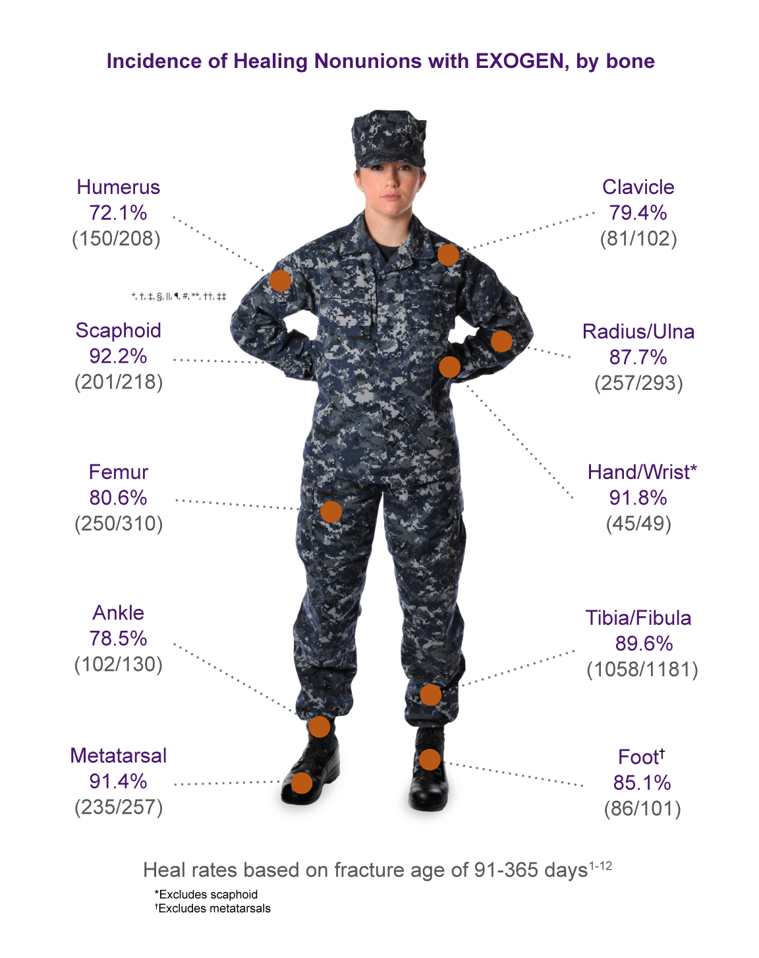
Reference | - Bioventus LLC. Humerus nonunion claims based on EXOGEN Registry. Data on file, RPT-000396. [RPT-000396: p2 tableA]  - Bioventus LLC. Scaphoid nonunion claims based on EXOGEN Registry. Data on file, RPT-000398. [RPT-000398: p2 tableA]  - Bioventus LLC. Femur nonunion claims based on EXOGEN Registry. Data on file, RPT-000395. [RPT-000395: p2 tableA]  - Bioventus LLC. Ankle nonunion claims based on EXOGEN Registry. Data on file, RPT-000408. [RPT-000408: p2 tableA]  - Bioventus LLC. Metatarsal nonunion claims based on EXOGEN Registry. Data on file, RPT-000389. [RPT-000389: p2 tableA]  - Bioventus LLC. Clavicle nonunion claims based on EXOGEN Registry. Data on file, RPT-000409. [RPT-000409: p2 tableA]  - Bioventus LLC. Radius/ulna nonunion claims based on EXOGEN Registry. Data on file, RPT-000410. [RPT-000410: p2 tableA]  - Bioventus LLC. Hand/wrist nonunion claims based on EXOGEN Registry. Data on file, RPT-000411. [RPT-000411: p2 tableA]  - Bioventus LLC. Tibia nonunion claims based on EXOGEN Registry. Data on file, RPT-000391. [RPT-000391: p2 tableA]  - Bioventus LLC. Foot nonunion claims based on EXOGEN Registry. Data on file, RPT-000412. [RPT-000412: p2 tableA]  - Nolte PA, van der Krans A, Patka P, Janssen IM, Ryaby JP, Albers GH. Low-intensity pulsed ultrasound in the treatment of nonunions. J Trauma. 2001;51(4):693‐703. doi:10.1097/00005373-200110000-00012 [Nolte 2001: p1 abstract col3/results; p1 col2 par2-3]

Smoking (Fresh Fractures and Nonunions)

Claim | EXOGEN treatment reduces healing time in smokers with tibial fracture.¹ [Cook 1997: 6a]
Graph [Cook 1997: 6a] | 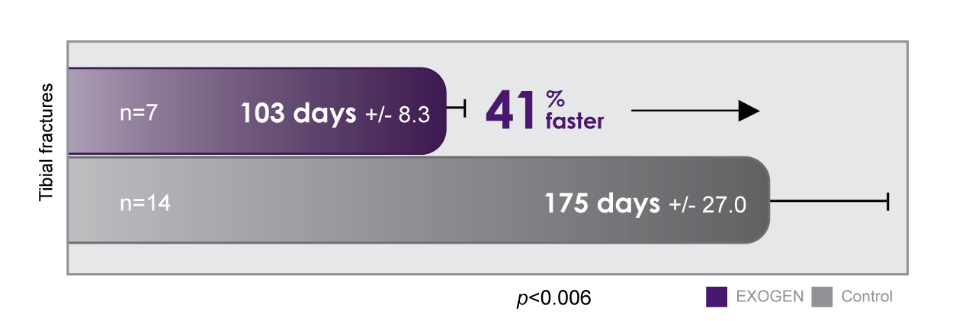
Reference | - Cook SD, Ryaby JP, McCabe J, Frey JJ, Heckman JD, Kristiansen TK. Acceleration of tibia and distal radius fracture healing in patients who smoke. Clin Orthop Relat Res. 1997;(337):198‐207. doi:10.1097/00003086-199704000-00022

Claim | - In a clinical study, no smokers developed a delayed union when treated with EXOGEN for indicated fresh tibial fractures (n=7).¹ [Cook 1997: 9a]  - EXOGEN treatment helps promote healing in patients who smoke.¹ [Cook 1997: 9d, 10c]  - In a clinical study, Cook et al reported that EXOGEN treatment healed tibial fractures more rapidly in current smokers than tibial fractures did in smokers not treated with EXOGEN.¹ [Cook 1997: 5a]  NOTE: Either claim may be used with the reference.
Reference | - Cook SD, Ryaby JP, McCabe J, Frey JJ, Heckman JD, Kristiansen TK. Acceleration of tibia and distal radius fracture healing in patients who smoke. Clin Orthop Relat Res. 1997;(337):198‐207. doi:10.1097/00003086-199704000-00022

Claim | EXOGEN treatment accelerates fracture healing in patients who smoke.¹ [Cook 1997: 5a, 7a]
Graph [Cook 1997: 5a, 7a] | 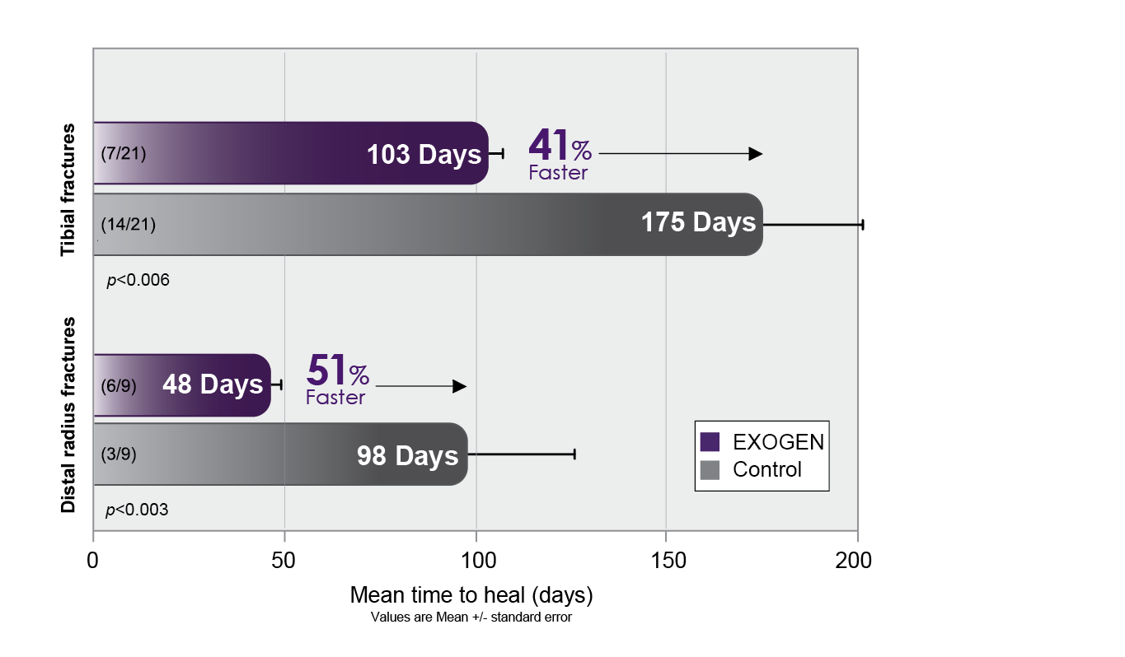
Reference | - Cook SD, Ryaby JP, McCabe J, Frey JJ, Heckman JD, Kristiansen TK. Acceleration of tibia and distal radius fracture healing in patients who smoke. Clin Orthop Relat Res. 1997;(337):198‐207. doi:10.1097/00003086-199704000-00022

Claim | EXOGEN treatment accelerates fracture healing in patients who smoke.¹ [Cook 1997: 5a, 7a]
Graph [Cook 1997: 5a, 7a] | 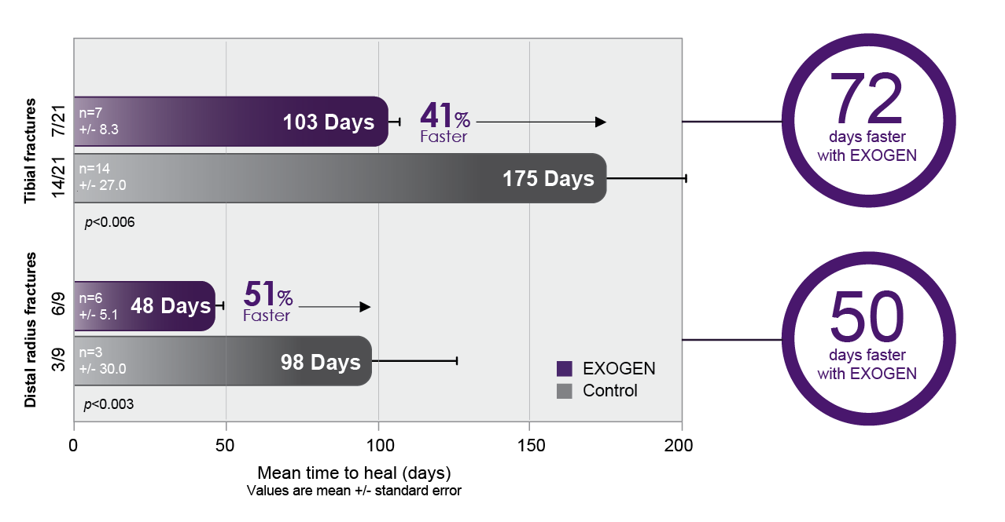
Reference | - Cook SD, Ryaby JP, McCabe J, Frey JJ, Heckman JD, Kristiansen TK. Acceleration of tibia and distal radius fracture in patients who smoke. Clin Orthop Relat Res. 1997;(337):198-207. doi:10.1097/00003086-199704000-00022

Claim | EXOGEN significantly accelerated time to fracture healing for smokers.¹ [Cook 1997: 5a, 7a]
Graph [Cook 1997: 5a, 7a]
Reference | - Cook SD, Ryaby JP, McCabe J, Frey JJ, Heckman JD, Kristiansen TK. Acceleration of tibia and distal radius fracture healing in patients who smoke. Clin Orthop Relat Res. 1997;(337):198‐207. doi:10.1097/00003086-199704000-00022

Claim | - All EXOGEN-treated fractures in smokers healed.¹ [Cook 1997: 3a, 4a-c, 5a-b, 7a-b]  - All EXOGEN-treated tibial fractures in smokers healed.¹ [Cook 1997: 3a, 4a-c, 5a-b, 7b]  - No smokers or ex-smokers with fresh tibial fractures treated with EXOGEN developed a delayed union, versus 33% treated with a placebo.¹ [Cook 1997: 7b, 9b]  - EXOGEN shows positive results in special patient populations, such as smokers and ex-smokers.¹ [Cook 1997: 9d, 10c]  Note: Any of the claims may be used with the reference.
Graph [Cook 1997: 9b] | 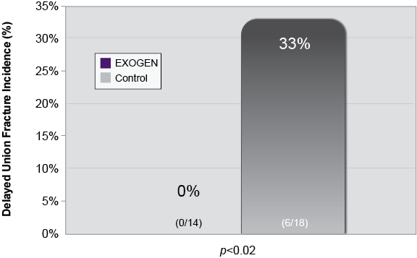
Reference | - Cook SD, Ryaby JP, McCabe J, Frey JJ, Heckman JD, Kristiansen TK. Acceleration of tibia and distal radius fracture healing in patients who smoke. Clin Orthop Relat Res. 1997;(337):198‐207. doi:10.1097/00003086-199704000-00022

Claim | EXOGEN accelerates bone healing in smokers.¹ [Cook 1997: 5a, 7a]
Graph [Cook 1997: 5a, 7a]
Reference | - Cook SD, Ryaby JP, McCabe J, Frey JJ, Heckman JD, Kristiansen TK. Acceleration of tibia and distal radius fracture healing in patients who smoke. Clin Orthop Relat Res. 1997;(337):198‐207. doi:10.1097/00003086-199704000-00022

Claim | High heal rate for femur nonunions in smokers¹ [RPT-000395: pg2/Table 2]
Graph [RPT-000395: pg2/Table 2] | 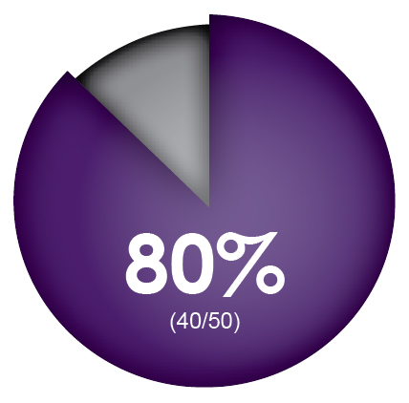
Reference | - Bioventus LLC. Data on file, RPT-000395.

Claim | High heal rate for tibia/fibula nonunions in smokers¹ [RPT-000391: pg2/Table 2]
Graph[RPT-000391: pg2/Table 2] | 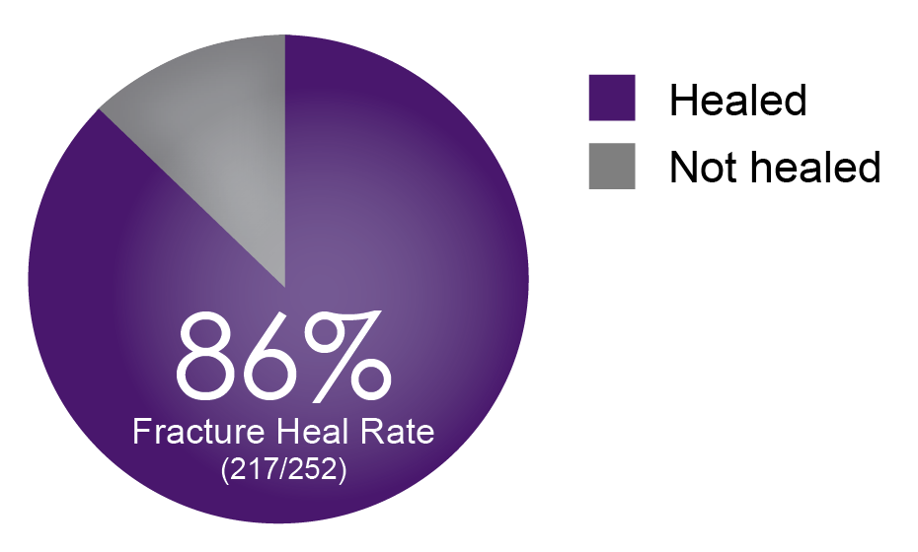
Reference | - Bioventus LLC. Data on file, RPT-000391.

Claim | High heal rate for metatarsal nonunions in smokers¹ [RPT-000389: pg2/Table 2]
Graph [RPT-000389: pg2/Table 2] | 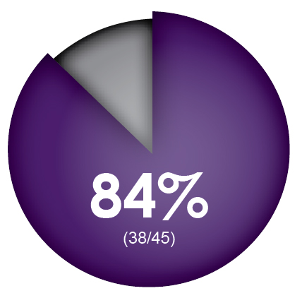
Reference | - Bioventus LLC. Data on file, RPT-000389.

Claim | 82% (9/11) of nonunions in smokers healed with EXOGEN treatment.¹ [Nolte 2001: 6b]
Reference | - Nolte PA, van der Krans A, Patka P, Janssen IM, Ryaby JP, Albers GH. Low-intensity pulsed ultrasound in the treatment of nonunions. J Trauma. 2001;51(4):693‐703. doi:10.1097/00005373-200110000-00012

Claim | 1. EXOGEN heals established nonunions.¹ [Nolte 2001: 6b, 9a]  2. In smokers, EXOGEN healed 82% of established nonunions.¹ [Nolte 2001: 6b]
Graph [Nolte 2001: 6b] | 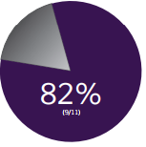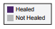
Reference | - Nolte PA, van der Krans A, Patka P, Janssen IM, Ryaby JP, Albers GH. Low-intensity pulsed ultrasound in the treatment of nonunions. J Trauma. 2001;51(4):693‐703. doi:10.1097/00005373-200110000-00012

Claim | Smokers have more than double the risk of developing a nonunion than nonsmokers.¹ [Scolaro 2014: 1a]
Reference | - Scolaro JA, Schenker ML, Yannascoli S, Baldwin K, Mehta S, Ahn J. Cigarette smoking increases complications following fracture: a systematic review. J Bone Joint Surg Am. 2014;96(8):674‐81. doi:10.2106/JBJS.M.00081

Claim | Smoking delays bone healing and increases the risk of nonunion.¹ [Scolaro 2014: 1a-b]
Reference | - Scolaro JA, Schenker ML, Yannascoli S, Baldwin K, Mehta S, Ahn J. Cigarette smoking increases complications following fracture: a systematic review. J Bone Joint Surg Am. 2014;96(8):674‐81. doi:10.2106/JBJS.M.00081

Claim | The risk of nonunions is twice as great in smokers.¹ [Scolaro 2014: 1a-b]
Reference | - Scolaro JA, Schenker ML, Yannascoli S, Baldwin K, Mehta S, Ahn J. Cigarette smoking increases complications following fracture: a systematic review. J Bone Joint Surg Am. 2014;96(8):674‐81. doi:10.2106/JBJS.M.00081

Claim | Nicotine directly affects an array of genes responsible for fracture repair.¹ [Scolaro 2014: 6a, 7a]
Reference | - Scolaro JA, Schenker ML, Yannascoli S, Baldwin K, Mehta S, Ahn J. Cigarette smoking increases complications following fracture: a systematic review. J Bone Joint Surg Am. 2014;96(8):674‐81. doi:10.2106/JBJS.M.00081

Claim | Smoking affects bone healing.^{1,2} [Scolaro 2014: 6a, 7a; Teoh 2018: 1a]
Reference | - Scolaro JA, Schenker ML, Yannascoli S, Baldwin K, Mehta S, Ahn J. Cigarette smoking increases complications following fracture: a systematic review. J Bone Joint Surg Am. 2014;96(8):674‐81. doi:10.2106/JBJS.M.00081  - Teoh KH, Whitham R, Wong JF, Hariharan K. The use of low-intensity pulsed ultrasound in treating delayed union of fifth metatarsal fractures. Foot (Edinb). 2018;35:52-5. doi:10.1016/j.foot.2018.01.004

Claim | In one study, smokers had a correlated cumulative odds ratio of 2.32 for developing a long bone nonunion compared to nonsmokers (n=1121, p<0.001).¹ [Scolaro 2014: 4a]
Reference | - Scolaro JA, Schenker ML, Yannascoli S, Baldwin K, Mehta S, Ahn J. Cigarette smoking increases complications following fracture: a systematic review. J Bone Joint Surg Am. 2014;96(8):674‐81. doi:10.2106/JBJS.M.00081

Claim | - EXOGEN accelerates fracture healing time in smokers:  - Smokers with tibial and distal radius fractures healed 72 and 50 days faster, respectively, compared to placebo-treated subjects.¹ [Cook 1997: 5a, 7a]  - In a comparative study, EXOGEN reduced healing time in smokers with tibial fractures (by 72 days) and distal radius fractures (by 50 days).¹ [Cook 1997: 5a, 7a]
Reference | - Cook SD, Ryaby JP, McCabe J, Frey JJ, Heckman JD, Kristiansen TK. Acceleration of tibia and distal radius fracture healing in patients who smoke. Clin Orthop Relat Res. 1997;(337):198‐207. doi:10.1097/00003086-199704000-00022

Claim | Nicotine hinders fracture healing by inhibiting vascularization at bone healing sites.¹ [Castillo 2005: 1a]
Reference | - Castillo RC, Bosse MJ, MacKenzie EJ, Patterson BM; LEAP Study Group. Impact of smoking on fracture healing and risk of complications in limb-threatening open tibia fractures. J Orthop Trauma. 2005;19(3):151‐7. doi:10.1097/00005131-200503000-00001

Claim | - Current smokers are 37% less likely to achieve union compared to nonsmokers.¹ [Castillo 2005: 1b]  - Former smokers are 32% less likely to achieve union compared to nonsmokers.¹ [Castillo 2005: 1b]
Reference | - Castillo RC, Bosse MJ, MacKenzie EJ, Patterson BM; LEAP Study Group. Impact of smoking on fracture healing and risk of complications in limb-threatening open tibia fractures. J Orthop Trauma. 2005;19(3):151‐7. doi:10.1097/00005131-200503000-00001

Claim | Smoking significantly increases the risk of nonunion of fractures overall, including tibial and open fractures.¹
Reference | - Scolaro JA, Schenker ML, Yannascoli S, Baldwin K, Mehta S, Ahn J. Cigarette smoking increases complications following fracture: a systematic review. J Bone Joint Surg Am. 2014;96(8):674-81. doi: 10.2106/JBJS.M.00081

Claim | EXOGEN mitigates the negative impact of certain comorbidities on bone healing.¹ [EXOGEN User Guide: 13g]  Smoking [Castillo 2005: 1a-c; Scolaro 2014: 1a-b] and advanced age [Heckman 1997: 2b-c, 7c] are just some of the risk factors known to impede fracture healing.²⁻⁴ EXOGEN has been shown to accelerate the fracture healing process for patients with certain comorbidities that can delay fracture healing, putting the fractures at risk of nonunion.⁵ [Cook 1997: 5a, 7a] One clinical study demonstrated that EXOGEN accelerated distal radius fracture healing by as much as 51% in patients who smoked, versus the incidence of healing in smokers with fractures not treated with EXOGEN.*⁵ [Cook 1997: 1a]level  *51% acceleration [EXOGEN (n) = 6; Placebo (n) = 3]
Reference | - Bioventus LLC. EXOGEN® User Guide. Last updated 2020. www.exogen.com/wp-content/uploads/2021/10/81087030-US-2020-User-Guide.pdf  - Castillo RC, Bosse MJ, MacKenzie EJ, Patterson BM; LEAP Study Group. Impact of smoking on fracture healing and risk of complications in limb-threatening open tibia fractures. J Orthop Trauma. 2005;19(3):151‐7. doi:10.1097/00005131-200503000-00001  - Scolaro JA, Schenker ML, Yannascoli S, Baldwin K, Mehta S, Ahn J. Cigarette smoking increases complications following fracture: a systematic review. J Bone Joint Surg Am. 2014;96(8):674-81. doi: 10.2106/JBJS.M.00081  - Heckman JD, Sarasohn-Kahn J. The economics of treating tibia fractures. The cost of delayed unions. Bull Hosp Jt Dis. 1997;56(1):63-72.  - Cook SD, Ryaby JP, McCabe J, Frey JJ, Heckman JD, Kristiansen TK. Acceleration of tibia and distal radius fracture in patients who smoke. Clin Orthop Relat Res. 1997;(337):198‐207. doi:10.1097/00003086-199704000-00022

Mechanism of Action Claims
Note: Throughout this section, if non-clinical (i.e. animal) data is discussed we need to add the following disclaimer for each claim:
*The clinical relevance of preclinical results is unknown.
Claim | Low-intensity, pulsed ultrasound activates bone fracture healing at the molecular level.^{1*} [Naruse 2010: 1a]  The EXOGEN Ultrasound Bone Healing System is a non-invasive orthobiologic that works at the molecular level.^{1-3*} [Naruse 2010: 1a; Tang 2006: 1a-d; EXOGEN User Guide: 3c]  *Add Note: The clinical relevance of preclinical results is unknown.
Reference | - Naruse K, Sekiya H, Harada Y, et al. Prolonged endochondral bone healing in senescence is shortened by low-intensity, pulsed ultrasound in a manner dependent on COX-2. Ultrasound Med Biol. 2010;36(7):1098‐108. doi:10.1016/j.ultrasmedbio.2010.04.011  - Tang CH, Yang RS, HuangHuang TH, et al. UltrasoundUltrasound stimulates cyclooxygenase-2 expression and increasesincreases bone formation through integrin, focal adhesion kinase, phosphatidylinositol 3-kinase, and Akt pathway in osteoblasts. Mol Pharmacol. 2006;69(6):2047‐57. doi:10.1124/mol.105.022160  - Bioventus LLC. EXOGEN® User Guide. Last updated 2020. www.exogen.com/wp-content/uploads/2021/10/81087030-US-2020-User-Guide.pdf

Claim | EXOGEN Mechanism of Action  Stimulation: EXOGEN sends ultrasound waves through the skin and soft tissue to the fracture.^{1*} [Greenleaf 2003 (abstract only): 2a]  Activation: EXOGEN ultrasound activates cell surface mechanoreceptors called integrins, initiating an intracellular cascade that leads to upregulation.^{3*} [Tang 2006: 1a-c]  Upregulation: EXOGEN ultrasound increases expression of genes and proteins critical to bone healing.^{2-6*} [Naruse 2010: 1a, 6a-d; Tang 2006: 1a-c; Leung 2004b: 1a, 4a; Coords 2011: 1a; Sant’Anna 2005: 1a]  *Add Note: The clinical relevance of preclinical results is unknown.
Graph  [Greenleaf 2003 (abstract only): 2a; Naruse 2010: 6b-d; Tang 2006: 1a-c; Leung 2004b: 1a, 4a, 3a, 5a-b; Coords 2011: 1a; Sant’Anna 2005: 1a; Schofer 2010] | 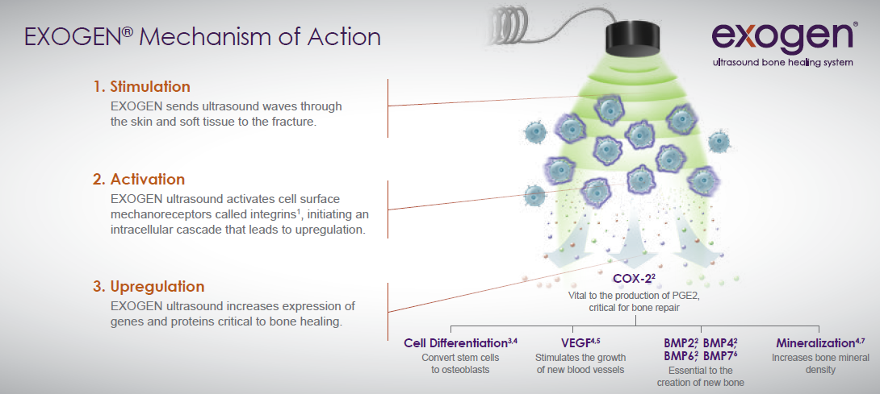
Reference | - Greenleaf JF, Kinnick RR, Bronk JT, Bolander M. Ultrasonically induced tissue motion during fracture treatment? Ultrasound Med Biol. 2003;29(5):S157-8. doi:10.1016/S0301-5629(03)00634-3  - Naruse K, Sekiya H, Harada Y, et al. Prolonged endochondral bone healing in senescence is shortened by low-intensity pulsed ultrasound in a manner dependent on COX-2. Ultrasound Med Biol. 2010;36(7):1098‐108. doi:10.1016/j.ultrasmedbio.2010.04.011  - Tang CH, Yang RS, Huang TH, et al. Ultrasound stimulates cyclooxygenase-2 expression and increases bone formation through integrin, focal adhesion kinase, phosphatidylinositol 3-kinase, and Akt pathway in osteoblasts. Mol Pharmacol. 2006;69(6):2047‐57. doi:10.1124/mol.105.022160  - Leung KS, Cheung WH, Zhang C, Lee KM, Lo HK. Low intensity pulsed ultrasound stimulates osteogenic activity of human periosteal cells. Clin Orthop Relat Res. 2004;(418):253‐9. doi:10.1097/00003086-200401000-00044  - Coords M, Breitbart E, Paglia D, et al. The effects of low-intensity pulsed ultrasound upon diabetic fracture healing. J Orthop Res. 2011;29(2):181‐8. doi:10.1002/jor.21223  - Sant'Anna EF, Leven RM, Virdi AS, Sumner DR. Effect of low intensity pulsed ultrasound and BMP-2 on rat bone marrow stromal cell gene expression. J Orthop Res. 2005;23(3):646‐52. doi:10.1016/j.orthres.2004.09.007  - R7. Schofer MD, Block JE, Aigner J, Schmelz A. Improved healing response in delayed unions of the tibia with low-intensity pulsed ultrasound: results of a randomized sham-controlled trial. BMC Musculoskelet Disord. 2010;11:229. doi:10.1186/1471-2474-11-229

Claim | - EXOGEN treatment accelerates fracture healing at every stage, with maximum benefit achieved when applied throughout the entire healing process.^{1*} [Azuma 2001: 1a, 4a-b, 5a-f, 6a-b]  - EXOGEN enhances bone healing at every stage.^{1*} [Azuma 2001: 1a, 4a-b, 5a-f, 6a-b]  - EXOGEN accelerates healing throughout the fracture healing process.^{1*} [Azuma 2001: 1a, 4a-b, 5a-f, 6a-b]  - In an animal model, the biomechanical strength of EXOGEN-treated femurs was significantly greater than placebo controls, even when treatment was limited to one phase of fracture repair.¹ [Azuma 2001: 1a, 4a]  *Add Note: The clinical relevance of preclinical results is unknown.
Graph [Azuma 2001: 1a, 4a] | 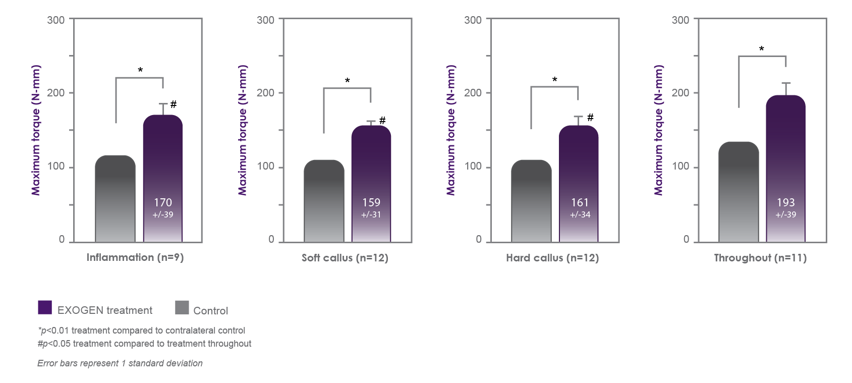  Maximum torsional torque of the EXOGEN-treated femurs was significantly greater than the placebo controls at each phase of fracture healing in an animal model. ¹* [Azuma 2001: 1a, 4a]  *Add Note: The clinical relevance of these findings is unknown.
Reference | - Azuma Y, Ito M, Harada Y, Takagi H, Ohta T, Jingushi S. Low-intensity pulsed ultrasound accelerates rat femoral fracture healing by acting on the various cellular reactions in the fracture callus. J Bone Miner Res. 2001;16(4):671‐80. doi:10.1359/jbmr.2001.16.4.671

Claim | In preclinical studies, EXOGEN has been shown to accelerate healing at each stage of the fracture healing process, with maximum benefit achieved when applied throughout the entire healing process.*¹ [Azuma 2001: 1a, 4a-b, 5a-f, 6a-b]
Graph [Azuma 2001: 1a, 4a] | *Add Note: The clinical relevance of these findings is unknown.
Reference | - Azuma Y, Ito M, Harada Y, Takagi H, Ohta T, Jingushi S. Low-intensity pulsed ultrasound accelerates rat femoral fracture healing by acting on the various cellular reactions in the fracture callus. J Bone Miner Res. 2001;16(4):671‐80. doi:10.1359/jbmr.2001.16.4.671

Claim | EXOGEN accelerates fracture healing at every stage.¹ [Azuma 2001: 1a, 4a-b, 5a-f, 6a-b]  The fracture repair process is divided into four stages: inflammation, soft callus formation, hard callus formation, and remodeling.^{2,3} [Schindeler 2008: 1a; Sheen 2021: 1a] EXOGEN treatment has been shown to accelerate fracture healing at every stage, with maximum benefit achieved when applied throughout the entire healing process.*¹ [Azuma 2001: 1a, 4a-b, 5a-f, 6a-b]  *The clinical relevance of these findings is unknown.
Graph [Azuma 2001: 1a, 4a]
Reference | - Azuma Y, Ito M, Harada Y, Takagi H, Ohta T, Jingushi S. Low-intensity pulsed ultrasound accelerates rat femoral fracture healing by acting on the various cellular reactions in the fracture callus. J Bone Miner Res. 2001;16(4):671‐80. doi:10.1359/jbmr.2001.16.4.671  - Schindeler A, McDonald MM, Bokko P, Little DG. Bone remodeling during fracture repair: the cellular picture. Semin Cell Dev Biol. 2008;19(5):459-66. doi:10.1016/j.semcdb.2008.07.004  - Sheen JR, Garla VV. Fracture healing overview. In: StatPearls. Treasure Island (FL): StatPearls Publishing; May 12, 2021.

Claim | EXOGEN at every stage of the fracture healing process*
Graph | 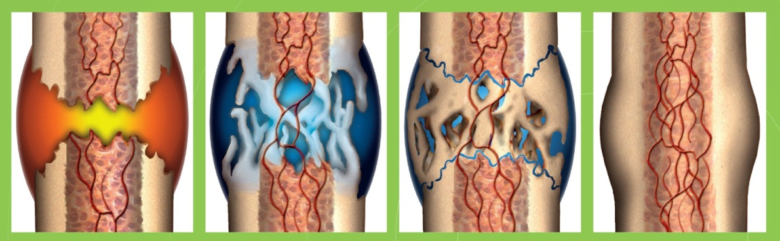  Inflammation Soft Callus Hard Callus Bone Remodeling  Inflammation Stage  EXOGEN's ultrasound signal increases cell division among periosteal cells in culture and upregulates growth factors that trigger formation of new blood vessels.^{1,2} [Leung 2004b: 1a; EXOGEN User Guide: 14e-f]  Soft Callus Stage  The ultrasound treatment enhances the TGFβ-triggered differentiation of chondrocytes in culture and accelerates formation of the extracellular matrix.³⁻⁵ [Ebisawa 2004: 1a; Lai 2010: 1a-b, 5a, 9a-b; Mukai 2005: 1a; 4a-d, 5 a-b]  Hard Callus Stage  EXOGEN upregulates endochondral ossification [Freeman 2009: 5a; Schofer 2010: 1a] and enhances osteoblast differentiation [Wu 2009: 3a-b] and mineralization.^{2,6-9} [Tang 2006: 1a-c; EXOGEN User Guide: 14f]  Bone Remodeling Stage  Accelerating both the formation and resorption of bone, EXOGEN ultrasound treatment yields faster remodeling of the mineralized callus.⁶ [Freeman 2009: 5b]  *Add Note: The clinical relevance of these findings is unknown
Reference | - Leung KS, Cheung WH, Zhang C, Lee KM, Lo HK. Low intensity pulsed ultrasound stimulates osteogenic activity of human periosteal cells. Clin Orthop Relat Res. 2004;(418):253‐9. doi:10.1097/00003086-200401000-00044  - Bioventus LLC. EXOGEN® User Guide. Last updated 2020. www.exogen.com/wp-content/uploads/2021/10/81087030-US-2020-User-Guide.pdf  - Ebisawa K, Hata K, Okada K, et al. Ultrasound enhances transforming growth factor ß-mediated chondrocyte differentiation of human mesenchymal stem cells. Tissue Eng. 2004;10(5-6):921-9. doi:10.1089/1076327041348437  - Lai CH, Chen SC, Chiu LH, et al. Effects of low-intensity pulsed ultrasound, dexamethasone/TGF-beta1 and/or BMP-2 on the transcriptional expression of genes in human mesenchymal stem cells: chondrogenic vs. osteogenic differentiation. Ultrasound Med Biol. 2010;36(6):1022‐33. doi:10.1016/j.ultrasmedbio.2010.03.014  - Mukai S, Ito H, Nakagawa Y, Akiyama H, Miyamoto M, Nakamura T. Transforming growth factor-ß1 mediates the effects of low-intensity pulsed ultrasound in chondrocytes. Ultrasound Med Biol. 2005;31(12):1713‐21. doi:10.1016/j.ultrasmedbio.2005.07.012  - Freeman TA, Patel P, Parvizi J, Antoci V Jr, Shapiro IM. Micro-CT analysis with multiple thresholds allows detection of bone formation and resorption during ultrasound-treated fracture healing. J Orthop Res. 2009;27(5):673-9. doi:10.1002/jor.20771  - Schofer MD, Block JE, Aigner J, Schmelz A. Improved healing response in delayed unions of the tibia with low-intensity pulsed ultrasound: results of a randomized sham-controlled trial. BMC Musculoskelet Disord. 2010;11:229. doi:10.1186/1471-2474-11-229229  - Wu S, Kawahara Y, Manabe T, et al. Low-intensity pulsed ultrasound accelerates osteoblast differentiation and promotes bone formation in an osteoporosis rat model. Pathobiology. 2009:76(3);99-107. doi:10.1159/000209387  - Tang CH, Yang RS, Huang TH, et al. Ultrasound stimulates cyclooxygenase-2 expression and increases bone formation through integrin, focal adhesion kinase, phosphatidylinositol 3-kinase, and Akt pathway in osteoblasts. Mol Pharmacol. 2006;69(6):2047‐57. doi:10.1124/mol.105.022160

Claim | Inside the body’s natural bone healing processes*
Graph | 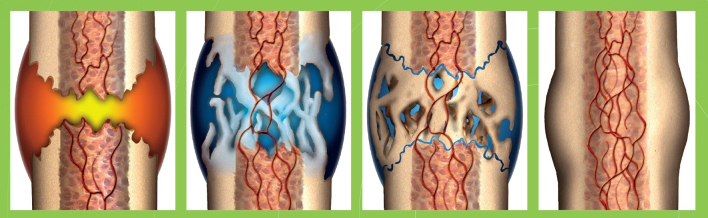  Inflammation Soft Callus Hard Callus Bone Remodeling  Inflammation  When a bone breaks, white blood cells move in to clean up debris created by the break. This creates inflammation, which triggers the growth of new blood cells—the first stage of healing.¹⁻³ [Sheen 2021: 1a-b; Shindeler 2008: 1a, 2a-b; ACFAS Bone Healing: 1a]  Soft Callus  Blood cells divide and multiply near the break and new blood vessels develop to fuel the repair process. The body also begins to create fibrous tissue to bridge the break in the bone. This fibrous material is called the soft callus.¹⁻³ [Sheen 2021: 1c, 2a; Shindeler 2008: 1a, 2c, 3a; ACFAS Bone Healing: 1b]  Hard Callus  The body gradually replaces the soft callus with a hard callus, connecting the bone fragments more solidly. This stronger callus, which creates a bulge at the site of the fracture, can generally be seen in X-rays just a few weeks after the fracture occurs.¹⁻³ [Sheen 2021: 2b; Shindeler 2008: 1a, 3b; ACFAS Bone Healing: 1b]  Bone Remodeling  In the final stage of bone fracture healing, the body replaces old bone with new bone tissue in a process called remodeling. Remodeling makes bones stronger and more compact and improves blood circulation in the bone.¹⁻³ [Sheen 2021: 2c-d; Shindeler 2008: 3c; ACFAS Bone Healing: 1c]*  *Add Note: The clinical relevance of in vivo findings is unknown.
Reference | - Sheen JR, Garla VV. Fracture healing overview. In: StatPearls. Treasure Island (FL): StatPearls Publishing; May 12, 2021.  - Schindeler A, McDonald MM, Bokko P, Little DG. Bone remodeling during fracture repair: the cellular picture. Semin Cell Dev Biol. 2008;19(5):459-66. doi:10.1016/j.semcdb.2008.07.004  - American College of Foot and Ankle Surgeons. Patient education: bone healing. Posted 2010. https://affc.com/wp-content/uploads/2019/06/Bone_Healing.pdf

Claim | Stages of Bone Healing
Graph | Inflammation Soft Callus Hard Callus Bone Remodeling  Inflammation  When a bone breaks, white blood cells move in to clean up debris created by the break. This creates inflammation, which triggers the growth of new blood cells—the first stage of healing.¹⁻³ [Sheen 2021: 1a-b; Shindeler 2008: 1a, 2a-b; ACFAS Bone Healing: 1a]  Soft Callus  Blood cells divide and multiply near the break, and new blood vessels develop to fuel the repair process. The body also begins to create fibrous tissue to bridge the break in the bone. This fibrous material is called the soft callus.¹⁻³ [Sheen 2021: 1c, 2a; Shindeler 2008: 1a, 2c, 3a; ACFAS Bone Healing: 1b]  Hard Callus  The body gradually replaces the soft callus with a hard callus, connecting the bone fragments more solidly. This stronger callus, which creates a bulge at the site of the fracture, can generally be seen in X-rays just a few weeks after the fracture occurs.¹⁻³ [Sheen 2021: 2b; Shindeler 2008: 1a, 3b; ACFAS Bone Healing: 1b]  Bone Remodeling  In the final stage of bone fracture healing, the body replaces old bone with new bone tissue in a process called remodeling. Remodeling makes bones stronger and more compact and improves blood circulation in the bone.¹⁻³ [Sheen 2021: 2c-d; Shindeler 2008: 3c; ACFAS Bone Healing: 1c]
Reference | - Sheen JR, Garla VV. Fracture healing overview. In: StatPearls. Treasure Island (FL): StatPearls Publishing; May 12, 2021.  - Schindeler A, McDonald MM, Bokko P, Little DG. Bone remodeling during fracture repair: the cellular picture. Semin Cell Dev Biol. 2008;19(5):459-66. doi:10.1016/j.semcdb.2008.07.004  - American College of Foot and Ankle Surgeons. Patient education: bone healing. Posted 2010. https://affc.com/wp-content/uploads/2019/06/Bone_Healing.pdf.

Claim | The EXOGEN signal is able to treat many fracture types, as per labeling.¹ [EXOGEN User Guide: 3a; Zura 2015].
Reference | R1. Bioventus LLC. EXOGEN® User Guide. Last updated 2020. www.exogen.com/wp-content/uploads/2021/10/81087030-US-2020-User-Guide.pdf  R2. Zura R, Della Rocca GJ, Mehta S, et al. Treatment of chronic (>1 year) fracture nonunion: heal rate in a cohort of 767 patients treated with low-intensity pulsed ultrasound (LIPUS). Injury. 2015;46(10):2036‐41. doi:10.1016/j.injury.2015.05.042

Claim | - Because the ultrasound waves travel easily through adipose tissue, it is suggested that EXOGEN therapy is effective for both patients with a normal body weight, as well as patients who are overweight or obese.¹  - Depth and breadth of penetration:  - Beam reaches a depth of up to 25.0 cm (10 inches).¹ [RPT-000368: p23 table row1-3]  - Effective diameter of the ultrasound beam is more than 5 cm (2 inches).¹ [RPT-000368: p23 table row1-3]  - The therapeutic span is 3.3 cm, even after passing through 20 cm of soft tissue.¹
Reference | - Bioventus LLC. EXOGEN ultrasound signal depth and penetration. Data on file, RPT-000368.

Claim | In an animal model of diabetic fracture healing, EXOGEN was shown to enhance angiogenesis, restoring a normal density of new blood vessels at the fracture site.^{1*} [Coords 2011: 1a]  *Add Note: The clinical relevance of in vivo findings is unknown.
Reference | - Coords M, Breitbart E, Paglia D, et al. The effects of low-intensity pulsed ultrasound upon diabetic fracture healing. J Orthop Res. 2011;29(2):181‐8. doi:10.1002/jor.21223

Claim | Preclinical models show that EXOGEN increases vascular endothelial growth factor expression (VEGF) at the fracture site,¹ influencing blood vessel formation.^{2,3*} [Naruse 2010: 8a; Coords 2011: 1a, 5a-c, Leung 2004b: 1a]  *Add Note: The clinical relevance of preclinical findings is unknown.
Reference | - Naruse K, Sekiya H, Harada Y, et al. Prolonged endochondral bone healing in senescence is shortened by low-intensity pulsed ultrasound in a manner dependent on COX-2. Ultrasound Med Biol. 2010;36(7):1098‐108. doi:10.1016/j.ultrasmedbio.2010.04.011  - Coords M, Breitbart E, Paglia D, et al. The effects of low-intensity pulsed ultrasound upon diabetic fracture healing. J Orthop Res. 2011;29(2):181‐8. doi:10.1002/jor.21223  - Leung KS, Cheung WH, Zhang C, Lee KM, Lo HK. Low intensity pulsed ultrasound stimulates osteogenic activity of human periosteal cells. Clin Orthop Relat Res. 2004;(418):253‐9. doi:10.1097/00003086-200401000-00044

Claim | In vitro and in vivo studies suggest EXOGEN upregulates the expression of vascular endothelial growth factor (VEGF) in osteoblasts and periosteal cells.^{1,2*} [Leung 2004b: 1a; EXOGEN User Guide: 14e-f]  *Add Note: The clinical relevance of preclinical findings has not yet been established.
Reference | - Leung KS, Cheung WH, Zhang C, Lee KM, Lo HK. Low intensity pulsed ultrasound stimulates osteogenic activity of human periosteal cells. Clin Orthop Relat Res. 2004;(418):253‐9. doi:10.1097/00003086-200401000-00044  - Bioventus LLC. EXOGEN® User Guide. Last updated 2020. www.exogen.com/wp-content/uploads/2021/10/81087030-US-2020-User-Guide.pd

Claim | Preclinical studies show that EXOGEN upregulates VEGF, angiogenesis, and chondrogenesis.^{1-3*} [Coords 2011: 4a-b, 5a-b; Azuma 2001: 1a; Leung 2004b: 1a]  *Add Note: The clinical relevance of preclinical findings has not yet been established.
Reference | - Coords M, Breitbart E, Paglia D, et al. The effects of low-intensity pulsed ultrasound upon diabetic fracture healing. J Orthop Res. 2011;29(2):181‐8. doi:10.1002/jor.21223  - Azuma Y, Ito M, Harada Y, Takagi H, Ohta T, Jingushi S. Low-intensity pulsed ultrasound accelerates rat femoral fracture healing by acting on the various cellular reactions in the fracture callus. J Bone Miner Res. 2001;16(4):671‐80. doi:10.1359/jbmr.2001.16.4.671  - Leung KS, Cheung WH, Zhang C, Lee KM, Lo HK. Low intensity pulsed ultrasound stimulates osteogenic activity of human periosteal cells. Clin Orthop Relat Res. 2004;(418):253‐9. doi:10.1097/00003086-200401000-00044

Claim | In vitro and in vivo studies show EXOGEN upregulates the expression of VEGF in osteoblasts and periosteal cells, [Leung 2004: 1a; EXOGEN User Guide: 14e-f; Coords 2011: 5a] leading to increased aggrecan and proteoglycan synthesis in chondrocytes.^{1-5*} [Ebisawa 2004: 1a; Parvizi 1999: 4a, 5a-b]  *Add Note: In vitro data only; the clinical relevance of these findings is unknown.
Reference | - Leung KS, Cheung WH, Zhang C, Lee KM, Lo HK. Low intensity pulsed ultrasound stimulates osteogenic activity of human periosteal cells. Clin Orthop Relat Res. 2004;(418):253‐9. doi:10.1097/00003086-200401000-00044R1  - Bioventus LLC. EXOGEN® User Guide. Last updated 2020. www.exogen.com/wp-content/uploads/2021/10/81087030-US-2020-User-Guide.pd  - Coords M, Breitbart E, Paglia D, et al. The effects of low-intensity pulsed ultrasound upon diabetic fracture healing. J Orthop Res. 2011;29(2):181‐8. doi:10.1002/jor.21223  - Ebisawa K, Hata K, Okada K, et al. Ultrasound enhances transforming growth factor ß-mediated chondrocyte differentiation of human mesenchymal stem cells. Tissue Eng. 2004;10(5-6):921-9. doi: 10.1089/1076327041348437  - Parvizi J, Wu C, Lewallen DG, Greenleaf JF, Bolander ME. Low intensity ultrasound stimulates proteoglycan synthesis in rat chondrocytes by increasing aggrecan gene expression. J Orthop Res. 1999;17(4):488-94. doi:10.1002/jor.1100170405

Claim | Preclinical studies show that EXOGEN increases the level of growth factors such as VEGF that stimulate new blood vessel formation.^{1,2*} [Leung 2004: 1a; Coords 2011: 1a]  *Add Note: The clinical relevance of these results has not yet been established.
Reference | - Leung KS, Cheung WH, Zhang C, Lee KM, Lo HK. Low intensity pulsed ultrasound stimulates osteogenic activity of human periosteal cells. Clin Orthop Relat Res. 2004;(418):253‐9. doi:10.1097/00003086-200401000-00044  - Coords M, Breitbart E, Paglia D, et al. The effects of low-intensity pulsed ultrasound upon diabetic fracture healing. J Orthop Res. 2011;29(2):181‐8. doi:10.1002/jor.21223

Claim | EXOGEN increases levels of BMP-2, BMP-4, BMP-6, BMP-7, alkaline phosphatase, MMP-13, collagen type 10, COX-2, and PGE2.^{1,2*} [Naruse 2010: 6a-d, 8a-b; Sant’Anna 2005: 1a]  *Add Note: The clinical relevance of preclinical findings has not yet been established.
Reference | - Naruse K, Sekiya H, Harada Y, et al. Prolonged endochondral bone healing in senescence is shortened by low-intensity pulsed ultrasound in a manner dependent on COX-2. Ultrasound Med Biol. 2010;36(7):1098‐108. doi:10.1016/j.ultrasmedbio.2010.04.011  - Sant'Anna EF, Leven RM, Virdi AS, Sumner DR. Effect of low intensity pulsed ultrasound and BMP-2 on rat bone marrow stromal cell gene expression. J Orthop Res. 2005;23(3):646‐52. doi:10.1016/j.orthres.2004.09.007

Claim | Preclinical studies have shown that EXOGEN increases levels of BMP-2, BMP-4, BMP-6, and BMP-7; these proteins are essential signals that trigger the formation of new bone tissue.^{1,2*} [Naruse 2010: 6a-d; Sant’Anna 2005: 1a-b]  *Add Note: The clinical relevance of these preclinical findings has not yet been established.
Reference | - Naruse K, Sekiya H, Harada Y, et al. Prolonged endochondral bone healing in senescence is shortened by low-intensity pulsed ultrasound in a manner dependent on COX-2. Ultrasound Med Biol. 2010;36(7):1098‐108. doi:10.1016/j.ultrasmedbio.2010.04.011  - Sant'Anna EF, Leven RM, Virdi AS, Sumner DR. Effect of low intensity pulsed ultrasound and BMP-2 on rat bone marrow stromal cell gene expression. J Orthop Res. 2005;23(3):646‐52. doi:10.1016/j.orthres.2004.09.007

Claim | EXOGEN stimulates formation of chondrocytes and osteoblasts, and helps accelerate the formation of new bone tissue in a rat model.^{1*} [Fávaro-Pípi 2010: 1a, 2a]  *Add Note: The clinical relevance of these preclinical findings has not yet been established.
Reference | - Fávaro-Pípi E, Bossini P, de Oliveira P, et al. Low-intensity pulsed ultrasound produced an increase of osteogenic genes expression during the process of bone healing in rats. Ultrasound Med Biol. 2010;36(12):2057‐64. doi:10.1016/j.ultrasmedbio.2010.07.012

Claim | - COX-2 produces PGE2, which is required for normal fracture healing.¹ [Naruse 2010: 8b]  - EXOGEN increases expression of COX-2 at the fracture site. This increase in COX-2 expression is vital to the production of PGE2, which is critical to multiple steps in the fracture repair process in an animal model.^{1*} [Naruse 2010: 8b]  *Add Note: The clinical relevance of these preclinical findings has not yet been established.
Reference | - Naruse K, Sekiya H, Harada Y, et al. Prolonged endochondral bone healing in senescence is shortened by low-intensity pulsed ultrasound in a manner dependent on COX-2. Ultrasound Med Biol. 2010;36(7):1098‐108. doi:10.1016/j.ultrasmedbio.2010.04.011

Claim | EXOGEN uses low-intensity pulsed ultrasound to stimulate a cascade of cellular reactions.¹ [Harrison 2016: 5a, 6a, 7b]  EXOGEN uses an ultrasound, mechanical pressure wave, composed of 1,000 pulses per second, to stimulate a response at the cellular level.² [EXOGEN User Guide: 14a-b,d] The ultrasound wave has an intensity of 30 mW/cm², [Harrison 2016: 5b] which is comparable to fetal sonography.^{1,2} [EXOGEN User Guide: 14c] The ultrasound wave penetrates up to 25 cm (10 inches) into the body, [RPT-000368: p23 table row1-3] and is safe to use with metal fixation.^{3,4} [Lehman 1959: 1a] After contacting the bone, the mechanical pressure wave creates a nanomotion at the fracture site, producing a reaction at the cellular level.¹ [Harrison 2016: 5a]
Graph [Harrison 2016: 5a] | 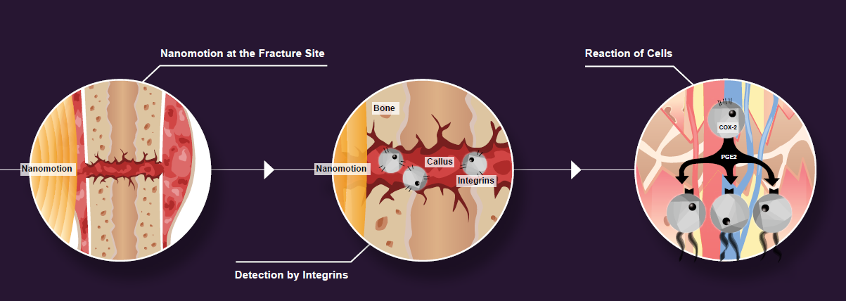
Reference | - Harrison A, Lin S, Pounder N, Mikuni-Takagaki Y. Mode & mechanism of low intensity pulsed ultrasound (LIPUS) in fracture repair. Ultrasonics. 2016;70:45‐52. doi:10.1016/j.ultras.2016.03.016  - Bioventus LLC. EXOGEN® User Guide. Last updated 2020. www.exogen.com/wp-content/uploads/2021/10/81087030-US-2020-User-Guide.pdf  - Bioventus LLC. EXOGEN ultrasound signal depth and penetration. Data on file, RPT-000368.  - Lehmann JF, Brunne GD, Martinis AJ, McMillan J. Ultrasonic effects as demonstrated in live pigs with surgical metallic implants. Arch Phys Med Rehabil. 1959;40:483-8.

Claim | EXOGEN uses low-intensity pulsed ultrasound to stimulate a cascade of cellular reactions.^{1,2} [Tang 2006: 1a-c, 10a; Harrison 2016: 5a, 6a, 7b]
Graph [Harrison 2016: 5a]
Reference | - Tang CH, Yang RS, Huang TH, et al. Ultrasound stimulates cyclooxygenase-2 expression and increases bone formation through integrin, focal adhesion kinase, phosphatidylinositol 3-kinase, and Akt pathway in osteoblasts. Mol Pharmacol. 2006;69(6):2047‐57. doi:10.1124/mol.105.022160  - Harrison A, Lin S, Pounder N, Mikuni-Takagaki Y. Mode & mechanism of low intensity pulsed ultrasound (LIPUS) in fracture repair. Ultrasonics. 2016;70:45‐52. doi:10.1016/j.ultras.2016.03.016

Claim | EXOGEN complements your treatment.  Four factors contribute to the process of bone restoration after fracture: osteoconductive scaffold, mechanical environment, osteogenic cells, and growth factors. These form the diamond concept of bone healing.¹ [Giannoudis 2007: 1a, 3a] Traditional fracture treatment can impact two of the four factors: osteoconductive scaffold and the mechanical environment. EXOGEN can complement treatment by stimulating the development of osteogenic cells and the expression of growth factors such as VEGF, BMP-2, and BMP-7.^{2,3*} [Naruse 2010: 6b-d; Sant’Anna 2005: 1a]  *Add Note: The clinical relevance of these preclinical findings has not yet been established.  You treat the injury, EXOGEN works on the biology.
Reference | - Giannoudis PV, Einhorn TA, March D. Fracture healing: the diamond concept. Injury. 2007;38(suppl 4):S3‐6. doi:10.1016/s0020-1383(08)70003-2  - Naruse K, Sekiya H, Harada Y, et al. Prolonged endochondral bone healing in senescence is shortened by low-intensity pulsed ultrasound in a manner dependent on COX-2. Ultrasound Med Biol. 2010;36(7):1098‐108. doi:10.1016/j.ultrasmedbio.2010.04.011  - Sant’Anna EF, Leven RM, Virdi AS, Sumner DR. Effect of low intensity pulsed ultrasound and BMP-2 on rat bone marrow stromal cell gene expression. J Orthop Res. 2005;23(3):646‐52. doi:10.1016/j.orthres.2004.09.007

Graph | 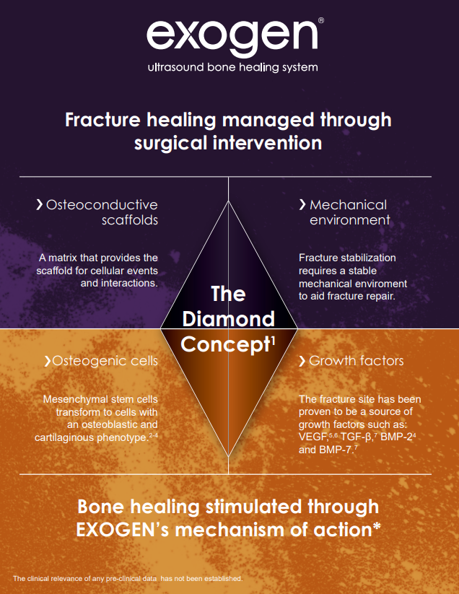  [Giannoudis 2007: 1a, 3a; Leung 2004b: 1a; Lai 2010: 1b; Ebisawa 2004: 1a; Naruse 2010: 6b-d; Coords 2010: 1a, 5a-b; Sant’Anna 2005: 1a]
Reference | - Giannoudis PV, Einhorn TA, Marsh D. Fracture healing: the diamond concept. Injury. 2007:38 (suppl 4);S3-6. doi:10.1016/s0020-1383(08)70003-2  - Leung KS, Cheung WH, Zhang C, Lee KM, Lo HK. Low intensity pulsed ultrasound stimulates osteogenic activity of human periosteal cells. Clin Orthop Relat Res. 2004;(418):253-9. doi: 10.1097/00003086-200401000-00044  - Lai CH, Chen SC, Chiu LH, et al. Effects of low-intensity pulsed ultrasound, dexamethasone/ TGF-ß1 and/or BMP-2 on the transcriptional expression of genes in human mesenchymal stem cells: chondrogenic vs. osteogenic differentiation. Ultrasound Med Biol. 2010;36(6):1022-33. doi:10.1016/j.ultrasmedbio.2010.03.014  - Ebisawa K, Hata K, Okada K, et al. Ultrasound enhances transforming growth factor ß-mediated chondrocyte differentiation of human mesenchymal stem cells. Tissue Eng. 2004;10(5-6):921-9. doi:10.1089/1076327041348437  - Naruse K, Sekiya H, Harada Y, et al. Prolonged endochondral bone healing in senescence is shortened by low-intensity pulsed ultrasound in a manner dependent on COX-2. Ultrasound Med Biol. 2010;36(7):1098-108. doi:10.1016/j.ultrasmedbio.2010.04.011  - Coords M, Breitbart E, Paglia D, et al. The effects of low-intensity pulsed ultrasound upon diabetic fracture healing. J Orthop Res. 2011;29(2):181-8. doi:10.1002/jor.21223  - Sant’Anna EF, Leven RM, Virdi AS, Sumner DR. Effect of low intensity pulsed ultrasound and BMP-2 on rat bone marrow stromal cell gene expression. J Orthop Res. 2005;23(3):646-52. doi:10.1016/j.orthres.2004.09.007

Health Economic Claims

Claim | - Economic research shows 40% to 50% cost savings with EXOGEN.^{1,2} [Heckman 1997: 7a,c-d; Mehta 2015: 7b]  - Analyses demonstrate that EXOGEN can save 40% to 50% in healthcare costs by shortening healing time and significantly reducing the incidence of a delayed union.^{1,2} [Heckman 1997: 7a,c-d; Mehta 2015: 7b]  - Greater than 40% cost savings versus the costs of surgical intervention^{1,2} [Heckman 1997: 7a,c-d; Mehta 2015: 7b]  - Reduces treatment costs associated with certain fractures¹⁻⁴ [Heckman 1997: 7a,c-d; Mehta 2015: 7b; Majeed 2020: 4a-b; Teoh 2018: 3a-b]
Reference | - Heckman JD, Sarasohn-Kahn J. The economics of treating tibia fractures. The cost of delayed unions. Bull Hosp Jt Dis. 1997;56(1):63-72.  - Mehta S, Long K, DeKoven M, Smith E, Steen RG. Low-intensity pulsed ultrasound (LIPUS) can decrease the economic burden of fracture non-union. J Med Econ. 2015;18(7):542‐9. doi:10.3111/13696998.2015.1019887  - Majeed H, Karim T, Davenport J, Karski M, Smith R, Clough TM. Clinical and patient-reported outcomes following Low Intensity Pulsed Ultrasound (LIPUS, Exogen) for established post-traumatic and post-surgical nonunion in the foot and ankle. Foot Ankle Surg. 2020;26(4):405-11. doi:10.1016/j.fas.2019.05.009  - Teoh KH, Whitham R, Wong JF, Hariharan K. The use of low-intensity pulsed ultrasound in treating delayed union of fifth metatarsal fractures. Foot (Edinb). 2018;35:52-5. doi:10.1016/j.foot.2018.01.004

Claim | - In the year following treatment with EXOGEN, patients with nonunion fractures incurred direct, overall medical costs that were 51% lower than that of surgery-only patients.¹ [Mehta 2015: 7b]  - In the year following treatment with EXOGEN, patients with nonunion fractures incurred outpatient costs that were 54% lower than costs for surgery-only patients.¹ [Mehta 2015: 7b]  - In the year following treatment with EXOGEN, patients with non-unions incurred inpatient costs that were 84% lower than for “surgery only” patients.¹ [Mehta 2015: 7b]
Reference | - Mehta S, Long K, DeKoven M, Smith E, Steen RG. Low-intensity pulsed ultrasound (LIPUS) can decrease the economic burden of fracture non-union. J Med Econ. 2015;18(7):542‐9. doi:10.3111/13696998.2015.1019887

Claim | - The total medical costs for patients with a nonunion fracture treated with surgery only is an average $11,276, and the total medical costs for patients with a nonunion fracture treated with EXOGEN only is an average $4,986. Thus, there is a potential medical cost-savings of 56% if a nonunion fracture is treated with EXOGEN without surgery.¹
Graph | 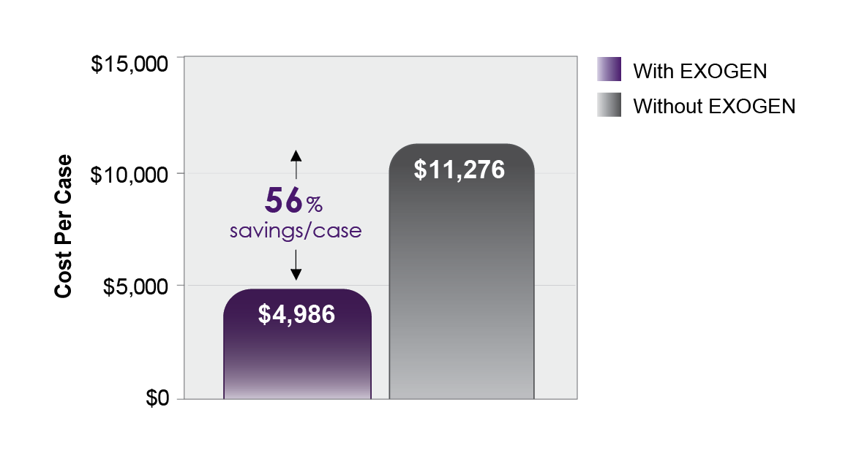
Reference | - Mehta S, Long K, DeKoven M, Smith E, Steen RG. Low-intensity pulsed ultrasound (LIPUS) can decrease the economic burden of fracture non-union. J Med Econ. 2015;18(7):542‐9. doi:10.3111/13696998.2015.1019887

Claim | - Helps expedite the patient’s ability to return to work¹  [Heckman 1997: 7a,c,d, 9b]  - Analysis of treatment costs associated with tibial shaft fractures¹  [Heckman 1997: 7a,c,d, 9b]  - Evaluated Workers’ Compensation, emergency room, surgery, outpatient, and device costs¹  [Heckman 1997: 7a,c,d, 9b]  - Conservative treatment of nonunion fractures with EXOGEN only could potentially result in healthcare savings in the United States projected to $4 billion annually.²  [Heckman 1997: 7a,c,d, 9b]
Graph [Heckman 1997: 4a, 9b] | 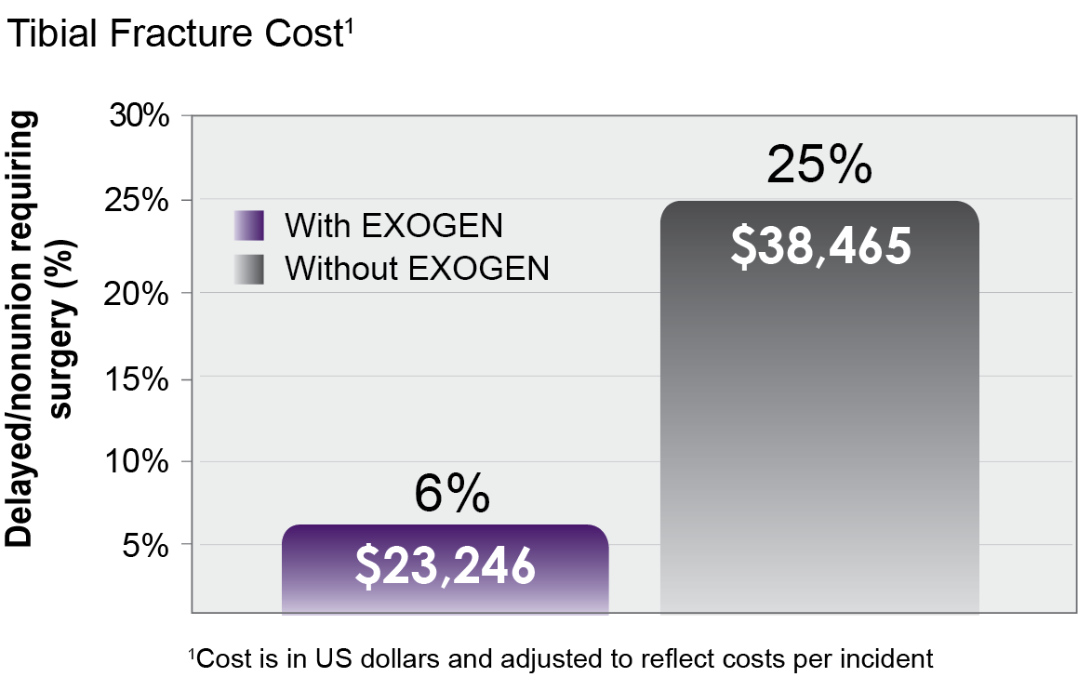
Reference | - Heckman JD, Sarasohn-Kahn J. The economics of treating tibia fractures. The cost of delayed unions. Bull Hosp Jt Dis. 1997;56(1):63-72.  - Mehta S, Long K, DeKoven M, Smith E, Steen RG. Low-intensity pulsed ultrasound (LIPUS) can decrease the economic burden of fracture non-union. J Med Econ. 2015;18(7):542‐9. doi:10.3111/13696998.2015.1019887

Claim | Based on a population of 1,000 patients with closed or open Grade I tibial diaphysis fractures, cost savings with EXOGEN treatment was associated with a reduction in the need for secondary surgery procedures.¹ [Heckman 1997:1a-c, 3a]
Graph [Heckman 1997: 4a, 9b] | 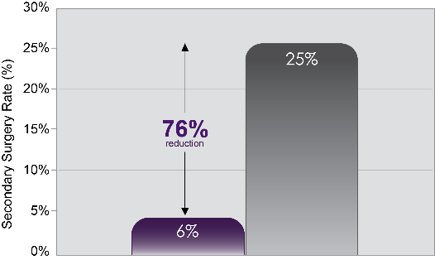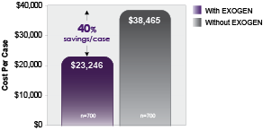
Reference | - Heckman JD, Sarasohn-Kahn J. The economics of treating tibia fractures. The cost of delayed unions. Bull Hosp Jt Dis. 1997;56(1):63-72.

Claim | EXOGEN helps reduce healthcare costs [Higgins 2014: 1a; Mehta 2015: 4b; Majeed 2020: 4a; Teoh 2018: 3a-b] and gets patients back to work faster.¹⁻⁵ [Heckman 1997: 9a, 10a]
Reference | - Higgins A, Glover M, Yang Y, Bayliss S, Meads C, Lord J. EXOGEN ultrasound bone healing system for long bone fractures with non-union or delayed healing: a NICE medical technology guidance. Appl Health Econ Health Policy. 2014;12(5):477-84. doi:10.1007/s40258-014-0117-6  - Mehta S, Long K, DeKoven M, Smith E, Steen RG. Low-intensity pulsed ultrasound (LIPUS) can decrease the economic burden of fracture non-union. J Med Econ. 2015;18(7):542‐9. doi:10.3111/13696998.2015.1019887  - Majeed H, Karim T, Davenport J, Karski M, Smith R, Clough TM. Clinical and patient-reported outcomes following Low Intensity Pulsed Ultrasound (LIPUS, Exogen) for established post-traumatic and post-surgical nonunion in the foot and ankle. Foot Ankle Surg. 2020;26(4):405-11. doi:10.1016/j.fas.2019.05.009  - Teoh KH, Whitham R, Wong JF, Hariharan K. The use of low-intensity pulsed ultrasound in treating delayed union of fifth metatarsal fractures. Foot (Edinb). 2018;35:52-5. doi:10.1016/j.foot.2018.01.004  - Heckman JD, Sarasohn-Kahn J. The economics of treating tibia fractures. The cost of delayed unions. Bull Hosp Jt Dis. 1997;56(1):63-72.

Claim | Surgery-only treatment of a nonunion fracture uses significantly and substantially more healthcare services than conservative treatment of a nonunion fracture with EXOGEN. Conservative treatment of a nonunion with EXOGEN only could potentially result in annual savings to the healthcare system in the United States projected to $4 billion.¹ [Mehta 2015: 2a]
Reference | - Mehta S, Long K, DeKoven M, Smith E, Steen RG. Low-intensity pulsed ultrasound (LIPUS) can decrease the economic burden of fracture non-union. J Med Econ. 2015;18(7):542‐9. doi:10.3111/13696998.2015.1019887

Claim | Based on an independent evidence review, EXOGEN is more cost-effective than surgical treatment of long bone fractures that have not healed within 9 months.¹ [Higgins 2014: 1a-b]
Reference | - Higgins A, Glover M, Yang Y, Bayliss S, Meads C, Lord J. EXOGEN ultrasound bone healing system for long bone fractures with non-union or delayed healing: a NICE medical technology guidance. Appl Health Econ Health Policy. 2014;12(5):477-84. doi:10.1007/s40258-014-0117-6

General Fracture Claims (not EXOGEN-specific)

General

Claim | Up to 5% of bone fractures progress to nonunion.¹ [Zura 2016: 1a]
Reference | - Zura R, Xiong Z, Einhorn T, et al. Epidemiology of fracture nonunion in 18 human bones. JAMA Surg. 2016;151(11):e162775. doi:10.1001/jamasurg.2016.2775

Claim | One in every 20 bone fractures may fail to heal properly.¹ [Zura 2016: 1a]
Reference | - Zura R, Xiong Z, Einhorn T, et al. Epidemiology of fracture nonunion in 18 human bones. JAMA Surg. 2016;151(11):e162775. doi:10.1001/jamasurg.2016.2775

Claim | If you have health complications or risk factors that impede your natural bone healing ability, it may take lengthy procedures or painful surgery for your bone to heal.¹⁻⁴ [Hernandez 2012: 1a-b Cook 1997: 8a, 9c; Scolaro 2014: 1a, 2a; Nolte 2001: 8a]
Reference | - Hernandez RK, Do TP, Critchlow CW, Dent RE, Jick SS. Patient-related risk factors for fracture-healing complications in the United Kingdom General Practice Research Database. Acta Orthop. 2012;83(6):653-60. doi:10.3109/17453674.2012.747054  - Cook SD, Ryaby JP, McCabe J, Frey JJ, Heckman JD, Kristiansen TK. Acceleration of tibia and distal radius fracture healing in patients who smoke. Clin Orthop Relat Res. 1997;(337):198-207. doi:10.1097/00003086-199704000-00022  - Scolaro JA, Schenker ML, Yannascoli S, Baldwin K, Mehta S, Ahn J. Cigarette smoking increases complications following fracture: a systematic review. J Bone Joint Surg Am. 2014;96(8):674-81. doi:10.2106/JBJS.M.00081  - Nolte PA, van der Krans A, Patka P, Janssen IM, Ryaby JP, Albers GH. Low-intensity pulsed ultrasound in the treatment of nonunions. J Trauma. 2001;51(4):693‐703. doi:10.1097/00005373-200110000-00012

Claim | The location, pattern, or severity of some fractures can impact bone healing.^{1,2} [Copuroglu 2013: 2a-b; Bishop 2012: 1a]
Reference | - Copuroglu C, Calori GM, Giannoudis PV. Fracture non-union: who is at risk? Injury. 2013;44(11);1379-82. doi:10.1016/j.injury.2013.08.003  - Bishop JA, Palanca AA, Bellino MJ, Lowenberg DW. Assessment of compromised fracture healing. J Am Acad Orthop Surg. 2012;20(5):273-82. doi:10.5435/JAAOS-20-05-273

Claim | Poor patient compliance reduces treatment benefits and can bias assessment of treatment effectiveness.¹ [McDonald 2002: 3a]
Reference | - McDonald HP, Garg AX, Haynes RB. Interventions to enhance patient adherence to medication prescriptions: scientific review. JAMA. 2002;288(22):2868‐79. doi:10.1001/jama.288.22.2868

Claim | Nonunions are fractures that have no visual progression in healing, and will not fully heal without further intervention.^{1,2} [Mayr 2000b: 1b-c; Zura 2015a: 2a-b]
Reference | - Mayr E, Frankel V, Rüter A. Ultrasound--an alternative healing method for nonunions? Arch Orthop Trauma Surg. 2000;120(1-2):1‐8. doi:10.1007/pl00021234  - Zura R, Della Rocca GJ, Mehta S, et al. Treatment of chronic (>1 year) fracture nonunion: heal rate in a cohort of 767 patients treated with low-intensity pulsed ultrasound (LIPUS). Injury. 2015;46(10):2036‐41. doi:10.1016/j.injury.2015.05.042

Claim | In most cases, nonunion fractures have little likelihood of healing without further intervention, particularly in chronic nonunions.¹ [Zura 2015a: 2a]
Reference | - Zura R, Della Rocca GJ, Mehta S, et al. Treatment of chronic (>1 year) fracture nonunion: heal rate in a cohort of 767 patients treated with low intensity pulsed ultrasound (LIPUS). Injury. 2015;46(10):2036‐41. doi:10.1016/j.injury.2015.05.042

Claim | Given variations in bone tissues and fracture characteristics, there is no uniformly accepted method of nonunion diagnosis that applies to all fractures.¹ [Nolte 2001: 1c,7b-c]
Reference | - Nolte PA, van der Krans A, Patka P, Janssen IM, Ryaby JP, Albers GH. Low-intensity pulsed ultrasound in the treatment of nonunions. J Trauma. 2001;51(4):693‐703. doi:10.1097/00005373-200110000-00012

Claim | There are multiple factors that lead to tibial nonunions, which include:¹ [Wiss 1996: 2a-b]  - Initial fracture displacement  - Surrounding soft tissue damage  - Disruption in microcirculation
Reference | - Wiss DA, Stetson WB. Tibial nonunion: treatment alternatives. J Am Acad Orthop Surg. 1996;4(5):249‐57. doi:10.5435/00124635-199609000-00003

Claim | Tibial fractures account for 35%-65% of all nonunion fractures.¹ [Heckman 1997: 1d]
Reference | - Heckman JD, Sarasohn-Kahn J. The economics of training tibia fractures. The cost of delayed unions. Bull Hosp Jt Dis. 1997;56(1):63-72.

Claim | There are multiple factors that lead to femoral neck nonunions, which include:^{1,2} [LeBlanc 2014: 4a; LaValle 2008]  - Thin periosteum  - Insufficient cancellous bone  - Poor blood supply  - Blood supply disrupted by injury
Reference | - LeBlanc KE, Muncie HL Jr, LeBlanc LL. Hip fracture: diagnosis, treatment, and secondary prevention. Am Fam Physician. 2014;89(12):945-51.  - LaValle DG. Fractures and dislocations of the hip. In: Canale ST, Beaty JH, eds. Campbell’s Operative Orthopaedics. 11th ed. Mosby Elsevier; 2008:3237-83.

Claim | Most hip fractures with involvement of the femoral neck are treated by orthopaedic surgery; displaced sub-capital fracutres of the femur have an incidence of nonunion as high as 33%.^{1,2} [Estrada 2002: 1a; UpToDate_Hip fracture in adults: 4a]
Reference | - Estrada LS, Volgas DA, Stannard JP, Alonso JE. Fixation failure in femoral neck fractures. Clin Orthop Relat Res. 2002;(399):110-8. doi:10.1097/00003086-200206000-00013  - UpToDate. Hip fracture in adults: epidemiology and medical management. Last updated December 10, 2021. Subscription-based website, www.uptodate.com/contents/hip-fracture-in-adults-epidemiology-and-medical-management

Claim | There are multiple factors that lead to fifth metatarsal nonunions, which include:¹ [Smith 1992: 1a]  - Lack of adequate blood supply  - Disruption of the nutrient artery
Reference | - Smith JW, Arnoczky SP, Hersh A. The intraosseous blood supply of the fifth metatarsal: implications for proximal fracture healing. Foot Ankle. 1992;13(3):143‐52. doi:10.1177/107110079201300306

Claim | There are multiple factors that lead to humerus nonunions, which include:¹  - Bone quality is typically poor (proximal humerus) [Badman 2006: 1a]  - Bone stock is limited (proximal humerus) [Badman 2006: 1a]  - Smoking or alcoholism [Badman 2006: 1b]  - Diabetes mellitus [Badman 2006: 1b]  - Soft tissue interposition [Badman 2006: 1b]  - Extensive comminution [Badman 2006: 1b]
Reference | - Badman BL, Mighell M, Drake GN. Proximal humeral nonunions: surgical technique with fibular strut allograft and fixed-angle locked plating. Tech Shoulder Elb Surg. 2006;7(2):95-101.

Claim | Patient-related factors may increase the risk of nonunions, such as:¹ [OrthoInfo_Nonunions: 2a, 3a]  - Tobacco use (smoking, chewing tobacco, and use of nicotine gum or patches)  - Older age  - Low vitamin D level  - Severe anemia  - Hypothyroidism  - Diabetes  - Poor nutrition  - Infection  - Anti-inflammatory drugs, such as aspirin, ibuprofen, or prednisone
Reference | - OrthoInfo, American Academy of Orthopaedic Surgeons. Nonunions. Last updated March 2014. https://orthoinfo.aaos.org/en/diseases--conditions/nonunions/#:~:text=Nonunions%20happen%20when%20the%20bone,supply%20to%20the%20broken%20bone

Claim | Hip fracture is among the most common injuries requiring hospital admission.¹ [Cohen 2012: 1a] Over 300,000 adults are hospitalized with a hip fracture each year.² [Remily 2020: 3a, 4a]
Reference | - Cohen J. Proximal femur fractures information. Accessed December 28, 2021. www.streetdirectory.com/travel_guide/112642/medical_conditions/proximal_femur_fractures_information.html  - Remily EA, Mohamed NS, Wilkie WA, et al. Hip fracture trends in America between 2009 and 2016. Geriatr Orthop Surg Rehabil. 2020;11:2151459320929581. doi:10.1177/2151459320929581

Claim | Smoking hinders fracture healing by inhibiting vascularization at bone healing sites.^{1,2} [Cook 1997: 1c, 2a; Castillo 2005: 1a-c]
Reference | - Cook SD, Ryaby JP, McCabe J, Frey JJ, Heckman JD, Kristiansen TK. Acceleration of tibia and distal radius fracture healing in patients who smoke. Clin Orthop Relat Res. 1997;(337):198‐207. doi:10.1097/00003086-199704000-00022  - Castillo RC, Bosse MJ, MacKenzie EJ, Patterson BM; LEAP Study Group. Impact of smoking on fracture healing and risk of complications in limb-threatening open tibia fractures. J Orthop Trauma. 2005;19(3):151‐7. doi:10.1097/00005131-200503000-00001

Claim | There is a strong association between smoking and nonunions.¹⁻³ [Castillo 2005: 1a-b; Cook 1997: 2a, 9a-b; Little 2006: 1a]
Reference | - Castillo RC, Bosse MJ, MacKenzie EJ, Patterson BM; LEAP Study Group. Impact of smoking on fracture healing and risk of complications in limb-threatening open tibia fractures. J Orthop Trauma. 2005;19(3):151‐7. doi:10.1097/00005131-200503000-00001  - Cook SD, Ryaby JP, McCabe J, Frey JJ, Heckman JD, Kristiansen TK. Acceleration of tibia and distal radius fracture healing in patients who smoke. Clin Orthop Relat Res. 1997;(337):198‐207. doi:10.1097/00003086-199704000-00022  - Little CP, Burston BJ, Hopkinson-Woolley J, Burge P. Failure of surgery for scaphoid non-union is associated with smoking. J Hand Surg Br. 2006;31(3):252‐5. doi:10.1016/j.jhsb.2005.12.010

Claim | Current and previous smokers are 37% and 32% less likely to achieve union than nonsmokers, respectively.¹ [Castillo 2005: 1b]
Reference | - Castillo RC, Bosse MJ, MacKenzie EJ, Patterson BM; LEAP Study Group. Impact of smoking on fracture healing and risk of complications in limb-threatening open tibia fractures. J Orthop Trauma. 2005;19(3):151‐7. doi:10.1097/00005131-200503000-00001

Claim | Smoking, fracture gap size, and advanced age are just some of the risk factors known to impede fracture healing.¹⁻³ [Copuroglu 2013: 1a, 2c, 2d; Giannoudis 2007b: 1a, 2a-b, 8a; Fong 2013: 1a-b, 7a]
Reference | - Copuroglu C, Calori GM, Giannoudis PV. Fracture non-union: who is at risk? Injury. 2013;44(11);1379-82. doi:10.1016/j.injury.2013.08.003003  - Giannoudis P, Tzioupis C, Almalki T, Buckley R. Fracture healing in osteoporotic fractures: is it really different? A basic science perspective. Injury. 2007;38 Suppl 1:S90-S99. doi:10.1016/j.injury.2007.02.014  - Fong K, Truong V, Foote CJ, et al. Predictors of nonunion and reoperation in patients with fractures of the tibia: an observational study. BMC Musculoskelet Disord. 2013;14:103. doi:10.1186/1471-2474-14-103

Claim | Effects of advanced age on fracture healing:¹  - Number of bone marrow stem cells drops considerably during aging. [Service 2000: 3a]
Reference | - Service RF. Tissue engineers build new bone. Science. 2000:289(5484):1498-500. doi:10.1126/science.289.5484.1498

Claim | Age hinders fracture healing by inhibiting vascularization at bone healing sites.^{1*} [Lu 2008: 1a]  *Add Note: The clinical relevance of in vivo findings is unknown.
Reference | - Lu C, Hansen E, Sapozhnikova A, Hu D, Miclau T, Marcucio RS. Effect of age on vascularization during fracture repair. J Orthop Res. 2008;26(10):1384‐9. doi:10.1002/jor.20667

Claim | Fractures caused by high-energy trauma are more likely to progress to nonunion.¹ [Karladani 2001: 1a]
Reference | - Karladani AH, Granhed H, Kärrholm J, Styf J. The influence of fracture etiology and type on fracture healing: a review of 104 consecutive tibial shaft fractures. Arch Orthop Trauma Surg. 2001;121(6):325‐8. doi:10.1007/s004020000252

Claim | A high degree of soft tissue damage is known to impair fracture healing.^{1,2} [Reverte 2011: 4a-b; Wiss 1996: 2a-b]
Reference | - Reverte MM, Dimitriou R, Kanakaris NK, Giannoudis PV. What is the effect of compartment syndrome and fasciotomies on fracture healing in tibial fractures? Injury. 2011;42(12):1402-7. doi:10.1016/j.injury.2011.09.007  - Wiss DA, Stetson WB. Tibial nonunion: treatment alternatives. J Am Acad Orthop Surg. 1996;4(5):249‐57. doi:10.5435/00124635-199609000-00003

Claim | Approximately 25% of patients fail to adhere to treatment recommendations.¹ [DiMatteo 2004: 1a]
Reference | - DiMatteo MR. Variations in patients’ adherence to medical recommendations: a quantitative review of 50 years of research. Med Care. 2004;42(3):200-9. doi:10.1097/01.mlr.0000114908.90348.f9

Claim | Nonadherence reduces treatment benefits and can bias assessment of treatment effectiveness.¹ [McDonald 2002: 3a]
Reference | - McDonald HP, Garg AX, Haynes RB. Interventions to enhance patient adherence to medication prescriptions: scientific review. JAMA. 2002;288(22):2868‐79. doi:10.1001/jama.288.22.2868

Claim | Compliance (synonym: adherence) is “the extent to which a patient acts in accordance with the prescribed interval and dose, as well as dosing regimen.” Compliance is measured over time and is reported as the proportion of prescribed doses taken at the prescribed time interval.¹ [Burrell 2005: 2a]
Reference | - Burrell A, Wong P, Ollendorf D, et al. Defining compliance/adherence and persistence: ISPOR special interest working group. ISPOR Annual Meeting 2005. Value Health. 2005;8(6):A194-5. Abstract PHP46.

Claim | Fractures with reduced vascularization are at a greater risk of nonunion.¹⁻³ [Wu 2013: 2a; Ricardo 2006: 4a; Brinker 2016: 4a-e]
Reference | - Wu N, Lee YC, Segina D, Murray H, Wilcox T, Boulanger L. Economic burden of illness among US patients experiencing fracture nonunion. Orthop Res Rev. 2013;5:21-33. doi:10.2147/ORR.S41123  - Ricardo M. The effect of ultrasound on the healing of muscle-pediculated bone graft in scaphoid non-union. Int Orthop. 2006;30(2):123‐7. doi:10.1007/s00264-005-0034-2  - Brinker MR, O’Connor DP. The biological basis for nonunions. JBJS Rev. 2016;4(6):e3. doi:10.2106/JBJS.RVW.15.00078

Claim | Vascularization is essential for bone healing, directly affecting chondrogenesis and thus ossification.^{1,2} [Miclau 2017: 1a; Ricardo 2006: 4a] Certain fractured bones are at risk of reduced vascularity, often progressing to delayed union or nonunion.² [Ricardo 2006: 1a, 2a]
Reference | - Miclau KR, Brazina SA, Bahney CS, et al. Stimulating fracture healing in ischemic environments: does oxygen direct stem cell fate during fracture healing? Front Cell Dev Biol. 2017;5:45. doi:10.3389/fcell.2017.00045  - Ricardo M. The effect of ultrasound on the healing of muscle-pediculated bone graft in scaphoid non-union. Int Orthop. 2006;30(2):123‐7. doi:10.1007/s00264-005-0034-2

Claim | The scaphoid bone, especially the proximal pole, has a peculiar vascular anatomy that is vulnerable to post-traumatic ischemia.¹ [Cerezal 2000: 3a] Research has reported scaphoid nonunion rates of 15.5%.² [Zura 2016: 3a]
Reference | - Cerezal L, Abascal F, Canga A, García-Valtuille R, Bustamante M, del Piñal F. Usefulness of gadolinium-enhanced MR imaging in the evaluation of the vascularity of scaphoid nonunions. AJR Am J Roentgenol. 2000;174(1):141‐9. doi:10.2214/ajr.174.1.1740141  - Zura R, Xiong Z, Einhorn T, et al. Epidemiology of fracture nonunion in 18 human nones. JAMA Surg. 2016;151(11):e162775. doi:10.1001/jamasurg.2016.2775

Claim | The fifth metatarsal, particularly in the proximal diaphysis, has reduced intraosseous vascular anatomy, which contributes to poor fracture healing.¹ [Smith 1992: 1a-b] For Jones fractures of the proximal fifth metatarsal, the incidence of nonunions may be as high as 28%.² [Rosenberg 2000: 4a]
Reference | - Smith JW, Arnoczky SP, Hersh A. The intraosseous blood supply of the fifth metatarsal: implications for proximal fracture healing. Foot Ankle. 1992;13(3):143‐52. doi:10.1177/107110079201300306  - Rosenberg GA, Sferra JJ. Treatment strategies for acute fractures and nonunions of the proximal fifth metatarsal. J Am Acad Orthop Surg. 2000;8(5):332‐8. doi:10.5435/00124635-200009000-00007

US Specific Data

Claim | Approximately 30.8 million adults in the United States smoke cigarettes.¹ That is 12.5% of the entire US adult population.¹
Reference | - Centers for Disease Control and Prevention. Current cigarette smoking among adults in the United States. Updated March 17, 2022. www.cdc.gov/tobacco/data_statistics/fact_sheets/adult_data/cig_smoking/index.htm

Claim | Approximately 15.3 million fractures occur in the United States annually.¹ [Raghavan 2012: 3a]
Reference | - Raghavan P, Christofides E. Role of teriparatide in accelerating metatarsal stress fracture healing: a case series and review of literature. Clin Med Insights Endocrinol Diabetes. 2012;5:39-45. doi:10.4137/CMED.S9663

Claim | Approximately 15.3 million fractures occur every year in the United States,¹ [Raghavan 2012: 3a] and as many as 5% may be at risk of not healing.² [Zura 2016: 1a]
Reference | - Raghavan P, Christofides E. Role of teriparatide in accelerating metatarsal stress fracture healing: a case series and review of literature. Clin Med Insights Endocrinol Diabetes. 2012;5:39-45. doi:10.4137/CMED.S9663  - Zura R, Xiong Z, Einhorn T, et al. Epidemiology of fracture nonunion in 18 human bones. JAMA Surg. 2016;151. doi:10.1001/jamasurg.2016.2775

Claim | Approximately 15.3 million fractures occur in the United States each year.¹ [Raghavan 2012: 3a] As many as 5% may be at risk of not healing.² [Zura 2016: 1a]
Reference | - Raghavan P, Christofides E. Role of teriparatide in accelerating metatarsal stress fracture healing: a case series and review of literature. Clin Med Insights Endocrinol Diabetes. 2012;5:39-45. doi:10.4137/CMED.S9663  - Zura R, Xiong Z, Einhorn T, Watson JT, Ostrum RF, Prayson MJ, Della Rocca GJ, Mehta S, McKinley T, Want Z, Steen RG. Epidemiology of fracture nonunion in 18 human bones. JAMA Surg. 2016;151. doi:10.1001/jamasurg.2016.2775

Claim | The tibia is the most commonly fractured long bone in the body,¹ [Schmidt 2003: 2a] with approximately 492,000 tibial fractures occurring in US adults every year.² [UpToDate Tibia shaft fractures: 1a]
Reference | - Schmidt AH, Finkemeier CG, Tornetta P 3rd. Treatment of closed tibial fractures. Instr Course Lect. 2003;52:607-22.  - UpToDate. Tibial shaft fractures in adults. Last updated August 25, 2021. www.uptodate.com/contents/tibial-shaft-fractures-in-adults

Claim | The tibia is the most commonly fractured long bone in the body, [Schmidt 2003: 2a] and the nonunion rate for these fractures may be as high as 14% [Zura 2016: 3a] (approximately 68,880 in 2016 in the United States each year.¹⁻³ [UpToDate Tibial shaft fractures: 1a] Nonunions in tibial fractures can be affected by smoking and other nonunion risk factors.^{4,5} [Wiss 1996: 2b; Gaston 2007: 1a, 2a-b, 3a-c, 4a-b, 5a]
Reference | - Schmidt AH, Finkemeier CG, Tornetta P 3rd. Treatment of closed tibial fractures. Instr Course Lect. 2003;52:607-22.  - Zura R, Xiong Z, Einhorn T, Watson JT, Ostrum RF, Prayson MJ, Della Rocca GJ, Mehta S, McKinley T, Want Z, Steen RG. Epidemiology of fracture nonunion in 18 human Bones. JAMA Surg. 2016;151. doi:10.1001/jamasurg.2016.2775  - UpToDate. Tibial shaft fractures in adults. Last updated August 25, 2021. www.uptodate.com/contents/tibial-shaft-fractures-in-adults  - Wiss DA, Stetson WB. Tibial nonunion: treatment alternatives. J Am Acad Orthop Surg. 1996;4(5):249‐57. doi:10.5435/00124635-199609000-00003  - Gaston MS, Simpson AH. Inhibition of fracture healing. J Bone Joint Surg Br. 2007;89(12):1553‐60. doi:10.1302/0301-620X.89B12.19671

Claim | In the United States, there are approximately 300,000 adults hospitalized for hip fractures every year.¹ [Remily 2020: 3a, 4a]  Hip fracture is among the most common injuries requiring hospital admission.² [Cohen_Proximal femur fractures: 1a] Over 300,000 adults are hospitalized with hip fracture each year.¹ [Remily 2020: 3a, 4a]
Reference | - Remily EA, Mohamed NS, Wilkie WA, et al. Hip fracture trends in America between 2009 and 2016. Geriatr Orthop Surg Rehabil. 2020;11:2151459320929581. doi:10.1177/2151459320929581  - Cohen J. Proximal femur fractures information. Accessed December 28, 2021. www.streetdirectory.com/travel_guide/112642/medical_conditions/proximal_femur_fractures_information.html

Claim | - Fifth metatarsal fractures represent 68% of all metatarsal fractures.¹ [East Lankashire F&A Hyperbook: 1a] For Jones fractures, a common type of fifth metatarsal fracture, [Healthline Jones Fracture: 1a] the incidence of nonunions may be as high as 28%.^{2,3} [Rosenberg 2000: p1 abs; p3 col3 par3]  - Fifth metatarsal fractures represent 68% of all metatarsal fractures. For Jones fractures, a common type of fifth metatarsal fracture,² [Healthline Jones Fracture: p1 par1] the incidence of nonunions may be as high as 28%.³ [Rosenberg 2000: 3a]
Reference | - East Lancashire Foot and Ankle Hyperbook. Fractures of the 1st-4th metatarsals. Last updated May 2011. www.foothyperbook.com/trauma/forefootTrauma/metatarsalFx.htm  - Healthline. Jones fracture. Updated October 21, 2018. www.healthline.com/health/jones-fracture  - Rosenberg GA, Sferra JJ. Treatment strategies for acute fractures and nonunions of the proximal fifth metatarsal. J Am Acad Orthop Surg. 2000;8(5):332‐8. doi:10.5435/00124635-200009000-00007

Claim | The incidence of humerus fractures is substantially higher in the United States than in other countries, and the most common form is proximal humerus fractures.¹ [Kim 2012: 1a-b]  The incidence of humerus fracture nonunion varies, but can be as high as 23%.² [Badman 2006: 1b]  Proximal humeral fractures are more common in older individuals (average age 64.5 years).³ [Srivastava 2019: 1a]
Reference | - Kim SH, Szabo RM, Marder RA. Epidemiology of humerus fractures in the United States: nationwide emergency department sample, 2008. Arthritis Care Res (Hoboken). 2012;64(3):407-14. doi:10.1002/acr.21563  - Badman BL, Mighell M, Drake GN. Proximal humeral nonunions: surgical technique with fibular strut allograft and fixed-angle locked plating. Tech Shoulder Elb Surg. 2006;7(2):95-101.  - Srivastava AK. Humerus fracture. Last updated November 7, 2019. https://emedicine.medscape.com/article/825488

Claim | In one study, 15% of clavicle fractures (8/52) followed for 38 months progressed to nonunion.¹ [Hill 1997: 1a]
Reference | - Hill JM, McGuire MH, Crosby LA. Closed treatment of displaced middle-third fractures of the clavicle gives poor results. J Bone Joint Surg Br. 1997;79(4):537‐9. doi:10.1302/0301-620x.79b4.7529

Claim | Scaphoid fractures account for 60%-70% of all carpal bone fractures.¹ [Ruby 1992: 3a]
Reference | - Ruby LK. Fractures and dislocations of the carpus. In: Skeletal Trauma: Fractures, Dislocations, Ligamentous Injuries. Browner B, Jupiter JB, Levine AM, Trafton P, eds. W.B. Saunders Company; 1992:1025-36.

Claim | According to the Department of Defense Military Injury Prevention Priorities Working Group (DMIPPWG), fractures significantly compromise military readiness and operational effectiveness.¹ [DoD Military Injury 2006: 9a; 17a; 18a; 24a, 25a]
Reference | - Department of Defense, Defense Safety Oversight Council. DoD Military Injury Prevention Priorities Working Group: leading injuries, causes and mitigation recommendations. Posted February 2006. https://apps.dtic.mil/dtic/tr/fulltext/u2/a458257.pdf

EXOGEN Indication Statement

Indication statement must be on all customer-facing materials.

USA
2020:
The EXOGEN Ultrasound Bone Healing System is indicated for the non-invasive treatment of established nonunions* excluding skull and vertebra.

The EXOGEN device has also been reported as effective as an adjunctive non-invasive treatment of established nonunions in patients:

- With internal or external fracture fixation hardware present. EXOGEN cannot penetrate metal and therefore should not be applied directly over hardware.
- Undergoing treatment for infection at the fracture site. EXOGEN is not intended to treat the infection.
- Believed to have diminished bone quality. EXOGEN is not intended to treat diminished bone quality.

In addition, EXOGEN is indicated for accelerating the time to a healed fracture for fresh, closed, posteriorly displaced distal radius fractures and fresh, closed or Grade I open tibial diaphysis fractures in skeletally mature individuals when these fractures are orthopaedically managed by closed reduction and cast immobilization.
There are no known contraindications for the EXOGEN device. Safety and effectiveness have not been established for individuals lacking skeletal maturity; pregnant or nursing women; patients with cardiac pacemakers; on fractures due to bone cancer; or on patients with poor blood circulation or clotting problems. Some patients may be sensitive to the ultrasound gel.

*A nonunion is considered to be established when the fracture site shows no visibly progressive signs of healing.

Full prescribing information can be found in product labeling, at www.exogen.com or by contacting customer service at 1-800-836-4080.

EXOGEN Writing Guidelines

1 | Name Usage  In all text usage, EXOGEN should be written in all capital letters.  Bioventus  In all text usage, the company name should always begin with a capital B and the remaining letters shall be lowercase. Do not write the name in all caps or in all lower case letters. The only time the company name should appear in all lower case is within the logo, and it must then be accompanied by the BioSphere. Do not put a trademark symbol beside the company name in text.  The word “Bioventus” is never abbreviated. (Do NOT use “BV”, Biov.”,etc.)
2 | EXOGEN Trademark Usage  EXOGEN®  The first reference of EXOGEN within a document should be appropriately trademarked with the ® symbol (superscripted). Additional uses of the product name do not need the registered trademark symbol.  At the end of the document (or for a slide deck, on the slide containing the ®), insert the following trademark notification:  EXOGEN is a registered trademark of Bioventus LLC  The same convention should be used competitive products
3 | Bioventus Trademark Usage  The Bioventus trademark notification must be on each marketing piece  For non-European countries, use either:  - The Bioventus logo is a trademark of Bioventus LLC.  - Bioventus and the Bioventus logo are trademarks of Bioventus LLC.
4 | EXOGEN URLs  www.exogen.com
5 | Address Format  Bioventus LLC (no period after LLC), 4721 Emperor Blvd., Suite 100, Durham, NC 27703  (Note: The above company name and address may be stacked if space allows).
6 | Telephone Format  USA:  Customer Service: 1-800-836-4080 (toll free)  General Information: 1-800-396-4325
7 | Writing Style  - Orthopaedic (with the “a”) is the appropriate spelling of the name in Bioventus materials  - As a company, Bioventus uses the US spelling conventions for all words  BioSphere, the emblem within the Bioventus logo, includes a capital “S” in its name
8 | Fonts for Marketing Materials  Century Gothic font should be used for all headlines, while Arial would serve as body copy.  - If a subhead, multiple headers, raised quotes, etc. are used in the printed pieces, these can either be century Gothic or Arial based on the design of the piece. If any text in the document is printed in bold, then the Century Gothic headline of the document must also be in bold.

- AMERICAN MEDICAL ASSOCIATION CITATION STYLE

- Each reference is numbered, and the superscript number in the text is used to indicate the reference
- Superscript numbers are placed outside periods and commas, and inside colons and semicolons.
- Use commas to separate multiple citation numbers in text
- References are listed numerically in the order they are cited in the text
- Unpublished works and personal communications should be cited in the text (and not on the reference list).
- When citing the same source more than once, give the number of the original reference, and then include the page number (in parentheses) where the information was found.
- For the reference:
  - Include up to 6 authors
  - For more than six authors, provide the names of the first three authors and then add et al.
  - If there is no author, start with the title

Citation Type | Example
Journal article – in print – one author
  Spencer J. Physician, heal thyself – but not on your own please. Med Educ. 2005;89:548-9.
Journal article – in print – 2-6 authors
  Salwachter AR, Freischlag JA, Sawyer RG, Sanfey HA. The training needs and priorities of male and female surgeons and their trainees. J Am Coll Surg. 2005;201:199-205.
Journal article – online *if there is no DOI, provide the URL for the specific article
  Coppinger T, Jeanes YM, Hardwick J, Reeves S. Body mass, frequency of eating and breakfast consumption in 9-13-year-olds. J Hum Nutr Diet. 2012; 25(1): 43-9. doi:10.1111/j.1365-277X.2011.01184.x
Journal article – online from a library database | Calhoun DJ, Trimarco TW, Meek RJ, Locasto DA. Distinguishing diabetes: differentiate between type 1 & type 2 DM. JEMS. 2011; 36(11):32-8. doi:10.1016/S0197-2510(11)70281-9
Newspaper article – in print  *if the city name is not part of the newspaper name, it may be added to the official name for clarity  *if an article jumps from one page to a later page write the page numbers like D1, D5 | Wolf W. State’s mail-order drug plan launched. Minneapolis Star Tribune. Posted May 14, 2004. www.startribune.com/viewers/story.php?template=a&story=4886132
Newspaper article – online
  Pollack A. FDA approves new cystic fibrosis drug. New York Times. Posted January 31, 2012.
  www.nytimes.com/2012/02/01/business
  /fda-approves-cystic-fibrosis -drug.html?ref=health
Websites | Centers for Disease Control and Prevention. Cholera in Haiti. Last updated November 7, 2014. www.cdc.gov/cholera/haiti/
Entire book – in print
  Modlin J, Jenkins P. Decision Analysis in Planning for a Polio Outbreak in the United States. Pediatric Academic Societies; 2004.
Book chapter – in print
  Solensky R. Drug allergy: desensitization and treatment of reactions to antibiotics and aspirin. In: Lockey P, ed. Allergens and Allergen Immunotherapy. 3rd ed. Marcel Dekker; 2004:585-606.
Unpublished items presented at a meeting (Includes conferences, oral, and poster presentations) | Durbin D, Kallan M, Elliott M. Risk of injury to restrained children from passenger airbags. Paper presented at: 46th Annual Meeting of the Association for the Advancement for Automotive Medicine; September 23-25, 2002; Tempe, AZ.

