

Find an Org Chart on Workday – A Tutorial

At Bioventus, we let you find Organizational Charts via our Workday system. If you are new to Workday or are not sure where to find it, first visit our Intranet page – Bionet.
Once there visit the drop down Quick Links Menu in the upper left.
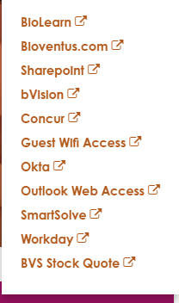
Click on Workday and once in Workday click on the Directory Icon you see. It should appear on the left side of the page after you log in.
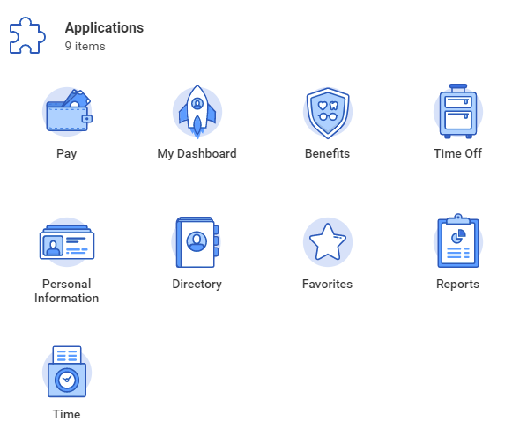

Next, open the Directory and search for any employee. In this example, we will search for Sharon Klugewicz

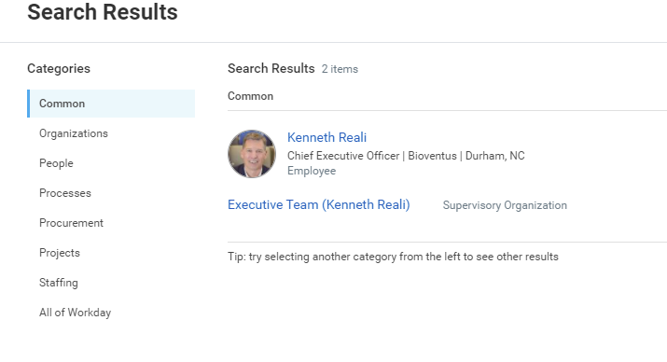
Then click on the employee’s name, in this case Ken and this icon should appear
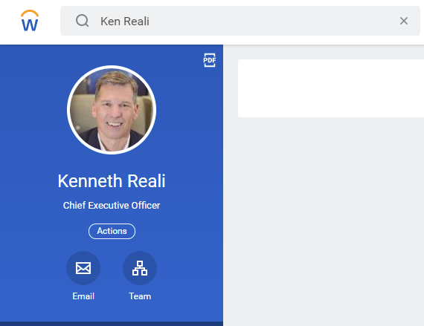
Then click on Team to see his Organization.
