Instructions for adding an Email Signature Graphic
- Save the email signature to your computer.
- Open Outlook and click on “File” in the top left corner
- Click on “Options” on the left hand navigation

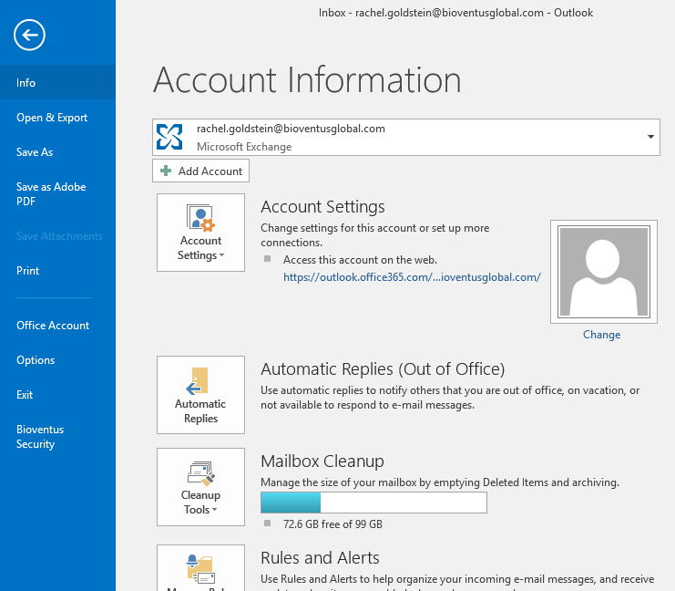

- Click “Mail” on left hand navigation in pop-up

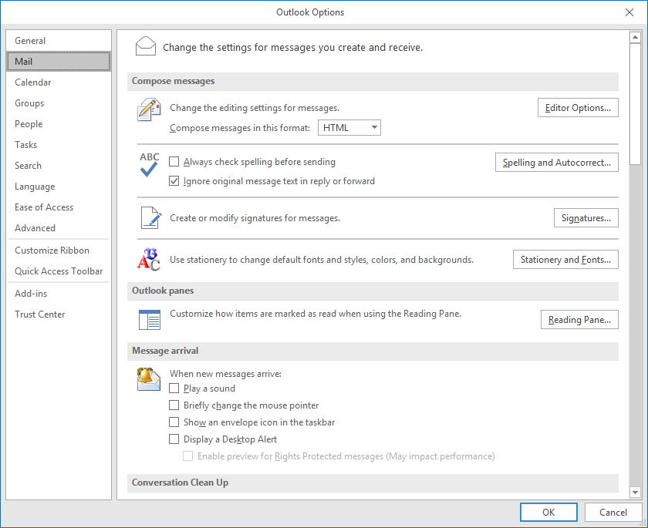

- Click on “Signatures”

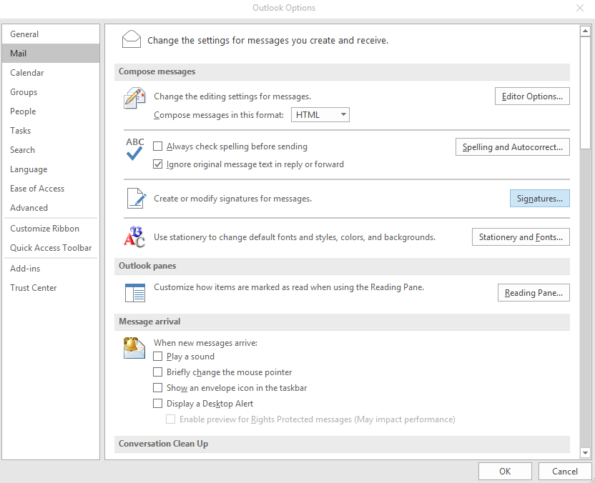

- Select “New” under “Email Signature tab
- Create a name for the signature
- Enter your contact Information in the box
- Click the image icon to add the image under your contact information

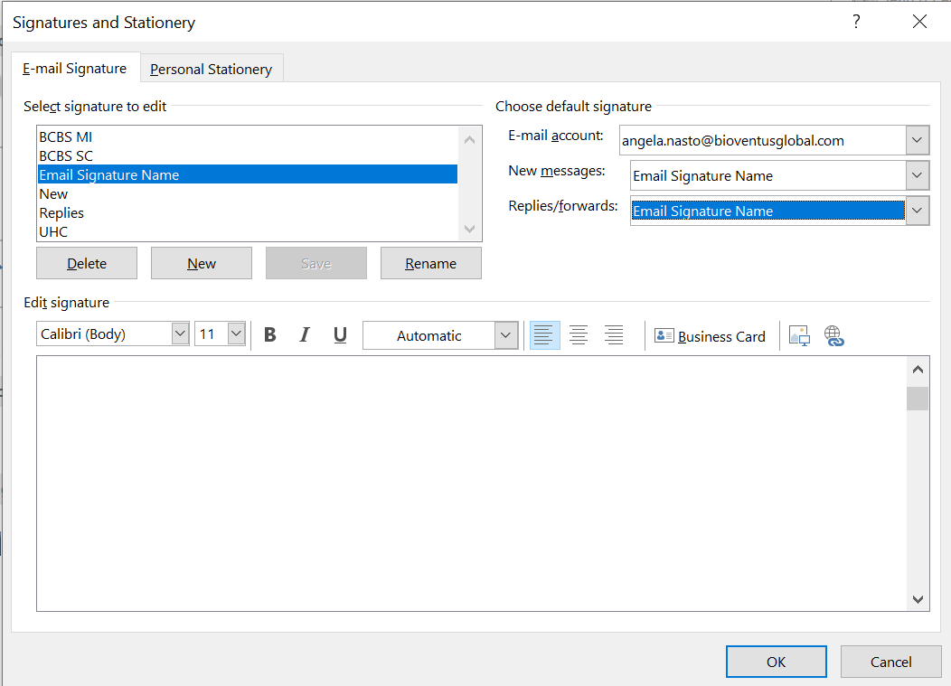
- Upload signature graphic from your files
- Click on image and then click on the hyperlink icon to add a link to the image
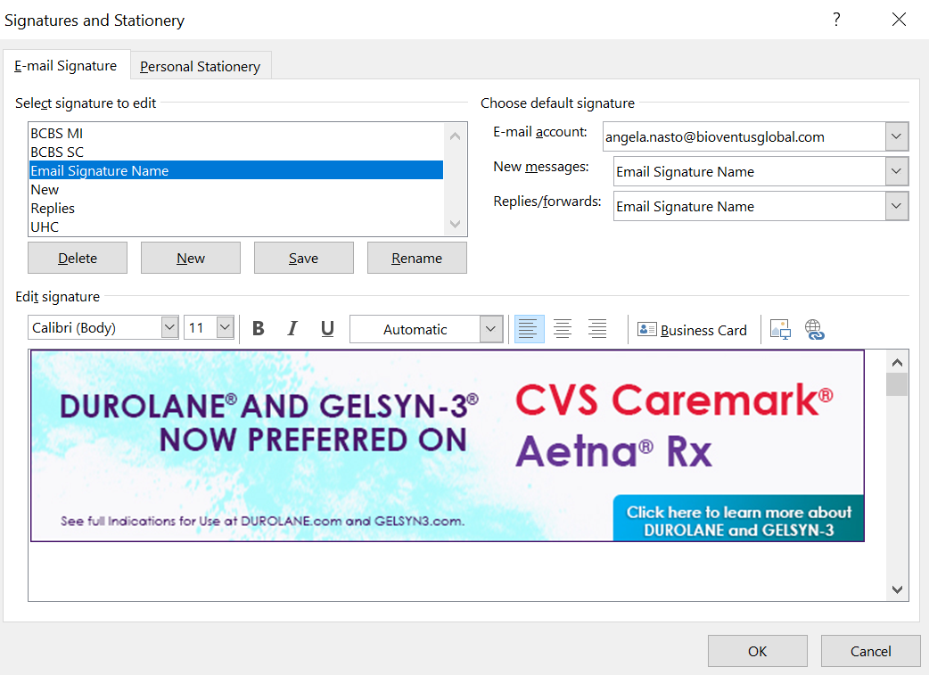

- Select “Existing file or web page”

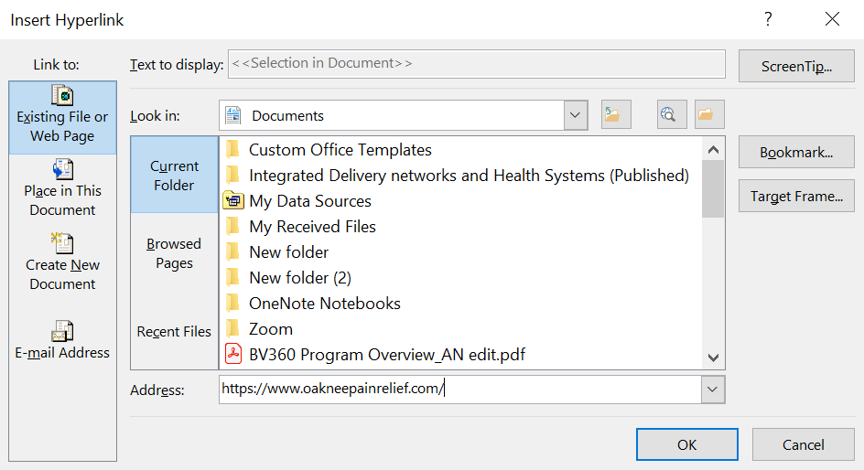

- Type https://www.oakneepainrelief.com/ in the address bar
- Click ok
- Select the email signature name in the drop down boxes for “New messages” and “Replies/forwards”

- Click ok
- Create a new email. Signature should be updated.

