UPDATING TAX ELECTIONS IN WORKDAY

Click on Pay worklet:
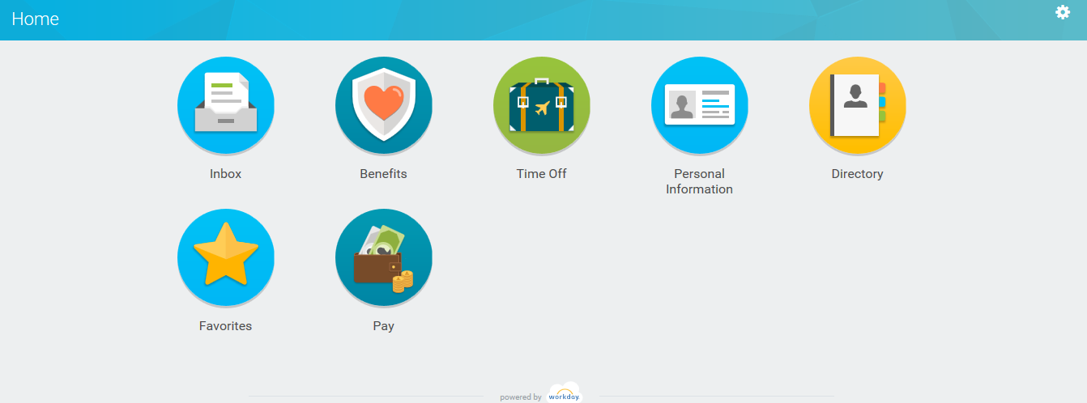

Click on Withholding Elections:
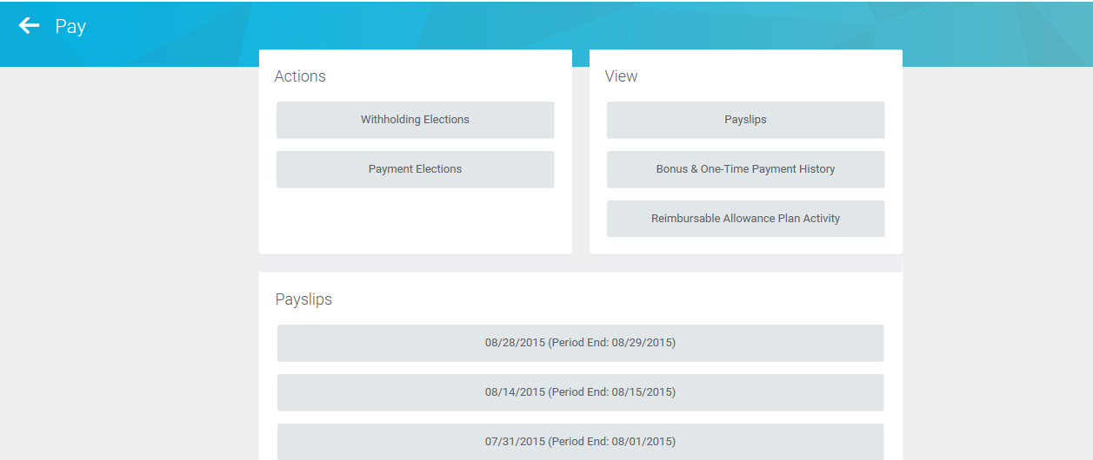

You will see your current elections. Click on type of tax election you want to update:
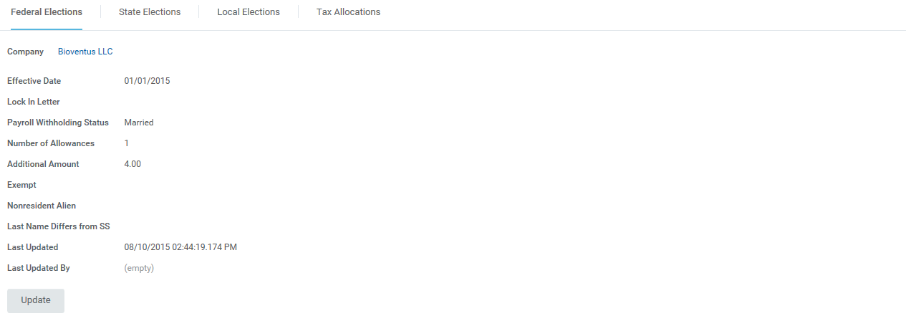

Enter effective date and click OK:
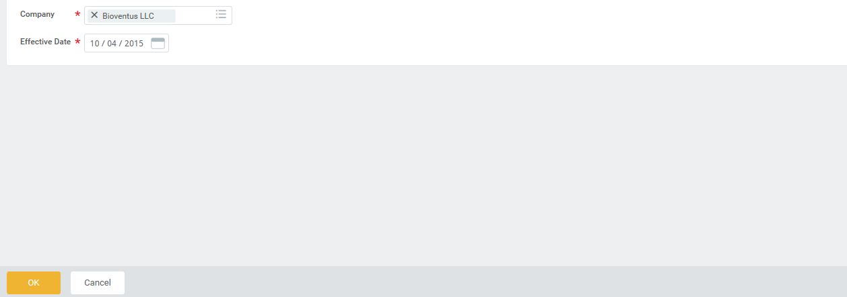

Make changes to Marital Status or Number of Allowances:
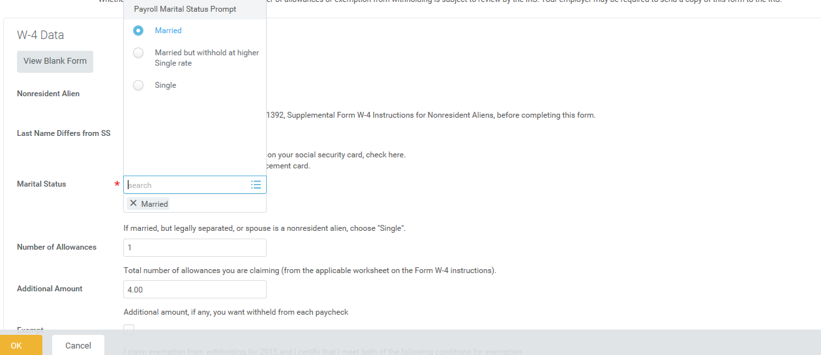

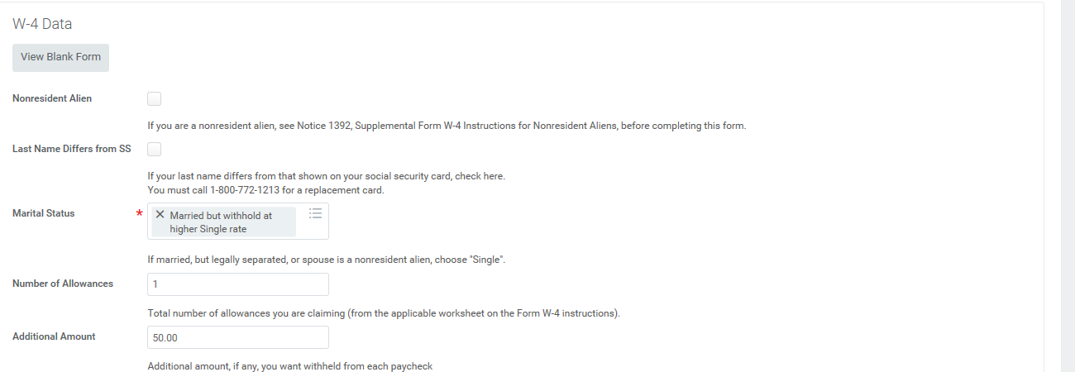

Check “I Agree” box and Click OK:
