Workday Manager Termination Instructions
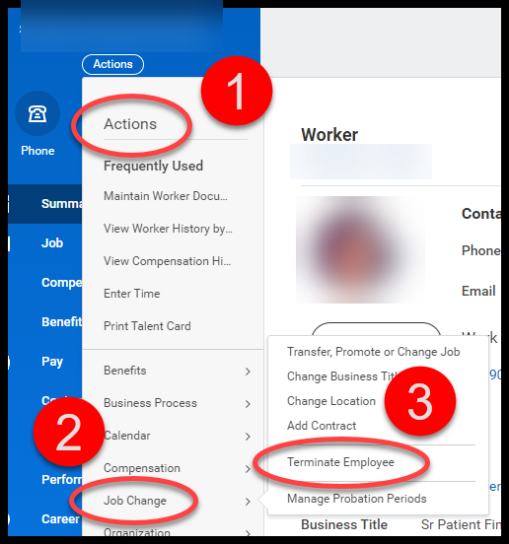
Go to the Workers Record in Workday
- Select “Actions”
- Select “Job Change”
- Select “Terminate Employee”
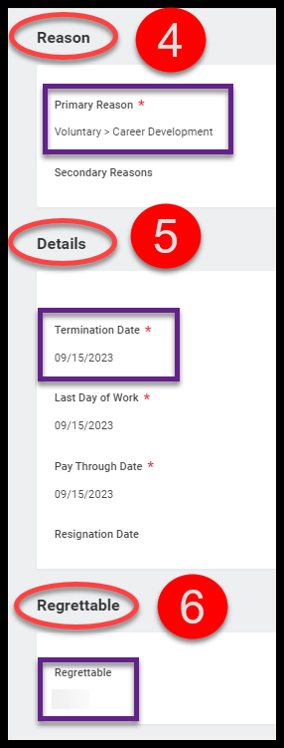

- Reason - Choose Primary Termination Reason
- Bioventus Employees (FT/PT) - Managers should process ALL Voluntary terminations. For involuntary terminations, managers must contact their HR Business Partner.
- Contingent Worker - Managers should process all terminations (Involuntary and Voluntary).
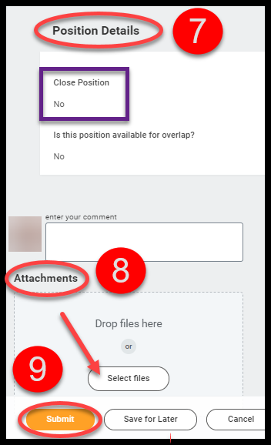
- Details – Enter Term Date
          - Last Day of Work & Pay Through Date will automatically populate.

- Regrettable – Choose Yes or No.
- Position Details – If you are back filling the position, leave as is (No). If you are not back filing the position, check the box to indicate that it should be “closed.”
- Attachments – If you have the resignation letter or email, please attach by selecting “Select files.”
- Submit – task will route to HR Business Partner to review.

FT/PT= Full Time or Part Time Employee
Contingent Worker = Contractors
Term Date = last day worked

